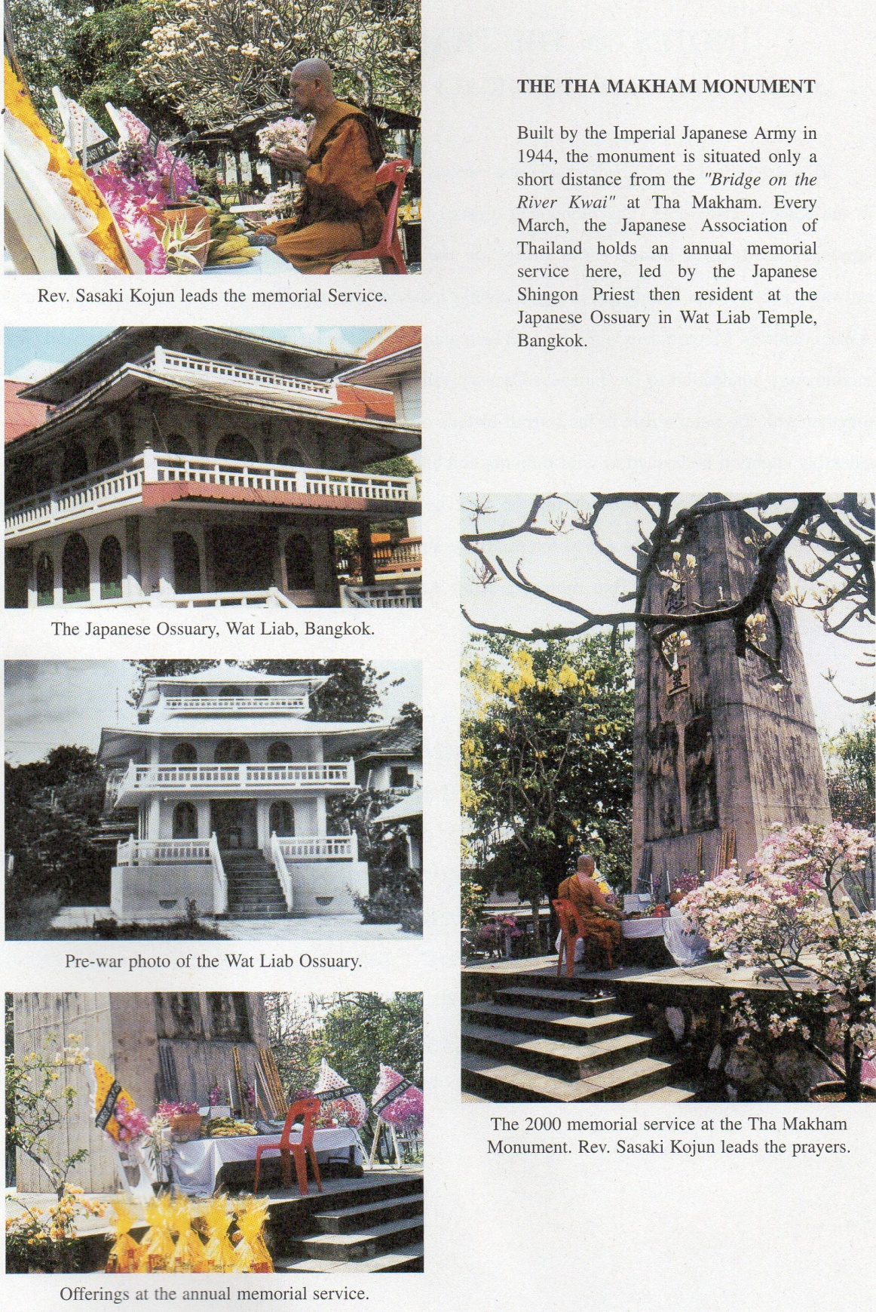

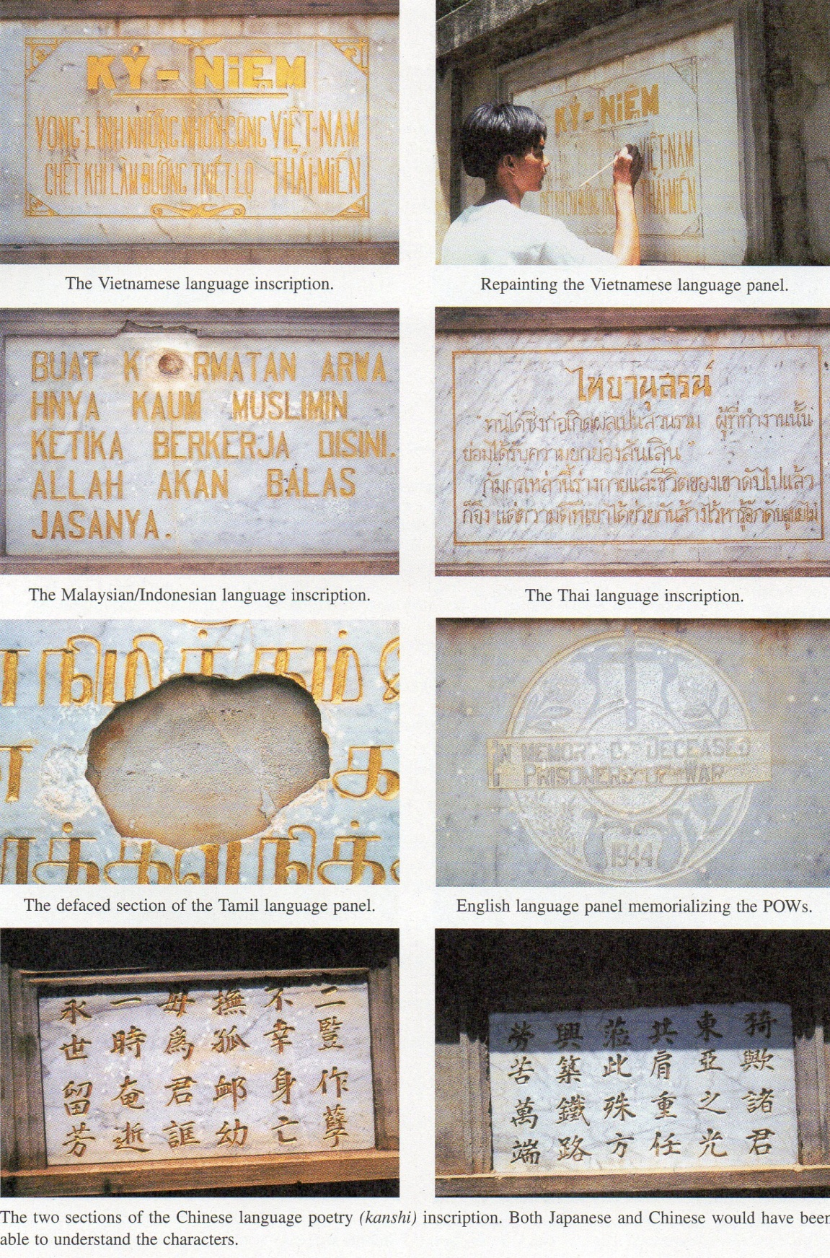

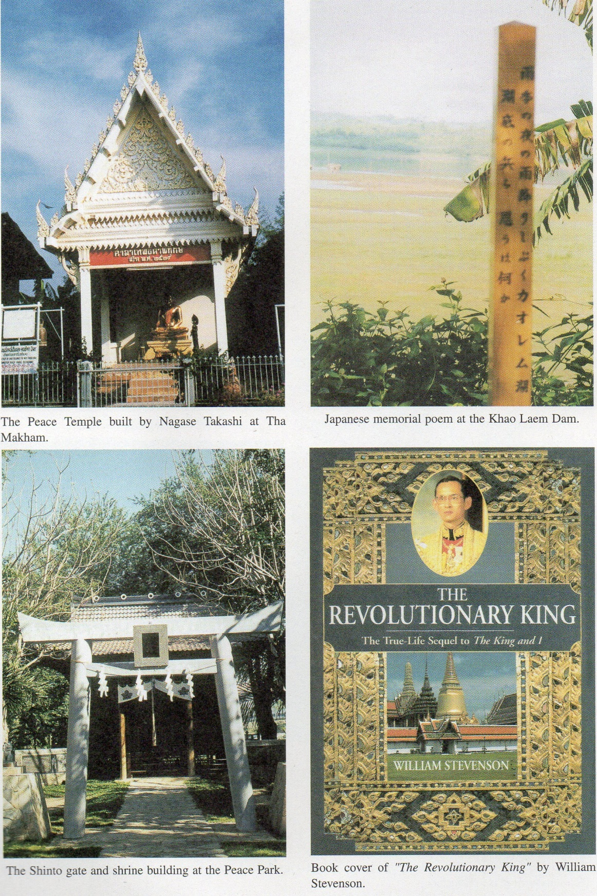

**NOTES ON THE THAI-BURMA RAILWAY PART X: JAPANESE MEMORIALS IN THE KANCHANABURI AREA**

The Japanese Military Memorial

Upon completion of the railway on October 17th 1943, the Japanese military authorities determined to erect a memorial to the many people who had lost their lives during the railway’s construction. This unusual monument still survives today, at Tha Makham, some 100 meters downstream from the famous bridge. Artistically, it is hardly a particularly attractive monument**,** being a cenotaph-type structure made of the rough concrete that had sufficed for the railway s construction. Usually unvisited and ignored by the regular tourists to Kanchanaburi, this monument is nevertheless of considerable significance and importance in memorializing the tragedy of the railway.

Forming the four corners of a square at some 10 meters distance from the cenotaph itself, are four wall-like structures, bearing memorial plaques of marble inscribed in the languages of those who had lost their lives in building the railway.[1] One corner structure (two tablets) records a poem in classical Chinese (a literary form known as *kanshi* in Japanese). At another corner, inscriptions appear in both Vietnamese [2] and the peculiar *“reformed”* Thai script in use during the era of Thai Prime Minister Plaek Phibunsongkhram. The third corner structure was bombed during an Allied air raid on the bridge, after which only the English language tablet memorializing the Western prisoners of war (POWs) was restored. (The second, now missing tablet possibly contained an inscription in Burmese). The final corner bears memorial inscriptions in the Indonesian/Malaysian [3] and Tamil languages. A further Japanese language inscription on the rear of the cenotaph itself mentions the deaths of Japanese military personnel. It might perhaps seem somewhat out of character for the Japanese military to erect monuments to the victims of its own brutality or mismanagement and, as early as 1944, even admitting that people had died at all, especially in the somewhat mundane task of building a railway! However, the memorial’s importance lies in the fact that so many Asian languages appear; this has given the Japanese army’s wartime memorial the distinction of being the *only* monument of the war era in the Kanchanaburi area to recognize the existence and enormous sufferings of the Asian labourers. [4] Those involved in the railway’s construction hold widely differing opinions about the validity of the monument. Opinions expressed by former Allied soldiers (POW5) have been fairly negative, with some notable exceptions. Comelis Evers, a former Dutch POW, writes of the railway’s completion in his own account, ***“****Death Railway”.*

“A holiday was declared for October 25 (1943) and on that day a gaily festooned train arrived at the camp, which unloaded extra rations for the Japanese troops and even some for the prisoners. All the Japanese and Koreans who had collaborated on the construction of the track received a medal. And we learned that a memorial to the Allied troops who had ‘contributed’ to it, was going to be erected near the bridge on the River Kwai. This did not interest us very much at the tune. It was only after the war when we came face to face with the monument that the cynicism of the Japanese in commemorating those whomthey had drive, mercilessly and callously, to their deaths, struck us in full force.” [5]

Eric Lomax, the former British POW whose account has been frequently mentioned in previous articles, points out that the monument has often been defaced by stones thrown by former Allied prisoners visiting Kanchanaburi, such is the hatred that they still bear towards Japan as a result of their cruel treatment.

“The Japanese War Memorial which POWs were forced to build some time in1944, is a sadder and more neglected place. A cenotaph now showing blotches of weather and stress was erectedin a compound surrounded by low trees: it is ill-kept and deserted. The cenotaph incorporates plaques to the dead of other countries, like an afterthought. Some ex-POWs, who can never forgive, throw stones at the memorial when they come here: the scars are visible on the stained concrete.” [6]

The projectiles thrown by visitors have done rather greater damage than Lomax indicates. Several of the inscriptions on the marble tablets have also been defaced. Although damage to the Malaysian/Indonesian language inscription was repaired by the Japanese Association, that of the Tamil language still renders a part of the text illegible. Former Japanese *Kempeitai* (Military Police) official, Nagase Takashi, is more specific;

“It is true that there is a memorial tower which was built by the Japanese Arm But there are very few visitors partly because of the difference in religion of the Thai. It has even become the object of hatred from the ex-prisoners who visited the Kwai. They throw stones at the memorial, (and) pull out flowers offered, candles and incense sticks to stamp on. The ex-POWs still have deep-seated resentment towards the Japanese. In the construction of the tower the British POWs were made to design it and carry cement for it. They still say in anger. ‘*Why did we, the victims, have to build the memorial tower for our own comrades?*’.” [7]

  Opinions about the annual memorial services held at the site by the Japanese army also differ considerably, depending on a prisoner’s perspective and memories. A particularly negative impression was recorded by Rohan Rivett.

“On arrival at Tamarkan (Tha Makham) we found a gang of British captives engaged in building a memorial to those who had died on the railway. The Japanese chose a point midway between the camp and the Tamarkan bridge across the river for this memorial, which had commemorative tablets at its four corners and a tall cenotaph in the center. On 21st March Brigadier Varley, together with a selected number of officers and men, has marched over to the memorial to witness the opening service. Representatives of the various native races and sects employed on the railroad were present, while gold-braided officers of the Thai army, navy and air force sat with the Japanese officers under a specially erected marquee. The Japanese, sublimely unconscious of the irony of things, decked out the whole memorial as if for a harvest festival, the cenotaph and oblation stone before it being covered with many types of the fruit and vegetables for lack of which the prisoners had died. While newsreel photographers filmed us from every angle, various Asiatic representatives delivered speeches which were received with absolute apathy by the natives present, who looked as if they had been shanghaied into attendance. The Japanese and Thai officers fidgeted and looked grim and bored throughout the whole ceremony. Finally, Brigadier Varley read out a statement emphasizing that the conditions under which prisoners had worked would be investigated after the war. The entire ceremony was an insult to God and man, carried through with a blatant hypocrisy and a lack of sincerity which no Japanese took the trouble to conceal. At the end, they lined us all up black, white, yellow and brown, and solemnly presented each person with a tin of biscuits - a gesture apparently meant to suggest that all was now forgiven and forgotten. I have never been present at a .function so patently meaningless to everybody concerned. Prisoners and Asiatics alike, knowing the Japanese by bitter experience, knew that this was merely a gesture required by the demands of face. The only real point of interest was that on the memorial the Japanese admitted 76.000 deaths among the fellow Asiatics whom they were ‘*redeemin*g *from Anglo-Saxon bondage*.” [8]

It would be interesting to know the opinions of the *“representatives of the various native races and sects”* but, needless to say, none of these were ever recorded. A rather different view of the same ceremony is, however, provided by Sir Edward Dunlopin his 12th March 1944 diary entry;

“Up betimes and on parade and ready to go to Takanoon. There is a most impressive monument tothose who have lost their lives in making the Thailand/Burma Railway. Aparty to attend consists of 20 British, 10 Dutch, 10 Australians and we were told to send well-dressed soldiers! This we did by free borrowing. We marched across between two rivers almost two miles to the monument - atall, substantial cenotaph of concrete with some marble slabs for inscription set in a square of approximately 20 metres with four right-angled corner bastions of stone and cement, each inscribed on the inner side with languages of the people concerned: Nipponese, Thai, Hindu, Malay etc. The English caption read, ‘*May they rest in peace,’* which indeed they deserve. The monument was adorned with fruits and vegetables, bottles of *saki* (sake), lampangs of tobacco and such good things. A table in front with a white cloth had upon it a brass urn in which three sticks smoked. Also some candles. We were drawn up before the monument with a hollow square arrangement, an N (Nipponese. i.e. Japanese) general and higher staff officers on the left; Many other N of high rank and many Thai officials and higher service officers on the right. In the center were the various native groups to the right, the British, American, Dutch and Australians on the left; a N priest, a 2-star private with bayonet at side, did most of the initial ceremony which was complicated and impressive. The N general then approached and read a scroll with his message and this was interpreted in several languages. Thai officials and many Japanese officers paid their respects then any religious persons approached the monument, paving their respects and reading scrolls. Brigadier Varley also read a scroll after advancing and saluting the cenotaph. ‘*They shall grow not old as we that are left grow old. In the morning and at the going down of the stat, we will remember them*’. Many pictures were taken, including cine films. Huge numbers of colourful wreaths were grouped about the central cenotaph. It was extremelyhot and this interesting ceremony took about two hours. I wish 1 understood more of it. Afterwards, all men were given a tin of biscuits and allowed to go to the Tamarkan camp for lunch.” [9]

After the war’s end, the monument’s maintenance passed from the (now defeated) Japanese Imperial Army to the Japanese Association of Thailand, an independent group run by Japanese residents to address the various needs of the substantial community of Japanese residing within the kingdom. Some years ago, the same association actually purchased the title to the land on which the monument stands, to prevent it from being appropriated by and incorporated within the neighbouring dubious “war museum” near the bridge, mentioned above. [10] The same association has continued to hold an annual memorial service for the railway’s victims every March. The Japanese Shingon priest who, re-ordained according to Thai Theravada Buddhist rites, is the resident monk at the Japanese Ossuary located in Bangkok’s Wat Liab Templecustomarily leads the service. The solemn prayers and sutras recited at the service make ample and clear reference to both the Western and Asian victims.

The Japanese Ossuary at Wat Liab

Wat Liab (the popular name for Wat Rajaburana) is a large temple located on the Chao Phaya River, near the Memorial Bridge (confusingly called *Saphan Phut* - literally *“Buddha Bridge”* - in Thai!) The origins of the Japanese Ossuary *(Nokotsudo* in Japanese - usually translated as *“ossuary”* or *“bone reliquary house”)* are rather obscure. From 1893 onwards, there were some 200 Japanese citizens resident in Thailand, first businessmen of various occupations and later more menial labourers. As early as 1897 approaches had been made to the Siamese Government of King Chulalongkorn (Rama V) for permission to suitably memorialize those who died within the Kingdom. The Japanese were finally permitted in 1932 to build a structure for use as an Ossuary to house the ashes of their dead. A monk from the Shingon sect’s center on Mount Koya, Fujii Shinsui, then a student in Bangkok, conceived of the idea of constructing the present Ossuary building, a plan that was realized in 1935 through financial contributions raised and donated by the Japanese Association of Siam concrete structure, modeled in shape after the famed *Kinkakuji* (Temple of the Golden Pavilion) in Kyoto and still stands today in the grounds of Wat Liab. The Ossuary contains a Kamakura period Japanese Buddha statue of Shaka Nyorai sent from a temple known as *Ni-Thai-Ji* (literally “*Japan-Thai Temple”)* in the Nagoya area.” [11] The Mount Koya monk, Fujii Shinsui, still in Bangkok on the outbreak of the Pacific War, was sent as a Military Buddhist Chaplain to serve with the Japanese army’s invasion of Burma, and left the Wat Liab Ossuary in the care of an elderly Nichiren sect monk, Chino, and a student novice, Sasaki Kyogo.

As Wat Liab was situated next to a Thai army encampment as well as near the chief electricity generating station for Bangkok, it became the center of an area targeted for Allied bombing. In 1943 more or less the entire temple was destroyed in a particularly deadly bombing raid. Paradoxically, the only building to survive the conflagration was the Japanese Ossuary, which suffered only minor damage to the roof (This was repaired the following year, again by the Japanese Association of Thailand). In the confusion surrounding the end of the war, all Japanese nationals in Thailand were placed in holding camps, pending their repatriation to Japan, and all their possessions confiscated. The Japanese Ossuary was, however, permitted to continue (though the title to the actual land had to be made over to the Religious Affairs Board of the Thai Government). The student monk, Sasaki Kyogo, was also permitted to continue to administer the Ossuary’s affairs. [12] Altogether, some 130 Japanese from the repatriation camps received permission to remain in Thailand. Among them was a trading company official, Kotani Kametaro, who was responsible for arranging (again through Fujii Shinsui, now back in Japan) for resident monks to be sent to the Ossuary from Mount Koya). [13]

Since the war, the Wat Liab Japanese Ossuary has always had a resident monk from the Mount Koya Shingon center, usually rotated on a three-year basis. Each resident must undergo a second ordination according to Thai Theravada Buddhist rites, in order to undertake religious practice with the Thai monks of Wat Liab. The wartime and first postwar resident, the Rev. Sasaki Kyogo went on to become a respected scholar and Professor Emeritus of Otani University in Kyoto. He also maintains his own small Shingon temple near the city, in Shiga prefecture. Although the Ossuary’s resident monks are rotated every three years, prominent among their numbers are Sasaki Kyogo’s son, Sasaki Koden, and grandson, Sasaki Kojun. When this writer attended the annual memorial service at the Japanese Military Monument in Tha Makham in 2000, it was the Rev. Sasaki Kojun who led the memorial prayers.

The Controversial Career of Tsuji Masanobu

The role of the Wat Liab Japanese Ossuary in providing a sanctuary and place of hiding at the end of the war for the Imperial Japanese Army’s Col. Tsuji Masanobu, - then wanted by the Allied occupying forces on charges of war crimes - might have remained but a curious footnote of history, had not serious and startling allegations quite recently been published, alleging that Col. Tsuji had somehow been implicated in the death of the young Thai King, Ananda (King Rama VIII, the elder brother of the present King), who mysteriously died under unexplained circumstances, on June 9th 1946, shortly after the end of the war. The fantastic and ill-supported allegations were made by William Stevenson in his 1999book, “*The Revolutionary King.”* ***[14]***

Stevenson’s fanciful innuendos, unsupported as they are by anything in the way of concrete evidence, might themselves have had little impact and quickly passed into oblivion, had not the book itself been banned by the Thai Government. Needless to say, when the government bans books written about Thailand, Bangkok’s intelligentsia automatically assumes that either the government is trying to hide some new information of import, or that the authorities actually wish to draw public attention to the publication in question! In either eventuality, the inevitable result is that many Thais actually acquire the book (which ordinarily they may not have considered purchasing) in neighbouring Malaysia or Singapore. Notwithstanding that in this instance, the purchasers are probably regretting their impetuous investment, *‘The Revolutionary King”* has thus attracted a surprisingly large Thai readership.

The controversies surrounding the career of Col. Tsuji Masanobu are many and complex and it would perhaps be considered inappropriate to attempt a full description in an article devoted to the Thai- Burma Railway, with which Col. Tsuji is but remotely and indirectly connected through his stay at the Wat Liab Japanese Ossuary. On the other hand, there will inevitably always be some few who feel uneasy about the Ossuary’s historical associations with a wanted (though unproven) war criminal, in view of the present role of its resident monk in leading memorial services on behalf of the victims of the Thai-Burma Railway. [15] Difficult though it is to evaluate Col. Tsuji’s contentious career, a brief and perhaps rather inadequate - but, hopefully, fairly impartial - description of the basic outlines and the issues they have raised is tentatively presented below.

“Already something of a living legend in the war, Tsuji had risen from the humblest origins in a blaze of glory very nearly achieving the extraordinarily rare fear of placing first in military prep school, military academy, and staff college (he settled for third in the latter). As a young officer he earned the everlasting devotion and respect of his men by his fervor and a willingness to endure even greater hardship than he asked of them. His admirers included Tojo (Hideki), but due to his self-righteousness and egotism he left a trail of bruised feelings as he hop-scotched from campaign to campaign: Nomonhan, Malay, the Philippines, Guadalcanal and finally Burma. His recklessness had paid off handsomely in Malay, but often **it** overshadowed his brilliance. Moreover, critics linked his name to some of the worst Japanese atrocities: the massacre of Chinese in Singapore, the Bataan Death March, and a cannibalism incident in Burma” [16]

Tsuji appears to have arrived in Bangkok in June of 1945. [17] He seems to have made a favourable impression upon bothThai Premier, Khuang Aphaiwong, [18] and the head of the Bangkok Garrison Command, General Nakamura Aketo, [19]despite his usual unorthodox activities.

“Tsuji considered his bed too comfortable (he disassembled it and threw it into the hallway) and china plates and bowls too extravagant (he tossed them out, also). Nakamura seemed incredibly lax (a command in a ‘peaceful dream’) and the officers soft (they drove instead of walking). Bangkok had too many Japanese entertainment spots (he sent the Japanese hostesses to work as nurses) and when the command invited female attendants from the officers’ club to a ceremony at the Headquarters’ Shinto shrine, he chased them away”. [20]

It is at the war’s end that the Wat Liab Japanese Ossuary enters the story. Being hunted by the occupying British army who intendedto arrest him as a suspected war criminal, Col.Tsuji, supported by 7 young Japanese, determined to go into hiding, with the probable intention of escaping from the country to China, where - he was convinced - Chiang Kai Shek’s Kuomintang troops (now engaged in a civil war with the Chinese Communist forces) would welcome his talents as an “*advisor*”.[21] In order to achieve these goals, he would disguise himself as a Buddhist monk and hide in the Wat Liab Ossuary. Despite later claims to the contrary, it is clear that the Thai authorities were aware of this plan (though not its instigators). Louis Allen,a former Royal Army Intelligence Corps officer and, until his death in early 1992, Britain’s foremost expert on Japanese war criminals, is quite specific in his account;

“Tsuji’s next step was to obtain the assent of the Siamese authorities. The Japanese Ambassador, Yamamoto (Kumaichi), agreed to approach the Siamese Premier and the Minister of Education on Tsuji‘s behalf. In an inner room at the Thailand Hotel, Tsuji and his seven remaining disciples were vested in their Buddhist robes by the priest Maruyama of the Nichiren sect... Their pictures were taken for identification by the Siamese authorities.” [22]

As the Ossuary vault had but limited space, only Tsuji and one follower took refuge there. The other six youths, in their priestly disguises, were sent to Wat Mahathat, a major temple right next to Thammasat University. Just inside the same university’s gate is the tower building from which Pridi Phanomyong (wartime Regent, soon to become Thai prime Minister) directed the *Seri Thai* (Free Thai) Movement. It is reported that Pridi himself often resided there in the latter days of the war. It is highly improbable that the Thai authorities were ignorant of the presence of 6 Japanese youths in such a major and central Bangkok temple. Tsuji himself has left a lengthy account of his days at the Wat Liab Japanese Ossuary in which he acknowledges the assistance rendered by the elderly monk, Chino, and the younger Sasaki Kyogo. [23] Col. Tsuji Masanobu left the Ossuary in the early hours of the morning of October 29th1945. Aided by members of Chiang Kai Shek’s Blue-Shirt Society, on November 1st the colonel, this time disguised as an elderly Chinese, boarded the train at Bangkok’s Hualompong Station bound for Ubon. From there, he was to head for Vientiane (Laos), on to Hanoi (Vietnam) and his destination, Chungking, the temporary capital and seat of Chiang Kai Shek’s Government of China, where he eventually arrived on March 9th 1946. [24]

The subsequent saga of Col.Tsuji; his return to Japan in May 1948; his later career as a politician in the lower and upper houses of the Japanese Diet and his final mysterious journey to Southeast Asia in 1961 and ultimate disappearance - is an equally intriguing narrative but, having no further hearing on this article’s subject, has been relegated to a footnote! [25] Rather, what is of relevance here is the new and fantastic claims made by William Stevenson in *“The**Revolutionary King”* to the effect that Col. Tsuji had used his postwar Bangkok sojourn in the Wat Liab Japanese Ossuary to plot the assassination of the young Thai King Ananda. The latter’s death was, needless to say, the pivotal event in Thai politics of the immediate postwar era. A palace chamberlain and two pages were ultimately executed for the crime of regicide; the wartime Regent and Thai postwar Prime Minister, Pridi Phanomyong, was forced to flee into exile, first to Canton and later to Paris (where he eventually passed away): and wartime Premier Plaek Phibunsongkhram (who had been arrested temporarily on charges of war crimes at the war’s immediate end) was able to return to power in Bangkok through a military coup d’état. The death of King Ananda occurred on 9th June 1946: Tsuji Masanobu left the Ossuary for the last time on 29th October 1945 and Bangkok on November 1st! [26] How is a fugitive Japanese soldier, hunted by an Allied occupation army as a suspected war criminal, disguised in the saffron robes of a Buddhist monk in the remote countryside of Thailand, Laos and Vietnam, far from Bangkok, supposed to have plotted the assassination of the Thai King? At no stage does Stevenson adduce any evidence, produce any co-plotters or suggest any plausible motives (other than a supposed innate and malicious evil!) Nowhere does Stevenson even mention that Tsuji had been absent from Thailand for at least six months prior to the time of the King’s death. Rather, Stevenson relies on a series of unsupported - and sometimes patently false - innuendos to suggest that Tsuji was the shady plotter behind the alleged assassination. This is surprising, in that Stevenson was definitely given high access to the Thai court:he was invited by the present King Bhumipol (Rama IX) to conduct his investigations in the first place;[27] his photograph section includes pictures of his daughter - Alexandra - studying at the palace school and himself relaxing together with King Bhumipol: and his list of interviewees contained in the book’s “*Acknowledgements*” section reads like a veritable “*who’s who*” of those in positions of power and status in Thai royal circles. It is even more puzzling given Stevenson s not inconsiderable background and personal experience in intelligence work.

William Stevenson worked with a curiousBritish intelligence operation known as *British Security Coordination*, founded and directed by Sir William Stephenson (no relation), a wealthy Canadian close to British Prime Minister Churchill. [28] In the inter war years, Sir William had invented (and patented) the innovative process by which photographs could be rendered in a form enabling their transmission by telegraph. [29] He was knighted after the war for his services in *British Security Coordination* (commonly referred to by its initials, BSC). The organization was initially based in the USA, its avowed purpose being to influence American public opinion - by misinformation, if necessary - in order to bring an isolationist USA into the war on the side of Britain, a major foreign policy objective of Churchill who (being partly American himself) believed it unlikely that Britain could succeed alone. The BSC in Washington is known to have cooperated with J. Edgar Hoover’s FBI and allegedly assisted in the formation of the important US intelligence agency, the OSS, the forerunner of today’s CIA [30] Clearly successful in its original purpose, the BSC developed into a substantial intelligence organization, operating in those parts of the world still controlled by Britain and its Allies. Stevenson claims that the present Thai monarch, King Bhumipol, was personally acquainted with Sir William and that the two maintained a correspondence in the postwar era. (Indeed. Stevenson asserts that it was due to his connection with now deceased Sir William that he had been invited to research and write *“The Revolutionary King”). [31]* The BSC attracted several unusual operatives who have hardly maintained much silence about their work since the war’s end: besides William Stevenson, they include the well-known author Ian Fleming, the creator of James Bond! (It is believed that several of the James Bond series were, in fact, based upon Fleming’s wartime experiences in the BSC - perhaps as good a testament as any to the strange aura of unreality that surrounds these people’s work!)

It would be a tedious waste of space to list all the innuendos about Tsuji Masanobu that Stevenson details in *“The Revolutionary King” [32]* and a few examples should suffice to illustrate the hook’s general tone. An irritating feature of Stevenson’s writing is his insistence in referring to most Thais by rather demeaning nicknames of his own devising (evidently his readership is expected to be unable to cope with the real, more lengthy and complicated names of the persons in question!) In order to clarify the text, the real names of the people concerned have been included in brackets.

“A Japanese military strategist, Masanobu Tsuji, wasin 1932 laying down the foundations of his later position as Emperor Hirohito’s spy. British investigators into Tsuji’s World War Two crimes would dub him, ‘*God of Evil*’. Much later from Japanese archives long overlooked, it became clear that this God of Evil had been armed with every tiny detail of both Siam and Mama’s sad little family (*The late Queen Mother and her two young sons*).[33]

“Stephenson (*Sir William*) knowing that foreigners had always used Overseas Chinese as political footballs, sent Lek (*King Bhumipol*) a disturbing document written by Tsuji before the Japanese invasion of Siam: “*How to Use the Overseas Chinese*” Tsuji had written in 1941: ‘*From the time of Kublai Khan ‘s invasion, Chinese began to emigrate in large numbers to South Asia and gradually rising from humble positions became men of wealth, and by deceiving the naturally lazy natives, increased their economic power You must realize in advance that it will be difficult, merely by urging on them an awareness of an Asian brotherhood, to enlist their cooperation in any scheme which does not promise personal profit. Siam should be controlled (by Japan) through a king appointed by a few key men of Chinese origin*’.” [34]

“World Commerce (*Sir William’s postwar successor to BSC*) was designed to help small countries like Siam resist subversion of the kind first described in Japanese insurrection manuals written by Tsuji Masanobu. “*An Insurrection Manual for Undeveloped Countries”* was published in Hanoi over the name of the Communist Vietnamese General Vo Nguyen Giap. It was almost a carbon copy of Tsuji’s textbooks. Tsuji had been reported in Hanoi by western-run agents after the American war in Vietnam. Stephenson (Sir William) kept extensive files on Tsuji as one of the most monstrous men of the twentieth century.” [35]

“I believed Tsuji. Japan’s God of Evil (or God of Strategy, depending on who you believe) had been in the vicinity of the Grand Palace that final morning but that he had come in the guise of a monk.” [36]

“The only possible motive for killing Elder Brother Nan (King Ananda) must have been to destroy the monarchy and Evans’ army intelligence officers were looking for Tsuji as ‘one of the most dangerous men on the planet’. He had been helped to go underground by the last Japanese ambassador in Bangkok, Kumaichi Yamamoto. The British knew Tsuji had disguised himself as a monk but now dismissed the first theory that he had slipped out of Bangkok. When reports first came in that the war was over Tsuji had quickly built secret bunkers in Bangkok, paying Chinese black marketers with gold from the Greater East Asia Ministry in Tokyo which supported ‘stay- behind’ groups in Asian jungles. The gold had been already cached in strategic places. Even back then, Tsuji was planning a new kind of struggle.” [37]

“A British Army colonel, Cyril Wild, doggedly followed the trail of Tsuji. Wild was a former prisoner of the Japanese who spoke their language fluently and flew to Tokyo as representative of the United Kingdom War Crimes Liaison Mission. Wild had explosive and well-documented files on Tsuji... Wild had unearthed twenty-four Japanese War Ministry reports, prepared after Japan’s defeat, instructing Tsuji on how to evade capture.... Wild left Hong Kong on 25th September 1946 for his headquarters in Singapore. His aircraft crashed shortly after take-off. Wild was killed, and all his personal notes on Tsuji were lost.” [38]

“But what if Tsuji had been captured in 1945? Perhaps Elder Brother (*King Ananda*) would not have been killed. Little Brother Lek (*King Bhumipol*) might never have become the Ninth Rama.” *[39]*

The book contains no footnotes and at no stage is any attempt made to justify the claims made about Tsuji’s activities. No evidence is adduced to corroborate any of the controversial statements, or to even remotely suggest that Tsuji Masanobu had planned to execute King Ananda in 1946. Nevertheless, Stevenson claims to have had access to such evidence; early in the book, on page 4, he writes,

“(Sir William) Stephenson had been in touch with the king for a long time when he asked me to read his files on the regicide and later sent me to Tokyo to question the man (Tsuji Masanobu) he believed did kill the Eighth Rama (King Ananda).”

We are thus informed that the author has seen files compiled on Ananda’s death, but no indications are given about the files’ contents. Stevenson also says that he met Tsuji in Tokyo, after the Jailer’s return from Chungking and Nanking, hut he does notprovide the dates or places on which the interview occurred, nor is any information revealed about the subjects discussed. Taken collectively, Stevenson’s comments about Tsuji suggest that one of his purposes in writing *“The Revolutionary King”* was to pursue a vendetta against a suspected war criminal who had escaped the clutches of British intelligence at the end of the war, a vendetta perhaps shared by Sir William Stephenson, if his alleged preoccupation with Tsuji is accurate. [40]

It is less clear why the Thai authorities should have chosen to ban a book that, ordinarily, would probably have aroused very little interest. Quite why high palace officials and government officers - (including, if we are to believe the book, King Bhumipol himself and other members of the royal family) - should have cooperated in Stevenson’s researches and even invited him to undertake them (Stevenson himself states he was in Bangkok from 1990, and the book was not published until 1999), is something of a mystery. The “*Revolutionary King*” of the book’s title refers to King Bhumipol himself, an appellation that would have hardly caused him much distress. It may perhaps be assumed that the banning was connected with another strange innuendo, the partial text of which has already been quoted above. It occurs on page 4 of Stevenson’s *“The Revolutionary King”.* Such an allegation hardly merits any serious comment, other than to note that it must have caused many Thai eyebrows to be raised!

“The original myth of a barbaric king had predisposed King George VI of England to believe Lek (*King Bhumipol*) killed his older brother (*King Ananda)* to seize the crown. There was, however, a former director of British secret operations in World War II, Sir William Stephenson, who was certain Lek did not kill his brother. After the war Stephenson (no relative of mine) started an enterprise to continue Anglo-American intelligence cooperation. It was eventually called World Commerce Corporation and became very active in Bangkok. Stephenson had been in touch with the king for a long time when he asked me to read his .files on the regicide and later sent me to Tokyo to question the man he believed did kill the Eighth Rama. Stephenson wrote ‘*King Bhumipol’s enemies keep alive the lie that he killed his brother so they can control the throne’*.”[41]

Other Japanese Memorials in the Kanchanaburi Area

Considerable attention has been given to the circumstances surrounding Col. Tsuji Masanobu’s peculiar and contentious activities, even though he is but vaguely connected to the Thai-Burma Railway itself, because the recent wild insinuations concern a regicide that he allegedly committed, planned, orwas privy to, during the time that he took refuge in the Wat Liab Japanese Ossuary (although he had already left long before the incident in question took place). The resident priest of the Ossuary still today leads the memorial services for the railway’s victims at the old Japanese Imperial Army’s monument in Tha Makham and the allegations, in view of Thai sensitivities on the subject, need to be clarified and dismissed.

There are other memorials in the area that merit some attention. Perhaps the most moving are the messages written in Japanese on flimsy slivers of bamboo that can occasionally be found along the rail course. The messages in the Japanese language are often written as poems or prayers, but due to their fragile bamboo structure thesehighly personal memorials are quickly lost to the inclement elements. They have been made and placed here by visiting Imperial Japanese Army veterans and their families and are usually in remembrance of colleagues who lost their lives in the area. One such memorial is illustrated in thephoto section and was standing by theside of theKhao Laem Dam near Sangkhlaburi. [42] Built in 1985 on the upper reaches of the River Kwae Noi, the Khao Laem Dam now covers much of the rail course and related military campsites in the area. A rough translation of the poem would be;

**In the monsoon evening’s   
Rainy downpour,   
Of what are the soldiers   
On the bed of Lake Khao Laem   
Thinking now?**

Another prominent memorial is the small Peace Temple erected nearTha Makham Bridge by the former Kanchanaburi *Kempeitai*official, Nagase Takashi, in atonement for the miseries he personally witnessed and participated in during his tour of duty. Nagase was author of the book,*“Crosses and Tigers,”*in which he details his experiences on the railway, and in acting as interpreter for Allied soldiers searching for the graves of the former prisoners along the course of the railway’s track. [43] The small temple was completed in 1986 when Nagase himself was ordained as a monk in the Thai Theravada tradition for a 3-day period of devotion and prayer. Little is written in the way of an introduction to the temple, although a prominent notice in Thai, Japanese and English announces, “*This plot of land belongs to Miss Thida Loh, the owner**of River Kwai Restaurant*”.

Finally, attention should be drawn to a slightly ambiguous Japanese memorial, named the *Peace Memorial Park*. It is located somewhat off the normal touristtrack, along the road out of Kanchanaburi in the direction of the Erawan waterfall. The monument’s provenance is uncertain, though its structures do not seem to be particularly old. An introductory notice in the English Language is dated December 1st 2000 and reads in part,

*“We would like to welcome you to the Peace Memorial Park This park was made in 1995 by (the) Japan committee for Asian Peace, a Japanese volunteer organization, with the hope that it could be the place to offer prayers to the workers who lost their lives in the construction of the Thailand-Myanmar Railway as well as those who were killed in World War II. First of all, we would like to face the bitter and tragic history of the past and pray for the spiritual peace of people, including Americans, British, Dutch, Australians, Koreans and Thais, who were forcibly brought to Thailand during the wartime to serve as labourers and died in the railway construction. We also want to pray for the souls of Japanese who died here. We strongly believe that it is important for all of us to look squarely at (the) historical truth and facts without misinterpreting or hiding them, and to assume our future responsibilities based on what we have learned from the past. This process is an essential element to lead (to) the world peace, we think....”*

Other similar texts are written in both Japanese and Thai. On a memorial structure within the Park are pictured the national flags of Australia, Britain, Holland, Japan, Thailand and, interestingly, the Republic of Korea.” [44] The Asian workers are represented by a flag resembling that of the United Nations with the letters APC written above the world symbol. (Perhaps the initials stand for Asian Pace Committee?) The written sentiments are, perhaps, somewhat marred by the inscription of the words *“Yamato Damashi” (The Spirit of**the Yamato Race)*on the Shinto style gate approaches to what appears to be a shrine building. There does not appear to be anyone permanently resident at the Park, though Japanese visitors report having met a Japanese Shinto priest from Tokyo at the shrine. Few Westerners visit the Park and the Thai tourist police seem to direct only Japanese tourists towards the memorial.

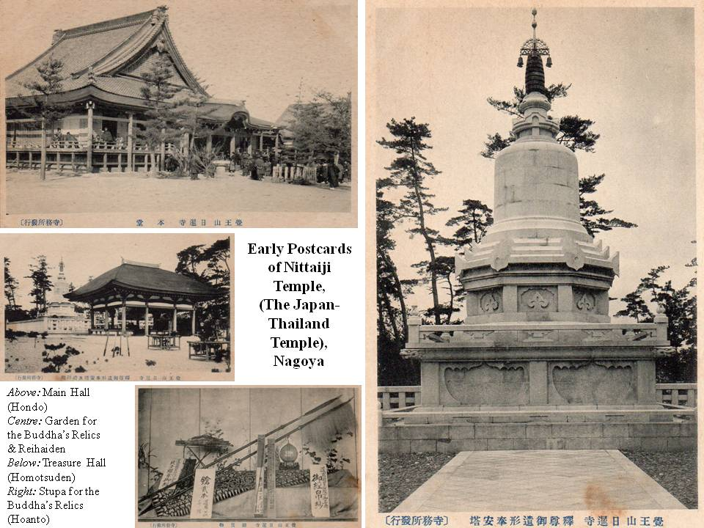

The evenly divided backs of these postcards indicate that they were produced between 1918 and 1932, in which year the postcard heading printed on card the backs was changed from “*ehakaki*” to “*ehagaki*”. The thick card on which they were printed suggests they were probably printed towards the end of the Taisho Era (1912-1926). As Japan followed the mandates of the Universal Postal Union, the card backs were unevenly divided until 1918. These cards must have been produced, therefore, between 1918 and 1926. The temple is unaltered today, except that there is now a statue of King Chulalongkorn in front of the Main Building (*Hondo*) erected in 1987.

1. One western POV account states that themarble slabs had been obtained by forcibly confiscating marble tables (a common Sino-Thai itemof furniture) from the local Chinese community, but I have regrettably been unable to locate the description in question.   
   
2. The Vietnamese language inscription reads, *“A memorial to the spirits of those Vietnamese labourers (lit. Romusha) who died constructing the Thai-Burma Railway”*
3. The national languages of both Indonesia and Malaysia *(Bahasa Indonesia* and *Bahasa Malaysia* respectively) are the same, the language of Sumatra having been selected as independent Indonesia’s national language, rather than Javanese, the language of the majority of the population. The language of Sumatra and that of the Malayan Peninsula, being populated by essentially the same peoples, was, to all intents and purposes, identical. The inscription reads. ***“****Paying our respects to the souls of Moslems who worked her; Allah rewards you.”* Translation by Murai Yoshinori from his article *“Asian Forced Labour (romusha) on the Burma-Thailand Railway”* in Gavan McCormack & Hank Nelson (eds.): *“The Burma-Thailand Railway”* (Silkworm Books,1993); p.61.   
   
4. More recent serious museum displays, especially those of the Australian Government’s Hellfire Pass Memorial Museum and the Thai-Burma Railway Center’s museum in Kanchanaburi itself, devote considerable display space in their exhibits to introducing the horrific situation faced by the Asian labourers. Another less reputable “*war*” museum, run by local business interests and conveniently located by the side of the famous bridge to attract as many tourists as possible, contains a rather distasteful memorial to Asian workers, displaying actual skeletons and bones, questionably obtained from the excavation of mass graves in Kanchanaburi. Further details about this somewhat controversial museum will appear in future articles.
5. Cornelis B. Evers: *“Death Railway”* (Craftsman Press, Bangkok); p.60.
6. Eric Lomax: *“The Railway Man’* (W.W. Norton, 1995); p.268.
7. Nagase Takashi: ***“****Crosses and Tigers****”*** (Post Publishing Co., Bangkok, 1990); p.70.
8. Rohan D. Rivett: *“Behind Bamboo: An Inside Story of**the Japanese Prison Camps”* (Angus **&** Robertson, London, 1946); pp.315-316. The grounds for Riven’s assertion of 76,000 Asian deaths are unclear,   
   
9. Sir Edward Dunlop: *“The War Diaries of Weary Dunlop: Japan and the Burma-Thailand Railway, 1942-1945”* (Penguin Australia,1990); pp.384-385.   
   
10. The same museum had previously purchased rights to the land on which lay the remains of the approaches to the (subsequently bombed) wooden bridge across the river, which was pictured in *Part* ***VI*** of this series. The photo was taken before the museum in question was constructed. The track and flimsy riverside approach to the wooden bridge now feature as one of the Museum s exhibits. Despite verbal undertakings to the contrary (and the illegality of such river-side construction), the same museum built an extension blocking the Japanese monument’s view of the river.
11. *Ni-Thai-Ji’s* origins are also rather curious. It seems that in the late nineteenth century, an urn believed to be full of the historical Buddha’s hones and ashes had been discovered in India and placed in the Calcutta Museum. King Chulalongkorn had requested the (British) Indian government of the day to send part of these relics to Thailand, as some had already been presented to both Burma and Sri Lanka. After a portion of the relics had arrived in Siam, a councilor at the Japanese Embassy, Inagaki Manjiro, made a formal request to the King to have a portion of the relics presented to Japan as a token of the friendly relations existing between Japan and Siam. (The British Indian Government would hardly have objected as good relations between Japan and Britain were fostered in the period before the Russo-Japanese War, culminating in the Anglo-Japanese Alliance of 1902, a pillar of British imperial foreign policy until well after the end of World War I. In 1900 King Chulalongkorn agreed to present some ashes to Japan, provided that a special temple was built in Japan tohouse the precious relics. In 1903, a special mission from Japan was sent to Bangkok to formally receive the bones and was received in the royal palace by King Rama V himself. The portion of the bones transferred to Japan was temporarily housed in Myoho-In, a prominent Kyoto temple of the Tendai sect. Finally in 1904, the present *Ni-Thai-Ji*, built specifically to house the sacred relics, was completed. The temple has no sect affiliations and all 19 Buddhist sects of Japan take turns in filling the position of Abbot every three years. In practice, the Tendai, Jodo and Soto sects are responsible for the everyday affairs of the temple, and it is the custom for every Thai Ambassador to Japan tovisit the temple shortly after his first arrival in Tokyo.   
    
12. Information on the background history of the Wat Liab Japanese Ossuary was taken from an explanatory pamphlet in Japanese language issued by the Ossuary itself and from additional information kindly provided by the Rev. Sasaki Kojun, then resident priest at the Ossuary.
13. Mani Kazuoshiho: *“Bangkok Nihonjin Nokotsudo to Sambo Tsuji Masanobu no Kisseki” (Bangkok’s Japanese Ossuary and Traces of**Tsuji Masanobu”; in* an article in *Rokudai Shimpo* (1999). I am grateful to the then resident priest, the Rev. Sasaki Kojun for preparing copies of this important article on which much of the Ossuary’s wartime history is based.
14. William Stevenson: “*The Revolutionary King”* (Constable, London, 1999).
15. The issues would seem to be quite separate. Personal observation of the 2000 ceremony at the Japanese Tha Makham Memorial, convincingly demonstrated that the service is a solemn occasion for the Japanese community in Thailand to reflect upon the railway’s victims. It is unlikely that many of those attending have ever heard of the name of Col. Tsuji, let alone details of his controversial, if colourful, career.   
    
16. . Chaiwat Khamchoo & E. Bruce Reynolds (eds.): *“Thai-Japanese Relations in Historical Perspective”* (Institute of Asian Studies, Chulalongkorn University. Bangkok,1988): Chapter 6*‘General Nakamura Aketo* - *A Khaki’ Clad Diplomat**in Wartime Thailand”* by E. Bruce Reynolds: pp.183-184. Space does not permit a full elaboration of Col. Tsuji’s alleged war crimes. It is, moreover, perhaps inappropriate to pass judgment on a suspect who, being now deceased, is unable to respond personally to such charges. Suffice it to mention that Col. Tsuji has many detractors, both within Japan and abroad. Among the latter are many distinguished academics and journalists. These include. John Toland: *“The Rising Sun; the Decline* & **Fall *of*** *the Japanese Empire, 1936.1945”* (Random House, 1970, Reprinted by Modern Library Editions, 2003): David Bergamini:   
    *“Japan’s Imperial Conspiracy’* (Heinemann, 1971); Louis Allen: *“The End of the War in Asia” (*Hart-Davis MacGibbon, 1976**):** Meirion & SusieHarris: *“Soldiers of the Sun: The Rise* & *Fall of the Imperial Japanese Army”* (Random House, 1991): Gavan Davis: *“Prisoners of the Japanese”* (Quill, 1994): and Ian Ward**:** *“The Killer They Called A God”* (MediaMasters, Singapore, 1992). Tsuji’s detractors accuse him of ordering a well-documented massacre of doctors, nurses and patients at the Alexandra Barracks Hospital (Singapore), as well as instigating the extensive killing of more than 6,000 Chinese citizens of Singapore. He has also been associated with atrocities committed in the Philippines during the Bataan Death March and issuing the order to murder the Chief Justice of the Philippines, Jose Abad Santos. Details of Col. Tsuji’s activities in Manchuria can be found in: Mark R. Peauje: *“Ishiwara Kanji and* *Japan’s Confrontation With the West”* (Princeton University,1975): and Alvin D. Coox: *“Nomonhan: Japan Against Russia, 1939****”*** (Stanford University, 1990). A definitive account of Guadalcanal appears in Richard B. Frank: *“Guadalcanal”* (Penguin, 1992).   
    
17. Chaiwat Khamchoo & E. Bruce Reynolds: op.cit: p.183.
18. According to Tsuji’s own account, he had been delegated to approach the Thai Premier with an apology after Premier Khuang had complained about being tailed by Japanese *Kempeitai* (Military Police). See Tsuji Masanobu: “*Senko Sanzenri” (Three Thousand Leagues in Disguise),* Mainichi Shimbunsha, Tokyo, 1950; English translation by Robert Booth and Taro Fukuda under the title*“Underground Escape”* (An Asian Publication, Tokyo, 1952).
19. Nakamura Aketo: *“Hotoke no Shireikan” (The**Buddha’s Commander),* Nihon Shuhosha, 1958; passim. Perhaps strangely, as Tsuji himself expressed very low opinions about Nakamura in his postwar writings.   
     *“He (Tsuji) also bore a large chip on his shoulder as someone at SGA (Southern General Army) had informed him that Nakamura considered him ‘an unwelcome guest’. Consequently, he mistrusted the Commander from the start, despite a warm welcome and the fact that Nakamura gave him great responsibility. According to Nakamura, Tsuji never revealed his true feeling; hence the Commander’s shock and dismay when Tsuji ridiculed him in his postwar best-selling book.”* (Chaiwat Khamchoo & E. Bruce Reynolds (eds.): op.cit**;** p.184).
20. Chaiwat Khamchoo & E. Bruce Reynolds (eds.): op.cit; p.185.
21. It is unclear at precisely what stage of his sojourn Tsuji determined to escape to China; accounts vary and his own is unclear.
22. Louis Allen: *“The End of the War in Asia”* (Hart-Davis, MacGibbon, 1976); p.56. Other sources list the hotel’s name as “*The Siam Hotel*”.
23. Tsuji Masanobu: *“Senko Sanzenri”* and *“Underground Escape”:*op.cit. An interesting portrait of the priest Chino’s background is provided in Louis Allen: op.cit; p.57, partially quoted below;  
     *“The old priest, Chin, was no**recluse himself. As a boy he had left Japan and emigrated to Northern Australia as a pearl diver and later worked on rubber plantations in Malaya and as a cabin boy. He settled in Rangoo, married and opened a laundry. Under the influence of the priest Fujii (Shinsui).... he underwent a religious conversion, threw over his business, and, as Tsuji puts it,**dedicated his life to**beating the drum.... For the past two**years he had supervised the Buddhist funerals of Japanese in Bangkok and was a well-known character in**the city”* There are some discrepancies in various accounts regarding Chino’ s sect affiliation. Allen states he was of the Nichiren sect, whereas some commentators believed he was of the Mount Koya branch of the Shingon sect. Mount Koya had a strong connection to wartime Burma and there is a small temple today on the mountain dedicated to the spirits of those who lost their lives in the Burma campaigns. The temple is named Seifuku-In and in it are displayed some rare photographs of the leaders of the Japanese-supported, “*independent*” Burmese government headed by Premier Ba Maw. The personal relations formed through Tsuji’ s sojourn in the Japanese Ossuary in those (for the Japanese community) dark days at the end of the war, have survived into this century in the form of regular annual reunions in Kyoto - hosted by the Rev. Sasaki Kyogo - of the seven youths who had volunteered to support Tsuji and stay with him in Bangkok.
24. The Blue-Shirt Society were a secret society organised by Chiang Kai Shek’ s feared intelligence chief Tai Li, whom Tsuji claimed to have known from his days in China. Members of the society had been infiltrated secretly into Thailand throughout the previous 3 years in order to organise Bangkok’s large Chinese community on behalf of the Kuomintang. After the war, the Society had opened offices in Suriwongse Road, where Tsuji had been able to establish contact with the organization. The Blue Shirt Society was probably responsible for the wave of clashes between the local Chinese community and the Thai police that broke out in Bangkok on October 28th The riots were evidently caused by Chinese insistence on flying the flag of Nationalist China and continued for 3 days. Thereafter, the Chinese community went on strike, closing rice shops and the fish and vegetable markets.

   
25. After his suspected war criminal status had been officially lifted in 1950, Tsuji returned (again secretly) to Japan and devoted his attention to publishing his memoirs, the first being *“Senko Sanzenri” (“*Underground Escape*”)* op.cit. Others included his account of *“Guadalcanal”* (1950) in which he admits bearing at least some responsibility for errors in that (for the Japanese) disastrous campaign. In 1952 his account of the Malayan campaign and the fall of Singapore was published in Japanese and in English translation in 1960 by Ure Smith Pty. Ltd. of Sydney. in 1960, under the title. *“Singapore; the Hinge of Fate”.* The book was again published in English in 1988 in a paperback Oxford University Press edition, entitled *“Singapore 1941-1942: The Japanese Version of the Malayan Campaign of World**War II”.* In the introduction Lt. General II. Gordon Bennett, Commander. Australian Imperial Forces in Malaya, wrote;   
     *“Every soldier worthy of the name pays ungrudging tribute to the military capacity of his opponents. I have no hesitation in recognizing Colonel Masanobu Tsuji as one of the ablest of mine****”.*** In Japan, the publications created considerable interest and Tsuji became very popular, if not a sort of hero. This enabled him to succeed in the 1952 elections to the Lower house of the Diet.   
     *“He became widely recognised as a leading proponent of Japanese armed neutrality. He was also seen as anti-communist, anti-American, and strongly opposed to his country’s Security Treaty with the US. To the delight of the**masses, and particularly the Japanese press of the day, he remained an habitual critic of the costs of government, the country’s renowned money politics, and corruption in high places.”* (Ian Ward: *“The Killer They Called a God,”*Media Masters. Singapore, 1992; p.305).   
     Tsuji was one of the founding members of the Japanese Democratic Party in 1954. The party platform contained two of Tsuji’s political goals: improved Japanese relations with China and the USSR, and reform of the national constitution that had been dictated by MacArthur. The Democratic Party was merged with the older Liberal Party to become the Liberal Democratic Party in 1955. Tsuji was expelled from the Liberal Democratic Party in 1959 (for openly criticising Prime Minister Kishi Nobusuke, whom he had known during his early days in Manchuria) of buying votes, but he was returned as an independent to a seat in the house of Councilors (The Upper House of the Diet) in the same year. In 1961, he embarked on his final mysterious trip to Indo-China and South East Asia from which he never returned. Much speculation has centered upon this journey and his disappearance. The most recent information was summarized in a *Japan Times* article of 14th October 1978 and is here quoted in full.   
     *“Masanobu Tsuji, the Dietman who disappeared in Southeast Asia in 1961, was executed by Pathet Lao soldiers in 1962* - *probably as a suspected spy* - *while trying to reach Hanoi disguised as a Buddhist monk, according to a fellow Japanese who says he saw Tsuji off from Vientiane. Katsumi Akasaka, 58, who was expelled from Laos last month as an ‘undesirable’ after staying in the country since World War II, told Kyodo News Service he learned of Tsuji’s fate last year, directly from one of the soldiers who shot him. The mystery of Tsuji’s disappearance has been one of the most intriguing cases in postwar history. A former colonel in the Japanese imperial army, Tsuji disguised himself as a Thai monk and wandered through Southeast Asia for 5 years (sic) rather than face charges as a war criminal. Cleared in 1950, he returned to Japan and wrote the best-seller ‘*Senko Sanzenri’ *(literally “*Three Thousand Miles in Disguise*”) before being elected to the House of Representatives in 1952. Akasaka, an ex-soldier himself who stayed on after Japan’s defeat to fight on the Laotian side in the French Indochina war, said he made arrangements for Tsuji in Laos when the latter, elected to the House of Councilors in 1959, went on an inspection tour of Southeast Asia in I 961. Akasaka, then an employee at the Bank of Tokyo’s branch office in Vientiane said Tsuji left the city with two young Laotian monks**in a secret bid to meet the late North Vietnamese President Ho Chi Minh and persuade him to seek peace in Asia. Tsuji vanished while heading north near the border of Laos and Thailand. Akasaka quoted the Pathet Lao soldier, who had served under his command earlier, as saying he and two other Pathet Lao shot Tsuji to death in early 1962 at a senior officer’s command and buried the body in the Plain of Jars. However, Akasaka refused to go into further details, saying incumbent high-ranking officials of the Laotian Government were involved. Akasaka, who more recently worked at the Japanese Embassy in Vientiane, was apparently deported from Laos because of his continuing inquiries concerning Tsuji. He said the Pathet Lao soldier who told him about Tsuji s execution revisited the Plain* of *Jars later but could not locate the spot where the body was buried. Akasaka says he asked the man to keep looking and report to him by the end of this year”*
26. British intelligence accounts (including Allen: *op.cit.)* agree with Tsuji s account about the date of his departure. The Wat Liab Japanese Ossuary also possesses a dated document announcing his departure in Tsuji’ s own calligraphy of October 28th.  
    
27. William Stevenson: *op.cit;* p.4 and p.196.
28. In order to avoid confusion between the two similar names, Sir William Stephenson will be referred to as *“Sir William’* in the rest of the article.
29. Until that time, newspaper editors wishing to print photos from overseas had had to wait for the arrival of the photographs themselves, usually by sea, entailing a considerable delay.
30. The founder of the OSS, William Donovan, was a close colleague of Sir William. Later, after the war, Donovan became one of the USA’s postwar ambassadors to Thailand.   
    
31. Stevenson’s previously published books, included two based on the life of Sir William: ***“A*** *Man Called Intrepid”* and *“Intrepid’s Last Case”* (Sir William evidently went by the name, *Intrepid,* within the organization).
32. Among the more absurd were that Tsuji had himself started and directed Thailand’s opium production and trade (William Stevenson: *op.cit;* p.42); that Tsuji was a personal friend and close advisor of Thai Police General   
    Phao Sriyanond, a relationship which continued into the postwar era *(op.ci;****:*** p.117) and that Sukarno, the first President of postwar independent Indonesia had been a “*prize pupil*” of Tsuji *(op.cit;*p.161).
33. William Stevenson: *op.cit;* p.22. No details of Tsuji s activities or career are offered. The alleged Japanese archives are neither identified, nor details of their contents described.
34. William Stevenson: op.cit; p.198. I have been unable to locate the original text of the document in question, but Tsuji did express similar sentiments - but with a rather different emphasis - in his account of the Malayan campaign. (See Tsuji Masanobu: *“Singapore 1941-1942: The Japanese Version of**the Malayan Campaign” op.cit****;*** p.3081. Stevenson seems to be implying that Tsuji had planned his campaign to eliminate the King as early as 1941!
35. William Stevenson: op.cit;p.196. It is well known that General Giap was aware of the contents of some of Tsuji s writings. Stevenson seems to be suggesting that Tsuji personally met the General in Hanoi and helped him prepare his treatise!
36. William Stevenson: *op.cit;* p.246. As detailed above, it is abundantly clear that Tsuji Masanobu was not even in Thailand at that time, let alone walking around the Grand Palace in Bangkok.
37. William Stevenson: *op.cit; p.70*. Tsuji stayed in the basement of the Wat Liab Japanese Ossuary that had existed some considerable number of years prior to his residence there. He built no ‘*secret bunkers.*’ *Evans* refers to Major-General Geoffrey Evans, British Commander of Allied Land Forces.   
    
38. William Stevenson: op.cit;pp.70-71. As the notes were destroyed in the air crash, their contents cannot be known. Nevertheless, the context of the accident suggests that Wild had been carrying notes implicating Tsuji Masanobu in the alleged war crimes - for which he was wanted and which have been referred to earlier - rather than anything connected with the death of King Ananda in Bangkok. It is difficult to see how the 24 War Ministry reports (*unidentified*) on how to evade capture, can represent *‘explosive’* files.
39. William Stevenson: op.cit; p.266. With these dramatic words, the book concludes. They were presumably inserted just in case the reader happened to have missed the numerous suggestive innuendos in the text!
40. Later Stevenson asserts “*I had read the wartime files on Tsuji”* (William Stevenson: op.cit; p.196). This impression is deepened by Stevenson’ s seeming lack of knowledge of any other published work on the subject of King Ananda s death. He appears to have overlooked the highly detailed account of this period of Thai politics in Wayne Kreuger’s book, ***“****The Devil’s Discus”.*The book is a brilliant piece of investigative journalism and ends with the perhaps controversial conclusion that King Ananda committed suicide. If Stevenson did read this account, he has concealed the fact well. (This hook was also banned in Thailand, an indication of the sensitivity of the subject).
41. William Stevenson: *op.cit:* p.4. Nevertheless, the suggestion that the young (King) Bhumipol might have inadvertently caused the death of his elder brother, King Ananda, in a shooting accident has persisted. The allegation was repeated shortly before this article’s publication in the journal, *“Seeds of Peace”* published by the internationally respected Buddhist scholar and human rights activist, Sulak Sivaraksa, in its Vol. 2, No.1 (January-April 2548/2005)issue. An article authored by ‘B.P.° entitled *“Siam: Revenge of the Forgotten Monarch: The True Life Sequel to the King and Land of Smile(s)****”*** bases its claims upon British intelligence reports.   
     *“As it happens, Britain played a significant role in the aftermath**of Ananda ‘s death, and formerly secret governmental documents give considerable insights into truth.”* The article suggests that repeated requests by the young monarch, King Bhumipol, to study in England and visit the British Royal families were refused in 1948.   
     *“It fell to Lord Mountbatten (the late cousin of Queen Elizabeth II) to breach it to the Siamese that their King was not welcome as long as he was under any suspicion... Mountbatten concluded... ‘1 said that I could not in any event recommend that the present King should visit England until the question of his being involved in the accidental shooting of his brother was completely cleared up.’* ... *The answer from Buckingham Palace was**diplomatic: ‘any* *question of his being invited to stay with our King and Queen, should be postponed until the King of Siam, has been crowned, and the trial concerning the late King’s death has been concluded.”* (B.P: *“Siam: Revenge of the Forgotten Monarch” (*Seeds of Peace, Vol. 21, No.1; Bangkok, January 2005). pp.6- 9.
42. I am grateful to the late Dr.Warin Wonghanchao for photographing this memorial on a recent trip to the Sangkhlaburi/Three Pagoda Pass area.
43. Nagase Takashi: *op.cit;* passim. Nagase’s work has often been quoted in this series of articles and his work for reconciliation, as well as repatriation of Asian workers, has been detailed in previous issues.  
    
44. The Republic of Korea (SouthKorea) was not in existence at the time of the railway’s construction. The entire Korean peninsula was then a colony controlled by Japan. It is unclear how many Korean guards brought to supervise the POWs and Asian workers came from today’s South and North Koreas respectively.