*“All of a sudden groups of barefooted Indians, Malays, Javanese and Chinese laborers surrounded the railcar, making dozens of circles around it…. The atmosphere turned weird… The Asian Romusha were gazing at the Allied officers and soldiers, neglecting the Japanese. The Asians gathered to appeal to the Allies for help. Japan's surrender brought them hope to return to their homes, released from their daily labor. At the same time, armed bands of robbers took advantage and attacked the laborers' camps night after night... The Romusha were stripped of what little they had. In addition to the robbers, tigers attacked them. There seemed to be numerous victims among them. That night the Allies and the Japanese stood on armed watch in turns, guarding the goods on the wagons as well as the laborers. They seemed to sleep a peaceful night.”*

Nagase Takashi (former Kempeitai/Secret Police official) recounting his experiences as interpreter for Allied officers searching for POW graves after Japan's surrender: "*Crosses and Tigers*" (Allied Printers, Post Publishing Co. Ltd., Bangkok, 1990).

LABOURERS TRANSPORTED TO WORK ON THE THAI-BURMA AND KRA RAILWAYS (8th October 1945)

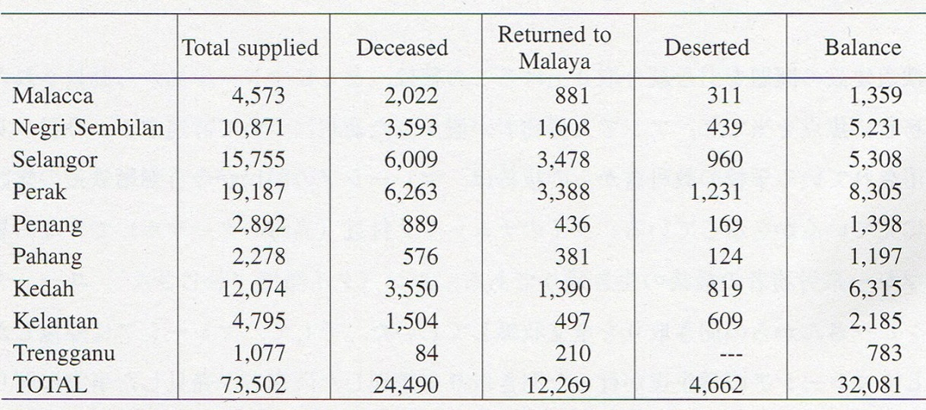Source: Translation Report Mo.75, 8th October 1945, Sel CA250/1945 From: Paul H. Kratoska: “*The Japanese Occupation of Malays, 1941-1945*” (Allen & Unwin, 1998); Table 6, p.184

KEY TO THE ILLUSTRATIONS

1. Japanese-built water tank, Wang Pho Station, Thasao

2. Japanese-built water pump, Wang Pho Station, Thasao.

3. Japanese-built water tank, Nong Pladuk Junction. Old goods trucks are visible in the distance.

4. Discarded and rusted German-built Henschel 4-6-2 steam locomotive and train, Home Phu Toey, Amphoe Saiyoke. How this locomotive came to be abandoned on the disused track beyond the present Nam Tok Station, is unclear, as the Henschels were normally used on a different part of the railway system, the Maeklong Line

5. Wang Pho Station is still in use today.

6. Site of Tonchan Station. The buildings are now part of Wat Phutakhian (Temple). The railway course runs directly in front of these buildings.

7. Site of Hintok Station. The rail bed in this area has been cleared for walking by the Hellfire Pass Memorial Museum; Amphoe Saiyoke.

8. Locals enjoy the Hin Dat Hot Springs, discovered, constructed and first used by the Japanese military. Near the site of Hin Dat (Hindato) Station; Amphoe Thong Pha Phum

9. Excavated hillside near the site of Hin Dat (Hindato) Station. Numerous skeletons were excavated from this mass burial site, mostly Asian workers, shortly after the war; Amphoe Thong Pha Phum.

10. Fresh-water spring high above the present River Kwai Village Hotel. The Tonchan Spring Camp, chiefly of Dutch POWs, was located beside the spring. Amphoe Saiyoke.

11. On the Burmese side of the border, a short length of track has been re-laid as a memorial to the railway at Phayathonzu (Three Pagoda Pass)

12. Japanese C56 locomotive in the livery of the Thai National Railways at Saiyoke Noi National Park; Thasao.

13. Rock bases for a rail bridge that spanned a small tributary river valley. Most of the railway's remains have reverted to the jungle; Saiyoke Yai National Park, Amphoe Saiyoke.

14. Nam Tok town, with its old wooden shop-houses, still looks much as it did during the war; Thasao.

15. Entrance to the Tham Krasae cave complex behind the perilous Tham Krasae viaduct. Many sick Asian labourers are believed to have sought refuge in these caves and some died here. The railway track runs outside the cave, beyond which, deep in the valley, meanders the River Kwae Noi. Lung Yu's account of the python incident occurred in this area.

16. Lung ("*Uncle*") Yu Chalawankumphi, a former labourer from Kelantan in West Malaysia, still lives in Nam Tok, Thasao. (Photo courtesy of Seto Masao/Viwat Sritrakul).

17. & 18. Commemorative medal made by the Japanese military to mark the completion of the railway. The rough, metal medals were probably made in Ban Pong. The inscription reads, "*Thai Men Tetsudo Kaitsu Kinen, Showa 18, 10 gatsu*" (In commemoration of the completion of the Thai-Burma Railway; October, 18th. year of the Showa Era). Only about six such medals are known to survive today, scattered around the world.

19. Old goods trucks on a siding at Nong Pladuk Junction. It was in such trucks that Lung Yu, other Asian labourers and the POWs were brought to the camps along the railway. They are still in use on the Thai National Railways today.

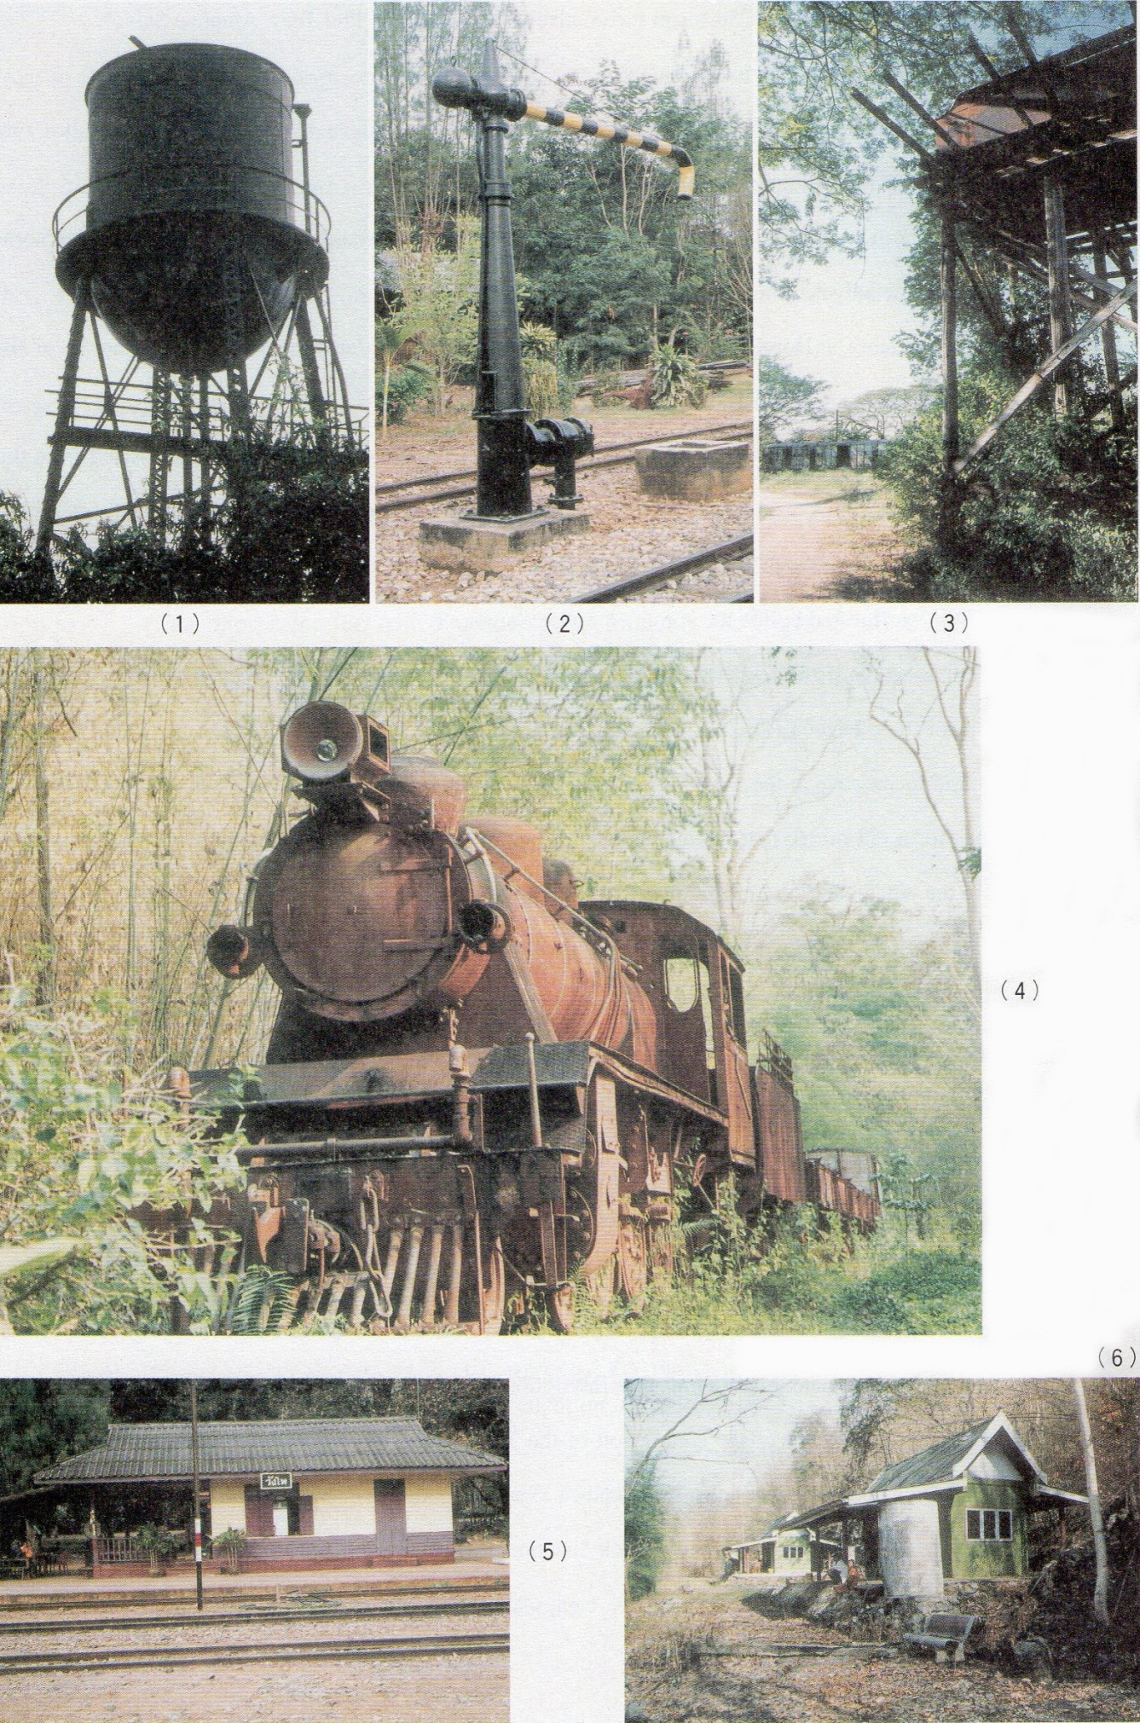

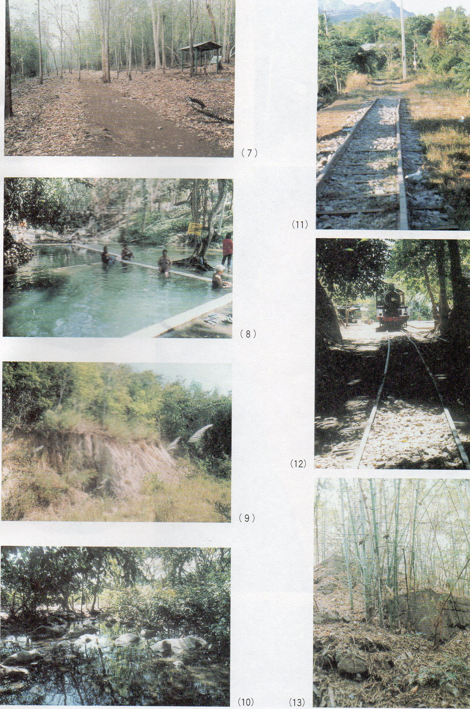

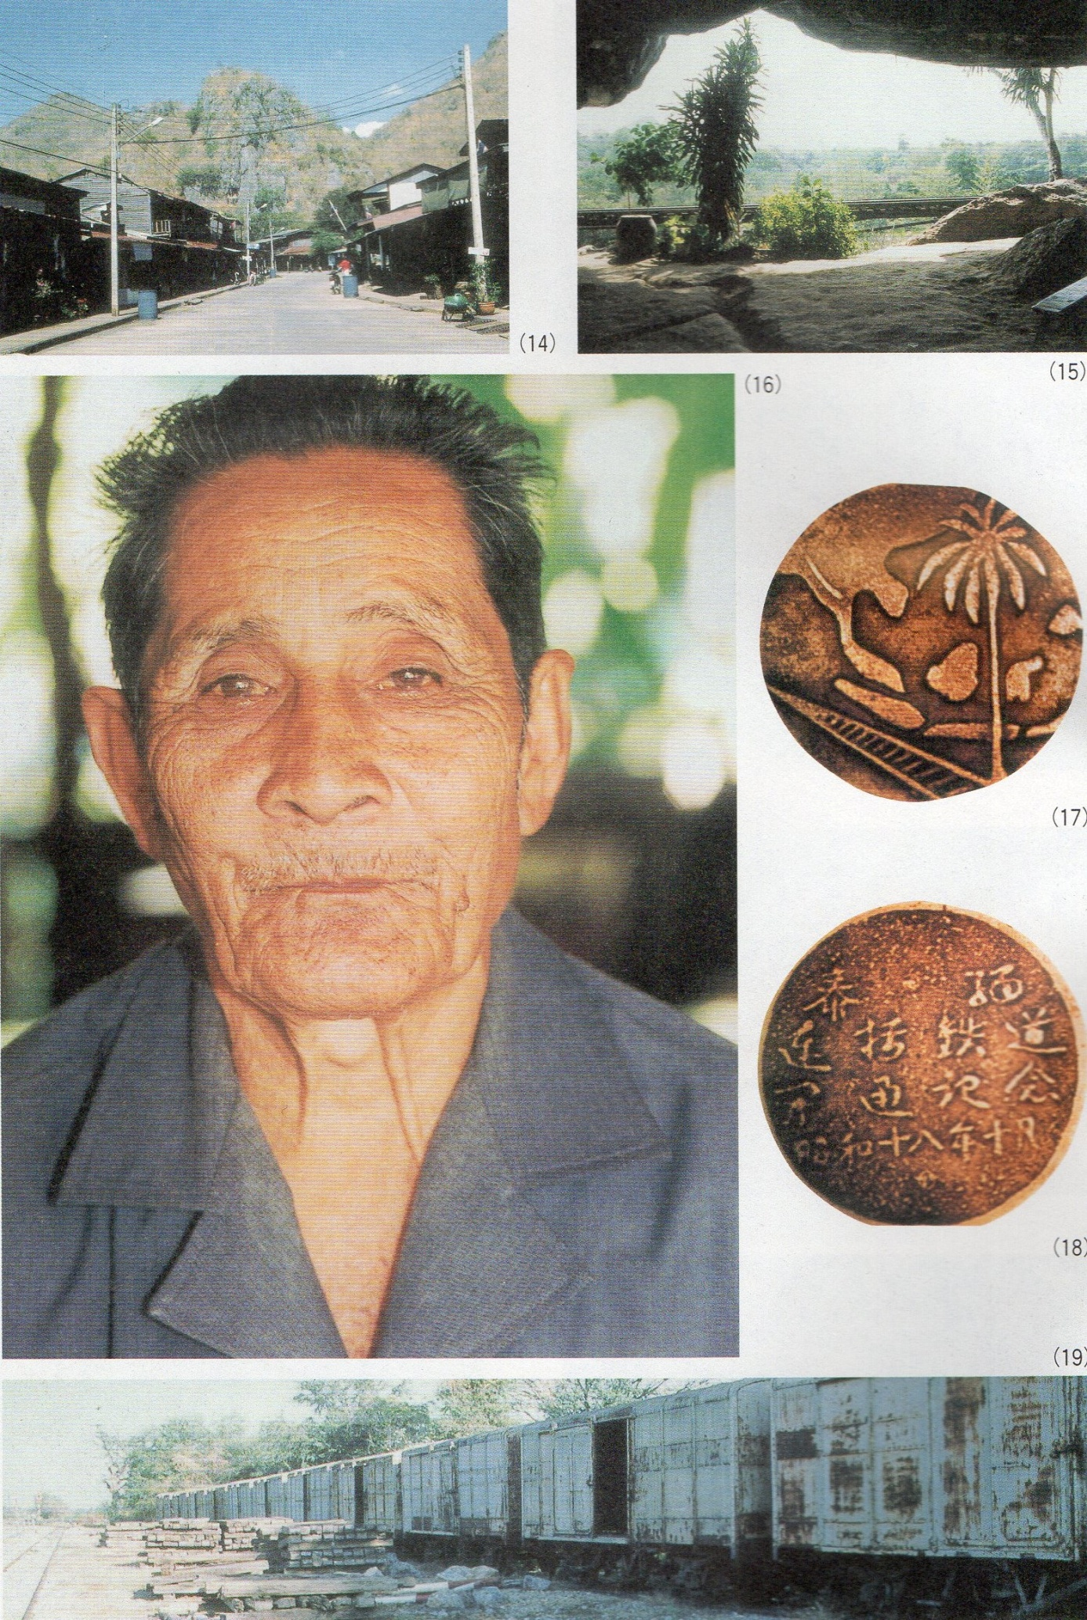

NOTES ON THE THAI-BURMA RAILWAY   
PART III: "PRAISE THE PROSPERITY & GLORY OF THE NEW EAST ASIA"

INTRODUCTION

The miserable plight of the Asian labourers on the Thai-Burma Railway indicates the harsh realities partially concealed by Japan's propaganda about creating a "*New Order*" in Asia. This article's title, "*Praise the Prosperity and Glory of the New East Asia*", is but one example of the many slogans that Japan promoted in its expanded Empire of South-East Asian countries, in a forlorn attempt to rally native support. [1] Unlike China and Korea (where the Imperial Japanese Army had already become the most feared and detested of imperialist predators), Southeast Asia - with the sole exception of Thailand - had long chafed against lengthy periods of Western colonial rule and already had its own nascent independence movements (as the respective Western imperial powers were only too well aware!) There was thus much potential support and perhaps even sympathy for Japan's original occupation of Southeast Asia. Such hopes were however quickly dashed by the treatment accorded to native Southeast Asian labourers mobilised for such projects as the Thai-Burma Railway. [2]

MALAYSIAN TEXTBOOKS

Memories of the conscription of Malay labourers are included in some school textbooks in Malaysia today. The following extract is taken from an English language textbook, "*The Story of Japanese Soldiers in Our Country*" by Milon Nandy from the penultimate chapter, "*How the People Suffered*";

"The Japanese were here for about four years. In these four years, thousands of people died not only at the hands of the Japanese but also of hunger and disease. Certainly, more people died of hunger and disease than from the cruel punishment of the Japanese soldiers. One of the causes of the shortage of food at that time was that there were few able-bodied men in the country to grow food. Soon after the Japanese came to this country, they caught all the young and able-bodied men and sent them to (Thailand). Even boys above the age of thirteen and fourteen were picked up wherever they were seen and sent to (Thailand). Most of them could not even say goodbye to their mothers or families. Their mothers or families, on the other hand, searched frantically for them, having no idea of where they might be or what might have happened to them. At that time, the Japanese were building a railroad in (Thailand) to go into (Burma).... However as most of the young and able-bodied men were in (Thailand) there were almost no men to work in the plantations to grow food. Most of the fields and plantations were swallowed by jungles. Young children could not get enough food to eat because the Japanese had taken their fathers away to build the railroad in (Thailand). Their mothers could not find work to earn any money. Many of these mothers had to steal and beg to get food for their children.... Fuel was also hard to find. People, especially those who lived in the neglected rubber plantations or in far-away places, spent their night in the dark. There were no lamps. Electricity was used only in some towns where Japanese officers lived. Women and children went to bed early. There were only a few old men in such places, as the young and able-bodied men were away in (Thailand), perhaps dying of hunger or illness, building the railroad there." [3]

RECOLLECTIONS OF A MALAY WORKER

The following is an edited version of an interview with the last surviving Malay worker still living in the Nam Tok (Tha Sao) area. Lung ("*Uncle*") Yu Chalawankumphi, now in his late seventies, eventually married locally in Thailand and settled in Nam Tok. The interview was arranged through the good offices of the Nam Tok Station-Master, Amol Vongvarn, and translated with the assistance of Seto Masao (Viwat Sritrakul) of the (Japanese) *Asahi Shimbun* (newspaper)'s Bangkok office. The interview took place on l0th. January, 2001 at the Santi Restaurant near Nam Tok Station and was attended by eighteen Japanese students from Kyoto Seika University as well as two Thai students from Thammasat University. In editing the text, the order has been somewhat altered for clarity, and the questions omitted. The only textual alteration is that where Lung Yu mistakenly refers to "*Taiwanese*", this has been changed to *"(Koreans)".* There are no records of Taiwanese guards working on the railway and Lung Yu must be referring to Koreans (whose presence as guards or auxiliaries is amply recorded both in Japanese military and POW documentation).

"I was brought here from Kota Bharu in Kelantan when I was fifteen years old. I was picked out at random by the Japanese. It wasn't voluntary; they simply took one out of three males. Perhaps out of every five or six young men, three would be picked out. It was all arbitrary - at random. Many of my friends from Kota Bharu were selected too, and we travelled up together. We were rounded up into trucks and then taken directly to the station. We came up here by the railway, in covered goods wagons, by night. I think the journey must have taken about 24 hours in all. Many people were brought up from Malaya; several hundred - at least a thousand or more - most came from Kota Bharu, along with me.

  “After we arrived, I was split up from the friends who'd been rounded up together with me. I was never able to meet them; we were all split up. I never knew where they were. The Japanese military never made any lists of the names of us labourers. I was put to work immediately. I started at Nong Pladuk and worked right up to the Burmese border. The area was virgin jungle then; very wild. I remember an incident at Tham Krasae when a huge python somehow got into our camp. It was immense! It killed several Japanese (it actually ate them!) before it was eventually killed by gunshot. I think it may have killed as many as five people. I was working more than two years. We had been promised pay at the rate of 600 a month. I can't recall the currency unit but it was certainly 600 a month! [4] The unit doesn't matter because we never actually received anything at all; no pay at all for all those months' labour! We were put to work from about 8:00 a.m. There was an hour's break around mid-day and we then worked again from 2:00 p.m. until around 5:00 p.m.

“We were given food three times a day. Well, it was edible, at least - if we didn't eat it, there was nothing else! We couldn't understand what the Japanese or (Koreans) were saying. There were no Japanese who spoke Malay. I couldn't understand anything at all! They would beat or prod us to show us how they wanted us to work. Most of the guards were terrible, though I do remember some Japanese who were decent. There was one soldier - he was quite old, I think - at Tham Krasae; he used to come out to look for us and tried to take care of us. But the (Koreans) were very cruel. We had to work every day, regardless of the weather; in the monsoon rains or the fierce sunlight.

“We didn't have to work through the night though, as nobody could see anything. We slept in rough attap huts with a considerable number of people together; I think as many as a hundred people to a hut. We did have some clothing and mosquito nets, but only very rough sandals for footgear. There was no medicine available in those days. Even when sick, we were forced to work. So many people died, especially of dysentery and cholera. Many also died of malaria. The dead bodies were just thrown into huge holes. That was all! The (Koreans) could be very fierce. Even if you just wanted to piss, you had to ask permission first. If you didn't, they would tie your hands behind your back and beat you with sticks teeming with live red ants. You would get bitten all over your body. The bites from these red ants were unbearably painful. We could often see Westerners and many Indians working on the railway and, of course, a great number of other Malays, but we could never speak together.

“After the war, I didn't go back. Indeed, many never returned; they remained scattered here and there along the course of the railway. Here at Nam Tok alone there were about 20 or more of us Malays. I was very depressed at that time and so sad. I'd wanted to return but I couldn't even contact my Mother! The British soldiers who came after the war never helped me; they never asked or tried to find out about us workers at all. They never offered any assistance. I was so miserable! Much, much later I was able to contact my family in Kota Bharu; they've been to visit us here and I've been to visit them too. But by then I had settled locally and I had my sons here, so in the end I no longer dreamed of returning (to Malaysia). I have six sons and they all have Thai nationality; they've all done their military service in the Thai army. They don't speak Malay; they're happy as they are! Today I'm too old to work and my sons look after me now. I've never really spoken to young Japanese since the war. This is the first time! I would simply advise you to act considerately to all peoples. I myself dislike the Japanese for many things - especially the red ants; I can't forget that! Don't do such things! This much I can say! I have often talked about my experiences with my sons and it has saddened them. But we have already forgotten the past; for them, dwelling on the past is not healthy - there's no point!"

Much of Lung Yu's account can be corroborated from the findings of other researchers, some of whose comments suggest that Lung Yu may have been minimising the hardships he suffered (possibly in view of his chiefly Japanese audience?). The most recent and comprehensive of such accounts is one by Abu Talib Ahmad. It was a collation of the notes of several student researchers who interviewed returned workers throughout the Malaya Peninsula in the 1990s. For purposes of comparison, it bears quotation at some length.

"Camp accommodation was primitive at best, consisting of thatched huts with a raised bamboo floor. It was overcrowded, and the ground was always damp and at times muddy. Despite the chilly nights, blankets were never provided. Every day they had to eat the same food consisting of salted fish and vegetables such as water pumpkin.... Meat was always a luxury, and as pork was the usual fare served, its consumption was out of the question for Malays (mostly adherents of Islam). Skin diseases were a common ailment and could even prove fatal. Outbreaks of water-borne diseases, such as dysentery, particularly in the dry season, were common, with malaria a perennial killer. The sick were not given adequate medical attention; very often the labourers had to resort to rudiments of traditional medicines. The serious cases among the sick were segregated in a separate hut, often with other half-dead bodies, only to be left to die. For 16-year-old Idris Bulat from Pasir Mas, the only consolation was that in the camp he was in, those alive were allowed to administer the proper last rites to their dead friends. Those involved recall the massive use of deception and coercion undertaken by the Japanese army, with the connivance of the *penghulu* (the village head in Kelantan).... Alias Salleh, 71 years old in 1994, recalled that he was taken by the promise of good treatment, proper food and clothing, mail services, and an attractive salary. Prospective candidates were informed that the *'tour of duty*' would last only three months, after which they would be sent home, at the expense of the Japanese Imperial Army. However, force and coercion were later used extensively when the initial euphoria, if any, turned sour. Village pranksters and so-called *'bad hats'*, such as the 17-year-old Setapa Mat Daud of Tanah Merah, or those in the bad book of the *penghulu*.... became obvious targets. Lads like Kassim Mohamed, also from Tanah Merah, and Abdul Rahman Yusof, from Machang, '*volunteered*' to go in place of their fathers who were too old to go.... The long and difficult journey from their villages to the work sites at the Siam-Burma border served as a harbinger of the nightmare that was to befall these unfortunate lads. The train journey from Kelantan was memorable for all; they were herded like cattle in freight coaches, and the doors were locked from the outside so as to prevent possible escape.... Some did try to escape but the summary Japanese treatment of those who failed in such attempts effectively discouraged the others.... If the train journey was unbearable, the last leg from the rail terminus to the various camp sites was worse, with the weak and sick abandoned in the inhospitable jungle to face certain death.... Camp life and the working conditions were atrocious and the rampant Japanese brutality made life extremely dangerous.... Accidents occurred quite frequently and for the Japanese army, life was cheap." [5]

Much of Lung Yu's account is similar, therefore, to the stories collected from other Malay romusha who returned to their homes after the war. In one significant area, however, Lung Yu's memories differ from Abu Talib Ahmad's collated findings. In an introductory summary, the latter writes, "*For the record, they never differentiated or were aware that some of these 'Japanese' were actually Koreans*."

By contrast, on at least three occasions - without any prompting from questions - Lung Yu clearly recognises that there were both Japanese guards as well as guards who were not Japanese. Lung Yu mistakenly identifies these non-Japanese as "*Taiwanese*", and draws attention to their particular ferocity on two occasions. Taiwan had been a Japanese colony far longer than Korea and, although Taiwanese guards or auxiliaries had been used by the Japanese army in other POW camps, none were utilised on the Thai-Burma Railway. Lung Yu is clearly referring to guards from Japan's other colony, Korea. [6]

But how is one to assess Lung Yu's important comments about his own situation at the war's end in relation to the British occupying forces? Paul Kratoska has produced a valuable table of the numbers of workers transported from Malaya under the categories; “Total Supplied, Deceased, Returned to Malaya, Deserted and Balance.” [7] "*Balance*" is perhaps rather a curious way of expressing what amounts to "*Numbers Unaccounted For*", a category which presumably consists chiefly of people, like Lung Yu, who remained in Thailand after the war. Of the "*Total Supplied*" (73,502), more than a third (32,081) are listed in this category. Needless to say, the number would also include those whose deaths went unrecorded and unnoticed by friends, and those deserters who never returned at all. Moreover, it should be noted that the number of 73,502 in the *Total Supplied* category is probably an underestimate; Kratoska himself cites other sources giving a total number of workers from Malaya as 75,000 of which some 28,000 (38%) died. [8] I have myself suggested that even this higher figure may well be grossly underestimated.[9] Nevertheless, taking even the minimal total of 73,502 (as Kratoska himself rightly notes, "*more than 1.3 per cent of the entire population*"), 32,081 people "*Unaccounted For*" (or "*Balance*") is, indeed, an enormous amount of "*lost*" humanity! How, then were the numbers in the other categories derived? Some clues may be found in a later statement,

"Following the Japanese surrender, the Allies prepared assembly points at Kanchanaburi, Bangkok, Chumphon and Haadyai for systematic repatriation of labourers, and by 3rd October 1945 had processed 27,900 workers." [10]

As Thailand had been occupied by the British at the war's end, "*Allies*" presumably refers to Britain. It may be inferred that it was probably chiefly from information given by "*processed*" workers that the other statistics were compiled. However, of the "*assembly point*" towns listed, only one - Kanchanaburi - relates directly to the Thai-Burma Railway. Even in this case, it is unclear precisely how those who - according to Lung Yu - "*remained scattered here and there*" along the lengthy railway course could be expected to know of any "*assembly point*" for labourers in distant Kanchanaburi. The other towns listed as "*assembly points*" bear little relation to the Thai-Burma Railway. Chumphon, far to the south, was the terminus of the Kra Isthmus Railway where, incredibly - despite the fact that the railway had ceased operation by the end of 1944 - there were still large camps of stranded Asian *romusha*. [11]

The Haadyai assembly point would have included some workers from the Thai-Burma Railway. For, Haadyai being situated in the far south of Thailand - not far distant from the Malaya border - and regarded as a sort of gateway to the Malay-speaking southern Thai provinces (Pattani, Yala, Narathiwat, etc.) would be the area which any Malay deserters from the railway would try to reach. Due to language difficulties and unfamiliarity with the local Thai terrain, the number of Malay *romusha* deserters in Thailand is much smaller than the numbers recorded elsewhere for Burmese deserters in Burma. The table lists only 4,662 Malay workers in this category. Several incidents of Malay desertions have, nevertheless, been recorded. Abu Talib Ahmad describes some narrative accounts;

"Under the existing conditions, it was not uncommon for the labourers to try to escape even if it meant escaping into the unknown jungle. Mat Ali Saud, then a lad of 17-18 years, planned his escape with nine others from Kelantan. As he told student researcher, Mohd. Norizan Yunos, in 1994, it was a very risky undertaking and certain death awaited those who were caught. Nevertheless, his group did reach its final destination, although he could not remember exactly when this took place. Haji Hassan Abdul Samad and his group of 10, also from Kelantan, had killed a Japanese guard to avenge the death of a friend. This group had a much more difficult time. Among other things, they had to flee from pursuing captors and cross a river infested with hungry-looking crocodiles. One of them was badly wounded by Japanese gunshot and had to be left behind, much to the regret of Hassan and his mates. The group later broke into two, so as to ensure greater mobility, and hence a greater chance of success. Hassan and three others in the group managed to reach a Thai village in the vicinity of the Kwai River. For six months, they stayed in this village working the rice fields of their hosts before drifting to Pattani, where they stayed for three months until the Japanese surrender. Haji Hassan and his three friends finally made it home in December 1945. In the interview with Yasmin Hashim, he did not say what happened to the other group."[12]

Paul Kratoska cites another case,

"Others, including some who had deserted from the worksites, eventually returned on their own. Teh bin Said, a Kelantanese who fled from the Burma railway and spent the balance of the occupation in the Malay-speaking area of southern Thailand, went home shortly after the Japanese surrender." [13]

THE CONFUSION SURROUNDING JAPAN’S SURRENDER

However, interesting and informative though these above accounts are, the numbers of Malay deserters from the railway was not great in terms of the total numbers mobilised. The difficulties surrounding the Japanese surrender in Thailand were compounded by the egotistic and senseless order by General MacArthur to the effect that no British or Allied troops were to move from their Ceylon (Sri Lanka) base into Southeast Asia (including Thailand) until MacArthur's theatrical formal surrender ceremony could be held aboard a U.S. battleship in Tokyo Bay. This, in effect, delayed the Allied forces' move into Southeast Asia for some two to three weeks.[14] During this "*delay*" period, some tens of Allied POWs in Thailand actually died, and the confusion created among the Asian *romusha* can well be imagined! It was doubtless because many labourers had tried to make their own way home-ward during this period that the British military established "*assembly points*" in Bangkok, Chumphon and Haadyai, all towns situated along the railways on which these workers would have tried to make for home.

But the issue raised by Lung Yu's account still remains; namely, how did the British military authorities expect the vastly-dispersed *romusha* to hear along the distant stretches of the railway about a perhaps far-off assembly point in Kanchanaburi? What efforts were made to advertise such repatriation efforts? Lung Yu's account would suggest - for him at least - none whatsoever. Moreover, far though Nam Tok (Tha Sao) may have been from Kanchanaburi, it was nowhere near as distant as Sangkhlaburi (Sonkurai) or the Three Pagoda Pass! Such efforts should have been successful; the railway was still then operational. How thorough were the British? Why do their own tables have the large (32,081) "*Unaccounted For*" ("*Balance*") figure for Malaya? All Malays were citizens of the British Empire, just as were the POWs. Moreover - unlike Burma - the Japanese had never even tried to form a puppet "*independent*" Malayan government; Malaya and Singapore had been forcibly occupied throughout. The contrast between this rather casual and haphazard treatment of the *romusha* is nowhere more evident than in a cursory glance at the POW cemeteries in Kanchanaburi, Chungkai and Thanbyuzayat maintained by the Commonwealth Graves Commission. Here, the graves of deceased POWs from Britain, Australia and Holland (the latter country, though an "*Ally*" was clearly never part of the British Empire or later Commonwealth!) are appropriately neatly laid out, the circumstances, dates and other details of each person's tragic death having been duly recorded and collated. Could not more have been done for the Malay, Indian, Tamil, Singaporean and even Burmese romusha, who all are - or were - likewise subjects of the British Empire? Echoes of this later dilemma can be detected in POW diaries. Dr. Robert Hardie's diary entry of 7 January 1944 reads,

"A Chinese labourer, with a huge deep sloughing ulcer on his leg, so that he cannot walk at all, is making his way to the coolie hospital camp a couple of kilometres down the line. He gets along seated, lifting himself by his arms - slow progress. The anti-malarial party has been taking him food from time to time. Colonel Williamson, our Indian Army camp commandant, has been asked to put a request forward to the Nips that we be allowed to send a party of officers with a stretcher to carry him down - there is a permanent Jap sentry on a bridge a little below this camp whom it is impossible to pass without authority - but he has refused even to approach the Nips on the subject. The Chinese is a British subject from Singapore. One can't but feel that if it had been a horse or a dog that was in question, he would have been more inclined to approach the Japs. At most they can only say no." [15]

Some more recent accounts of the initial Japanese invasion of Malaya and Singapore have suggested that British treatment of their Malay and other colonial subjects may not have been entirely exemplary;

"A local man... was arrested at Alor Star on 9th December (1941) after the freshwater pipeline feeding the airfield was blown up by saboteurs. On the following day... seven Malays were taken into custody at the airfield and, according to the War Diary of the General Staff, Singapore, it was '*directed that they be obtained from the police immediately and all of them to be disposed of as expeditiously as possible'*." [16]

An unknown number of Malays, merely suspected of pro-Japanese sympathies were rounded up throughout the peninsula;

"Harvey Ryves says that many of the Malays arrested in various parts of the country as established fifth-columnists were schoolmasters. Field Security and Liaison officers were kept busy whenever locals were seen near the front-line. Several natives are known to have been shot.... Guy Madoc, the Officer Superintending the Police Circle (OSPC) at North Kedal.... recalls one Chinese '*suspect*' being brought into the High Street police station in Kuala Lumpur, where a Military Policeman shot a Chinese who was probably a vegetable gardener - there were many such in the area - and whose only crime was to be in the wrong place at the wrong time. Harvey Ryves also noted that a fifth-column mania seemed to beset the military.... Two weeks later (around mid- January, 1942) men of the (2nd Loyals) brought in a suspected sniper, and he was shot.... Some police officers were critical of military action taken against suspects on the flimsiest of evidence.... One officer (of a military '*Death Squad'*) is reported to have detected and executed no fewer than nine Malays in the week before Singapore fell.... It is likely that innocent men were executed. " [17]

After the Japanese landings, all Japanese residents - and their suspected Malay "*sympathisers*" - were rounded up and dispatched to Singapore for interrogation and detention. In an incident somewhat reminiscent of the more extreme Japanese behaviour on the Thai-Burmese Railway, the same account notes;

"The operation seems to have involved at least one tragedy. Colonel R.R. Bailey of the Malay Regiment says that a locked wagon of detainees, after it was shunted into a siding at Kuala Lumpur, was inadvertently left there. All the occupants succumbed to heat-stroke and when Japanese troops later took Kuala Lumpur and discovered this, they went on a murderous rampage." [18]

Former POW, Ernest Gordon, in his autobiographical account, "*Miracle on the River Kwai*", records some haunting echoes of such summary treatment of Malays;

"I remember a fellow prisoner in my hut who was dying of cerebral malaria. As he turned and twisted on his pallet he carried on a conversation with an unseen presence. He had been ordered to kill a Malay, accused of being a spy, for security reasons. His conversation went something like this: *'Of course I had to kill him. There was nothing else to do. But before I shot him through the head he looked at me with eyes pleading for mercy. He cannot forgive me; his wife cannot forgive me; nobody can forgive me!*' He went on for hours arguing with himself in this vein. As he reached the darkest depths of the valley, he became quieter and then shouted out, '*But I am forgiven. You've given me peace!*' He was at rest, and at rest he died." [19]

How widespread such isolated incidents of British summary treatment of Malay "*suspects*" was, will probably remain a matter of speculation. [20] But that such incidents did occur at all, suggests that some British military officials might perhaps have been less sympathetic to the plight of Malay (and other Asian) labourers on the railway; and possibly less enthusiastic or thorough in dealing with their plight - than they were regarding the records and remains of Western POWs. Although the chief responsibility for the miseries experienced by the Asian *romusha* clearly must rest with the Japanese military; nevertheless, any lack of conscientious concern on the part of the British occupation authorities in Thailand - as indicated in Lung Yu's account - can hardly have helped to alleviate the suffering.[21]

1. The sub-title is taken verbatim from a leaflet dropped throughout Malaya from Japanese aircraft prior to the invasion of Malaya/Singapore. The text of the "*Decree*", issued in the name of "*The Commander of the Nippon Army*", exhorts Malayans to cooperate with the Japanese and refrain from acts of sabotage against the Imperial Army. Full details can be found in Leo Rawlings: "*And the Dawn Came up like Thunder*" (Rawlings, Chapman Publications, 1972); p. xxxi.   
   
2. Many examples from Malaysian and other Asian authors could be cited. A typical example occurs in "*Malaya Upside Down*" by a Malaysian Chinese author, Chin Khee Onn, first printed and distributed privately shortly after the war and eventually formally published in book form in 1976. The account notes - among other examples of arbitrary Japanese behaviour - "*In rural areas, the Japanese went for young, strapping fellows. They packed them into army lorries and drove away. What happened to them is a mystery*." There is no longer any "*mystery*" surrounding the fate of such youths; it is now clear that most of these young men were sent to the Thai-Burma Railway as *romusha*. The author concludes his introductory account with the observation, "*(The Japanese) had the supreme chance to win over a conquered people by love and fair treatment. But by their first impact with the masses, they chose to alienate and antagonise, and by their later oppressive acts they confirmed their unutterable ignorance, so that instead of living among friends, they lived among enemies; instead of getting full-hearted co-operation, they got hypocrisy and veiled disgust*." Chin Kee Onn: "*Malaya Upside Down*", Federal Publications, Kuala Lumpur, 1976; pp.90 & 91.   
   
3. Milon Nandy: "*The Story of Japanese Soldiers in Our Country (Dec.1941 - Aug. 1945*)" (Cetakan Pertama, 1993, Penerbit Sanmin Sdn. Bhd., Perak, Malaysia); pp.23-25. In a curious error, the text suggests that the Japanese were building the railway from Burma to India, - rather than Thailand to Burma - and that the Malayans died in Burma. I have corrected the original by replacing "*Burma*" with *"(Thailand*)". There are few records of Malays - or other Malayans - being sent to the Burma end of the railway; this part of the line was constructed almost exclusively by POWs and Burmese romusha. The confusion seems to have arisen due to the author's concern that the Japanese invasion of India (the Imphal Campaign) be included in the text. Elsewhere he notes, "*The Japanese wanted to reach India to drive the British out of India. They had ambitions of taking over India and ruling over the Indians. The Japanese were so ambitious that they could not judge their own strength properly, though they were growing weaker and weaker*."
4. The unit of "600 per month" is rather problematic. Clarke mentions that in Malaya promises were made "*with pay at the rate of one dollar a day*". Hugh V. Clarke: "*A Life for Every Sleeper; A Pictorial Record of the Burma-Thailand Railway,”* Allen & Unwin, 1986; p.4). He adds that later, in Java, "*even more attractive rates of pay (were) promised as well as advances of up to 100 dollars for the three-month contract*". Dunlop also mentions promises to Tamils from Malaya "*their rate of pay to be $1 a day plus food*" and a later entry about a newly-arrived group of "*about 500 Malay, Chinese and Thai coolies*" reads "*They say their pay is $1 a day, although they have not got it yet.... Contrast with our pay of 25c a day.*" Sir Edward Dunlop: "*The War Diaries of Weary Dunlop: Japan & the Burma-Thailand Railway, 1942-1945*", Penguin, Australia, 1990; pp.241 & 261). Another reliable source states, *"Dependents of Malayan labourers received an allowance of $15 per month, plus a gratuity of $120 and a certificate of service if a labourer died, but the allowance was stopped if the labourer absconded.... The allowance for dependents also seems not to have been paid regularly.... As Malaya's labour surplus turned into a labour shortage, the Japanese found it increasingly difficult to obtain workers. In 1943 the administration paid $1 per day with free food and lodging, but by 1945 the rate had increased to $20 per day with food and lodging, and there were few takers."* Paul H. Kratoska: *"The Japanese Occupation of Malaya, 1941-1945*"; Allen & Unwin, 1998; pp.182-186. The 1945 figure of $20 per day (in Japanese military scrip) would give $600 per month, the amount mentioned by Lung Yu, but from his account about working on the early stages of the railway from Nong Pladuk, it is clear that Lung Yu was brought to Thailand before 1945. Other accounts mention pay in terms of Thai Baht; "*The labourers recalled that they were paid a salary of 1-l0 baht, but none told the student researchers what happened to the money*". Abu Talib Ahmad: "*The Malay Community and Memory of the Japanese Occupation*," p.55.
5. Abu Talib Ahmad: "*The Malay Community and Memory of the Japanese Occupation*" in P.Lim Pui Huen and Diana Wong (eds.): "*War & Memory in Malaysia and Singapore*" (Institute of Southeast Asian Studies, Singapore, 2,000); p.54-56.
6. Abu Talib Ahmad: op. cit.; p.54. Taiwanese did, however, accompany the Japanese occupying forces elsewhere in Thailand (Bangkok), Malaya and Singapore in various capacities. The Taiwanese appear to have been widely disliked and resented by the ethnic Chinese communities in these countries. (See, for example, two accounts by ethnic Chinese citizens - Chin Kee Onn: "*Malaya Upside Down*"; Federal Publications,

   Kuala Lumpur, 1976; passim, and N.I. Low: "*When Singapore Was Syonan-to*"; Eastern Universities Press Sdn. Bhd., 1973; passim.) Ethnic Chinese in Bangkok have expressed similar views of Taiwanese in interviews with this author. It is possible that such negative images of Taiwanese, expressed by the largely town-based ethnic Chinese population of Thailand may have led Lung Yu to mistakenly identify the non-Japanese guards as Taiwanese. The Korean guards on the railway will be the subject of a future article.
7. Paul H. Kratoska: “The Japanese Occupation of Malaya” (Allen & Unwin, 1998); p.124 reproduced in the first section of this article.
8. SEATIC Bulletin 246: "*Burma-Siam Railway,"* 8th October, 1946. The Bulletin quotes the statistics of the 4th Railway Corps in Thailand.
9. David Boggett: "*Asian Labourers: The Silenced Voices of History*" (Journal of Kyoto Seika University, No.20, 2000).
10. Paul H. Kratoska: op. cit.; p.184. Footnotes indicate that this information came from reports by Major S. E. Chanier and A. Arbuthnott. (C0537/1571).
11. See the account of such a camp by Sir Andrew Gilchrist: "*Bangkok Top Secret; Being the Experiences of a British Officer in the Siam Country Section of Force 136*,” Hutchinson 1970; p. 224.   
    
12. Abu Talib Ahmad: op.cit; p.56.
13. Yuszah Akmal bte Yusoff: "*Teh bin Said, 1942-1945: Pengalaman Sebagai Buruh dan Pengalaman Melarikan Diri Dari Jepun di Burma*" in Paul H. Kratoska & Abu Talib Ahmad (eds.): "*Pendudukan Jepun di Tanah Melayu, 1942-1945"*, quoted in Paul H. Kratoska: op.cit; p.185.   
    
14. The confusion caused by the implementation of this order cannot be exaggerated. For Malaysian citizens' bewilderment at the delayed arrival of the Allied forces of Mountbatten's South East Asia Command, see Chin Kee Onn: op. cit.; pp.184-187. Although the war officially ended on August 15th 1945, Allied forces under Mountbatten's command did not arrive in Penang until 3rd September and in Singapore until 5th September. Details of POW deaths during this delay have been researched by Rod Beattie, Supervisor of the Commonwealth War Graves Commission's cemetery in Kanchanaburi, who has identified from public records 35 POW deaths in this period.   
    
15. Robert Hardie: "*The Burma-Siam Railway: The Secret Diary of Dr. Robert Hardie, 1942-45*", Quadrant Books & Imperial War Museum, 1983; p.131.
16. Peter Elphick: "*Far Eastern File: the Intelligence War in the Far East-1945*" (Hodder & Stoughton, 1997); p.331.
17. Peter Elphick: op.cit; pp. 332-333. Harvey Ryves was Assistant Police Superintendent at Kuala Kangsar. His memoir, "*Seventy Days*" is in the Imperial War Museum (catalogue no. 84/30/1). Guy Madoc later became, during the postwar Malaya Emergency, "*the top policeman of General Templar's staff."* He corresponded with and gave several interviews to Elphick between 1994 and 1996. The incident involving men of the 2nd Loyal Regiment can be found in "*War Diary of the 2nd. Loyals*" (Public Record Office document W0172/147).   
    
18. Peter Elphick: op.cit; p.328. The information was contained in a letter from Colonel R.R. Bailey to Elphick dated 12th September 1995. The number of casualties and their ethnic origin (Malay or Japanese) is not mentioned, nor whether the railway truck contained only Japanese residents of Malaya.
19. Ernest Gordon: "*Miracle on the River Kwai,*" Collins, 1963; p.173.
20. It is far from clear whether all relevant official information on the Far East has been made public. Many curious "*theories fed on the secrecy procedures adopted by the British and American authorities who did not release into the public domain all the relevant material involved*." Elphick: op.cit; p.434. Another author notes, "*In Britain.... the destruction of secret service papers has been considerable*." The British themselves burned reams of official documentation, not only prior to the Japanese invasion of their colonial domains, but - subsequently - as the various former colonies achieved independence. Richard J. Aldrich: "*Intelligence & the War against Japan; Britain, America & the Politics of Secret Service*”; Cambridge University Press, 2,000; p.386. Furthermore, *"The many Colonial Office files dealing with Siam created by the Eastern Department (series CO 825) have been 'destroyed under statute' by the Foreign and Commonwealth Office during a review process conducted during the 1950s*." Richard J. Aldrich: "*The Key to the South; Britain, the United States, and Thailand during the Approach of the Pacific War, 1929-1942*." Oxford University Press 1993; note 110, p.141.   
    
21. Such remarks are not intended to imply any blanket condemnation of the British military administration, many of whose members produced some remarkably thorough reports on the Asian labourers. One such valuable account by Major R. Campbell, "*Malayan Labour on the Bangkok-Moulmein Railway"*, dated 25th November, 1945, came into my possession too late for inclusion in this article. Its important contents will be discussed in a future contribution.