NOTES ON THE THAI-BURMA RAILWAY   
PART V: INDONESIAN ROMUSHA

*“Considering I was already a member of the* family, *even the aids had knocked off. I figured it was now or never. I began to pick at him.*

*“Is it or isn’t it true that you volunteered thousands of Romusha to the Japanese knowing these countrymen of yours would never come back alive?”*

*“No,” he answered sullenly.*

*“Isn’t it true you knew these slave labourers would be packed tight in airless boxcars and that the majority would never survive? And didn’t the university students come to you and accuse you point blank of selling them out by turning your back on the tortures that were inflicted on them? And wasn’t it so that...”*

*“Stop it* ... *slop it,” he shouted and slammed his fist on the table. Beads of perspiration clotted his face. A vein in his temple throbbed. The cords in his neck stood out.*

*“Stop picking on me. Stop digging into me. Stop asking me such questions. Use more fantasy”*

*“I can’t use fantasy,” I answered. “This is not a fairy tale. I must have the truth.”*

*Sukarno’s hands gripped the arms of his chair Baring his teeth at me, he spat.*

*“Your questions are too penetrating. Don’t ask me such questions!”*

*“Don’t raise your voice to me”, I shouted back. Sukarno stared at me.*

Cindy Adams in “My Friend The Dictator” (Bobbs-Merrill, 1967).

KEY TO THE ILLUSTRATIONS

1. A 4-6-0 type locomotive built by the North British Locomotive Co. for the Thai railway system and delivered in 1919 or 1921. Below the Tha Makham Bridge, Kanchanaburi.

2. Maker’s plaque; “*Nippon Sharyo Gaisha Taisho 13 (1924)*” found along the railway course. Nippon Sharyo built at least seven of the C56 locomotives sent from Japan for use on the railway.

3. A variety of tropical bamboo, common along the railway course. Cuts from the bamboo’s thorns would fester into tropical ulcers overnight; a great hazard for the labourers and POWs.

4. British military insignia found along the railway course.

5. A P-class 4-6-2 locomotive built by the North British Locomotive Co. for the Federated Malay States Railway (FMSR) in 1919. The locomotive was moved to Thailand by the Japanese military in 1942 after their occupation of Malaya and Singapore. Tha Makham Bridge, Kanchanaburi.

6. Remains of coal - transported to Thailand by the Japanese to power their C56 locomotives over steep gradients - can still be found at the coaling station site in Saiyoke Yai National Park

7. Remembrance poppies, memorial crosses and Australian flags adorn an old timber railway sleeper in the Hellfire Pass cutting. Various implements used in constructing the railway are also visible, Amphoe Saiyoke.

8. Remains of two rail box cars outside the Hellfire Pass Memorial Museum. The wheels have long since been removed. Both POWs and Asian labourers were transported to Thailand in such box cars. Amphoe Saiyoke.

9. Model of a wooden trellis bridge in the Hellfire Pass Memorial Museum. Amphoe Saiyoke.

10. Reconstructed bamboo trellis-bridge near the Hellfire Pass cutting. Amphoe Saiyoke.

11. British military insignia of the Argyll & Sutherland regiment, found along the railway course. (Collection of Rod Beattie, Supervisor of the Commonwealth War Graves Commission’s Kanchanaburi Cemetery).

12. Manually powered dump truck abandoned after the construction of the Hellfire Pass cutting, Amphoe Saiyoke.

13. A metal “*tap*” still embedded in the rock face of Hellfire Pass cutting. Such “*taps*” were hammered, then hand- turned to bore holes in the solid rock face, into which dynamite was loaded to blast the rock loose. The entire operation was carried out using only manual labour, Amphoe Saiyoke.

14. & 15. A box car from the FMSR (Federated Malay States Railway). The letters “*FMSR*” are clearly engraved above & the axles. Both POWs and labourers were transported in such box-ears from Malaya and Singapore. Many FMSR box cars were later used on the Thai railway system; this one is now preserved at Home Phu Toey resort. Amphoe Saiyoke.

16. Overall view of Hellfire Pass. The entire cutting through solid rock was created using only manual hand labour, Amphoe Saiyoke.

17. A section of steel rail in Hellfire Pass cutting. It is inscribed with the date. (18)98, and with the letters FMSR (Federated Malay States Railway). The Japanese military used rails from the former British colony of Malaya to construct the track for the Thai-Burma Railway, Amphoe Saiyoke.

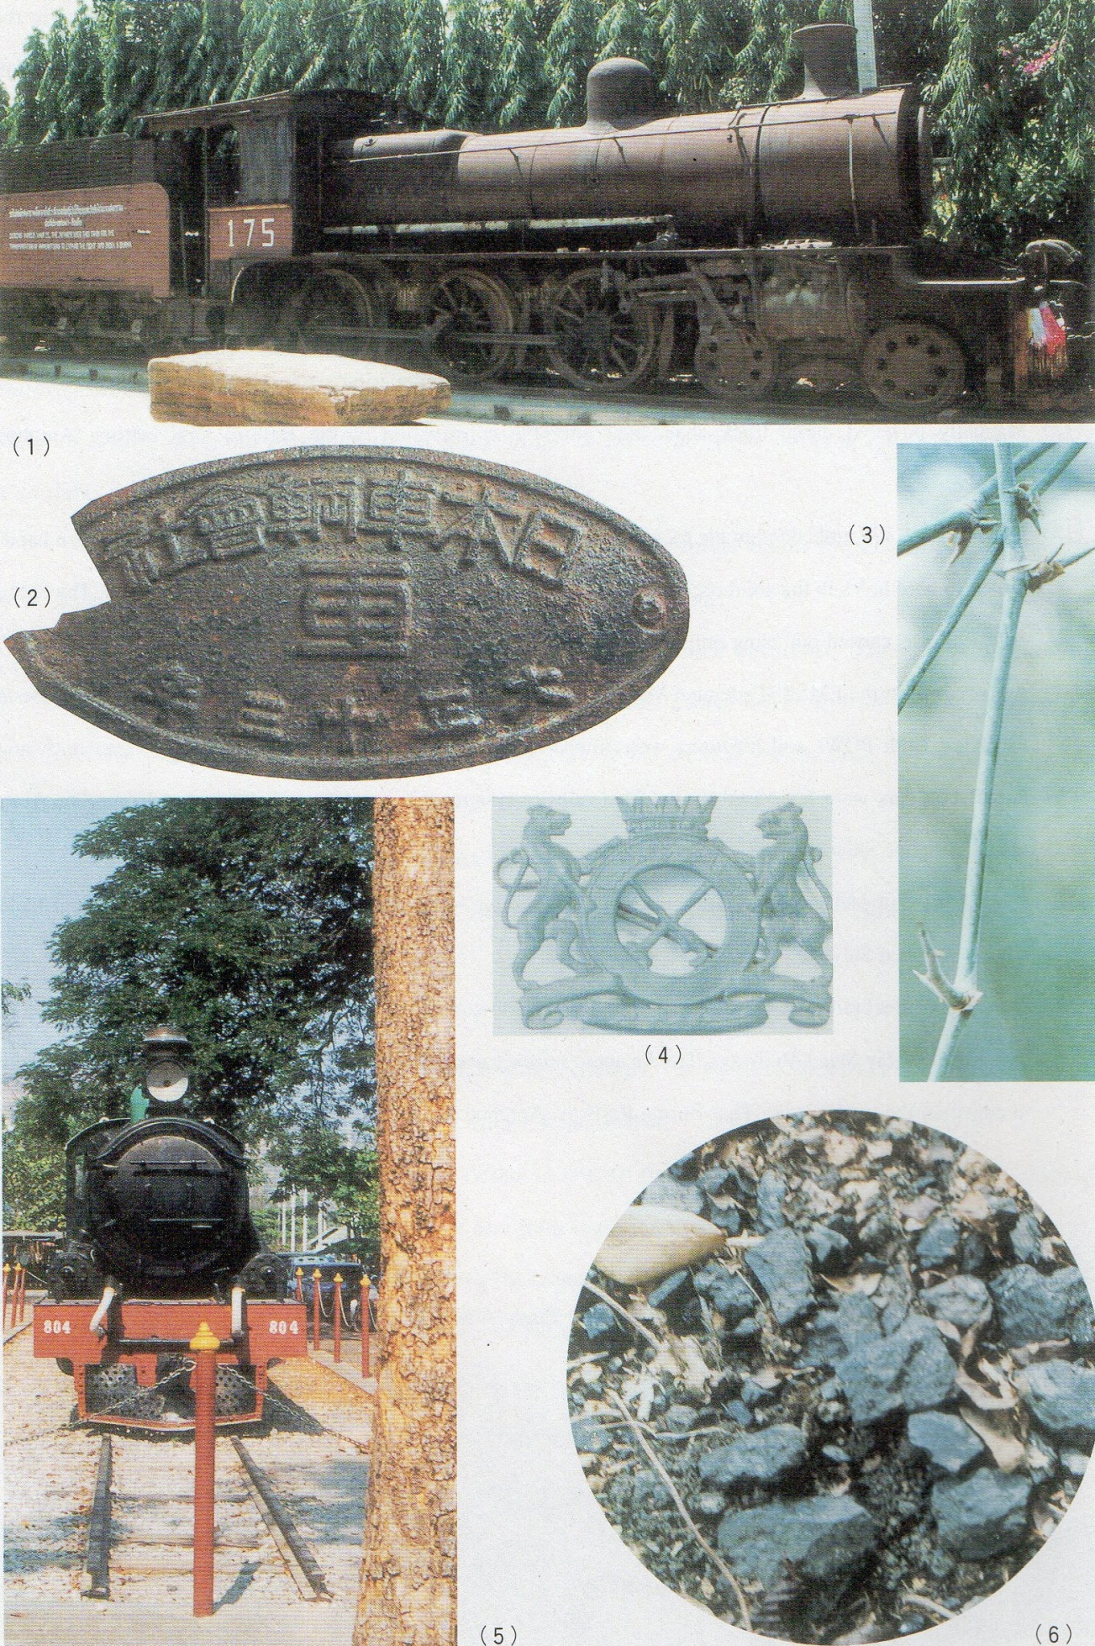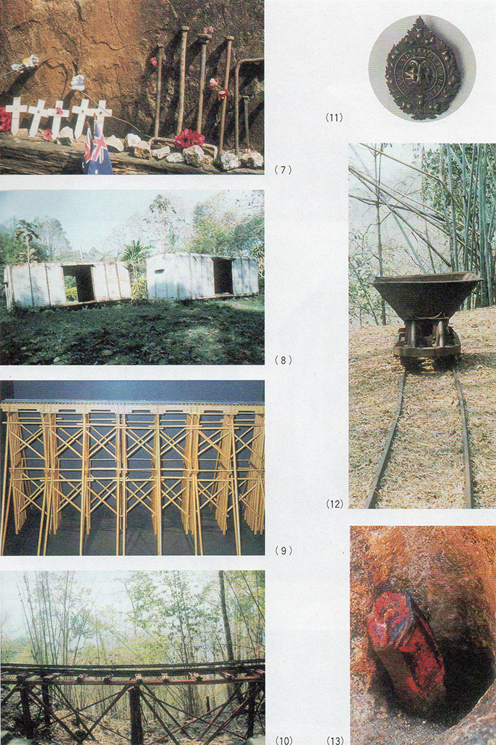

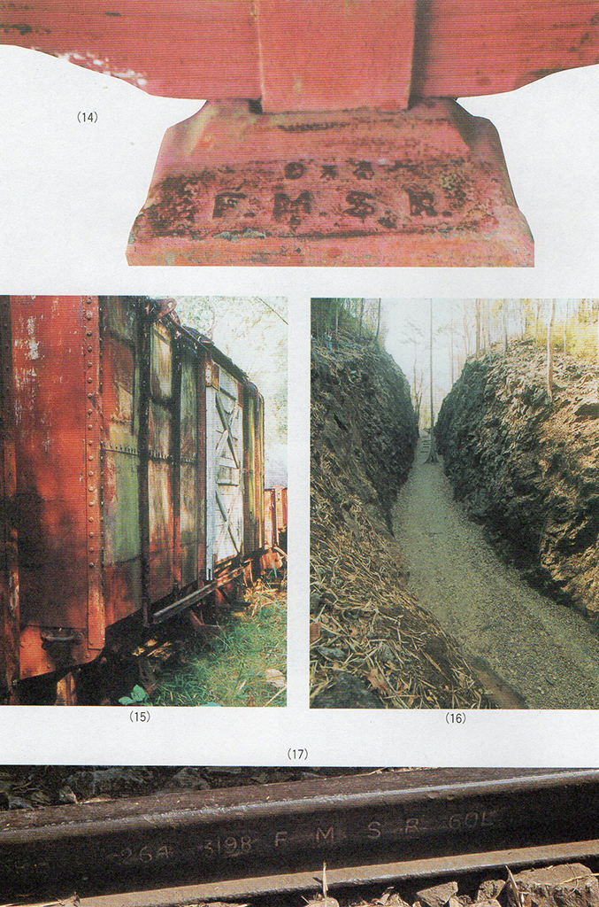

NOTES ON THE THAI-BURMA RAILWAY   
PART V: INDONESIAN ROMUSHA

The plight of Asian *romusha* on the Thai-Burma Railway was butone example - if the best known - of a much wider phenomenon: the relentless Japanese mobilisation of labour resources throughout Southeast Asia for military projects and war-related industries. This conscription of local labour has left perhaps the most indelible memories of the Japanese occupation throughout the area. Needless to say, much of this indigenous labour was employed on military construction works within the countries of the workers concerned, as has been indicated in earlier articles. [1] Some reference has already been made to the enormous extent of labour mobilisation from Java, together with some of the problems surrounding verification of the total numbers involved.[2] In the case of Java, the Thai-Burma Railway workers were probably only a small portion of a thorough labour mobilisation programme that caused Javanese workers to he sent throughout the Indonesian archipelago as well as to several other Southeast Asian countries. So extensive was labour mobilisation on Java that the Japanese word, *romusha,* has become part of the vocabulary of the contemporary Indonesian language (Bahasa Indonesia). One Indonesian dictionary notes,

“romusha: *see* ROMUSJA.   
romusja: *involuntary worker for the Japanese in Indonesia.* me-kan: *to work as a romusja.”[3]*

While unable to claim any special expertise in Indonesian affairs, this series of “*Notes on the Thai- Burma Railway*” must at some stage draw serious attention to the overall situation pertaining to Java, for it is from Java that perhaps the best and most reliable observations on the *romushas’* situation have survived.   
Tan Malaka was, by any accounts and standards, a remarkable figure: the subject of much **r**umourand fantasy even during his own lifetime. His twenty odd years of exile from his homeland, then the Dutch East Indies, took him to Holland, China, Hong Kong, the Philippines, Burma and Singapore. (In many of these countries he spent at least some time in prison). Probably born in 1897 of local Minangkabau nobility in West Sumatra and murdered by Indonesian Republican troops in 1949, Tan Malaka had been a delegate to the Comintern in Moscow and sometime leader of the PKI (Indonesian Communist Party). Tan Malaka’s anti-imperialist credentials (whether the imperialism happened to be of a Dutch, Japanese or British variety) are beyond doubt. His autobiography, “*From Jail to Jail*” (*Dan pendjara ke pendjara*) was written in various prisons in postwar independent Indonesia. Tan Malaka’s descriptions of life in South China, the nationalist movement in the Philippines and the Japanese invasion and occupation of Singapore deserve a wider audience, in that his perspective as a colonised Southeast Asian subject, but nevertheless not a national of any of the countries observed, is necessarily unique. “*From Jail to Jail*” is an important record that contributes to a deeper understanding of much of Asia on the eve of the Japanese invasion. The more than 900-page work has been meticulously translated and the text researched and checked by Helen Jarvis who - according to her own account - spent twelve years on the project. [4] Dr. Jarvis has produced an invaluable record from which this article takes the liberty of freely quoting, and without which, it would have been impossible to create at all.

It is not, however, the legends, myths or acrimonious allegations that surround Tan Malaka’s extraordinary career, nor his valuable observations on Asian society that concern this section of “*Notes*”. but rather Tan Malaka’s employment during the Japanese occupation of Indonesia as a clerk in the remote Bayah coalmine in West Java. Tan Malaka’s responsibilities included the recording of *romusha* arrivals, deaths, desertions and general conditions He was thus in a unique position to understand the *romushas’* concerns and the problems associated with the system of semi-forced labour and the evils of its implementation.[5] Though not himself a *romusha,* but deeply sympathetic to their situation, Tan Malaka’s account is probably the most comprehensive description of the Javanese *romusha* experience. His diary, therefore, merits careful consideration. The description begins with his first journey to Bayah. along the railway course that had been constructed to facilitate the coal’s extraction:

“About 5 or 6 kilometers from Bayah. along the coast, was a place called Pulau Manuk, which was feared by everyone, for few were the *romusha* who emerged from that place uninfected by fatal diseases such as ulcerated boils, dysentery and malaria. The *romusha* were provided with insufficient food, very few medicines and an inadequate nursing staff: practically no care at all was given to the sick and dying. Every day along the road from Pulau Manuk to Bayah one could see *romusha* covered with festering lesions struggling to reach a market place or an empty building where they could stretch themselves out to await death. In all the towns along the road from Saketi to Jakarta the markets, roadsides, and empty yards were filled with living corpses. Sometimes in the Bayah area up to ten corpses were buried in a single grave, because of official indifference and the lack of grave-diggers. In the rainy season the corpses were piled into graves half-filled withwater”[6]

Although there will doubtless be those few who claim that his comments on *romusha* are an exaggeration; some sort of anti-Japanese diatribe, Tan Malaka clearly differentiated between and communicated with many of the Japanese with whom he came into contact: he always believed that there were certain among the Japanese with whom he could hold a meaningful discussion and dialogue. One such was Nishijima Shigetada who had worked for the Chiyoda Hyakkaten (Department Store) in Surabaya, Batavia and Bandung before the war. On the outbreak of hostilities, Japanese civilians in the Dutch East Indies were detained and moved to Australia. After release as part of a prisoner-of-war exchange, Nishijima, due to his sympathy for Indonesian nationalism, was prevailed upon to join the *Kaigan Bukanfu*(Navy Liaison Office) under Admiral Maeda. Nishijima Shigetada’s record of his meeting with Tan Malaka just after Japan’s defeat indicatesmuch about the latter’s personality and ideals;

“The impression of myfirstmeeting with Tan Malaka, one day immediately after the declaration ofindependence, is still deeply inscribed in my memory . . . Anyway, we began to talk. I was immediatelysurprised by the man’s abundant knowledge and consistency of thought. It was apparent from his comments on revolution and the political structure after revolution that he was well acquainted with Marxism. Moreover, he talked about the strategy of mass movement, of propaganda, and of warfare. I was deeply impressed by his arguments because they were firmly based on an analysis of the international situation. . . .Tan Malaka was evidently sought after by the Japanese Army during the occupation, and it was rumoured several times that he had been arrested. However, there was no substance to such rumours. On each occasion, the Japanese arrested a man as Tan Malaka, only to find that he was not. Although I did not usually reveal my weakness, I was unable to conceal the great shock caused me by the Japanese surrender. I explained my feelings to Tan Malaka: ‘We are defeated. Nothing can be done now. I do not want to go back to Japan. In short, I am completely confused.’ Tan Malaka listened to me, and then answered slightly reprovingly, ‘I met Sano Manabu through my activities in the Comintern. I also know Ho Chi Mirth and have argued with Stalin. Thus I believe I understand the position of other countries and the international situation. . . . Yousaid Japan is defeated. That is certainly true. But have you thought how many people now belong to defeated countries? There are more than 200 million in Japan, Germany and Italy alone. Can you imagine how great a number of oppressed people are living in Asia? The earth is revolving and history never ceases to move on. In ten or twenty years, Japan will be changed. This can be said for sure from my experience.’ I understood well what Tan Malaka meant and felt thankful for his encouragement. Apart from the activity of Tan Malaka, I was deeply impressed by his words of encouragement.” [7]

To return to Tan Malaka s experiences and account of the Bayah Kozan (mine): Helen Jarvis indicates in her introduction and notes to “From Jail to Jail that she took considerable efforts to ascertain the veracity of Tan Malaka’s account:

“A holiday visit to Indonesia also in 1980 enabled me to renew old contacts and to make an unexpectedly rewarding journey to Bayah, on the south coast of West Java, where Tan Malaka stayed during most of the Japanese occupation. I happened to be in Jakarta at the same time as Harry Poeze, who was undertaking research for his continuing work on Tan Malaka, and so we decided to travel together to Bayah. [8] It was our intention merely to look at the place in order to providea context for Tan Malaka s description of it. To our surprise, our host, on hearing of our interest in Tan Malaka, informed us that there were still a number of people in the town who remembered him. Our host made immediate arrangements for us to meet these people and to hear their reminiscences, and they took us around the town pointing out landmarks referred to in the autobiography [9] . . . On 21st September 1980 1 was able to interview several former *romusha* who had been brought to Bayah from central Java and who still live there (some at Pulau Manuk). Abdulkadir Djaelani (b.1911 in Lehang, Banyumas). Dimin (b.1916 in Prambanan) and Abdulkadir’s wife gave graphic accounts of life as *romusha* in Bayah. As Tan Malaka reports, food was very poor, consisting of small rations of rice, tapioca. salted fish, and sugar. Abdulkadir maintains that he survived by selling most of his rations and living almost entirely on coconuts and sugar. As to medicines, they recall the pill (quinine) was the only drug available and was issued for all illnesses. They say that malaria was not such a problem in Bayah and Pulau Manuk as in Malingping, where it was virulent. . . It was the unchecked infection of even a slight cut, combined with weakness due to poor food and hard work, that caused the greatest havoc in the lives of the *romusha*. They were issued one set of clothes (cotton shorts and shirt) every six months, but Abdulkadir recalls that most *romusha* sold these to the local people and instead wore rags or even clothes made from latex.” [10]

“*From Jail to Jail*” also includes a photograph of a small memorial to Tan Malaka erected on the local school sports ground. The photo was taken by Dr. Jarvis on her visit to Bayah mentioned above. In his account, Tan Malaka makes some estimates of *romusha* casualty rates,

“It was a case of 80 per cent of the romusha who worked at Bayah Kozan dying, disappearing, or completely breaking down. When one considers that there were about fifteen thousand *romusha* there at any one time, making roughly fifty thousand a year from the various regions, the number of people harmed over a three-year period was something that demanded our fullest attention. If this calculation were extended to take account of all the *romusha* from Indonesia who were put to work in Southeast Asia making roads, forts and airfields for the Japanese, then there must have been some three or four million *romusha* lost during the Japanese occupation. This no longer represents a regional issue but must be seen as a national disaster, more terrible and more extensive than a volcanic eruption.” [11]

Helen Jarvis has again devoted considerable effort to verify the accuracy of Tan Malaka’s figures. Her overall impression, based on the estimates of other scholars, was,

“It is highly likely that the actual number of Indonesian *romusha* who died during the war did reach this staggering figure,’ [12]

And with regard to the Bayah coalmine estimates,

“The precise figure for the number of romusha in Bayah is hard to ascertain. Tan Malaka’ s figures *are* not disputed by local informants, who estimated one hundred thousand as a total over the whole occupation period [13]. . .My informants at Bayah claim that local hospital records placed the number of *romusha* who died at Bayah at 42.000, but they believe it to be closer to sixty thousand. The former *Kucho,* Zainuddin, states that there are 38 hectares of burial grounds in the Bayah vicinity . . . .One indication of the death rate among *romusha* is that of thirty-three who went to Bayah with Abdulkadir Djaelani in 1943, all hut five or six perished there during the occupation.’[14]

Tan Malaka’s account of his time at Bayah details the methods of *romusha* recruitment.

“As is well known, the Japanese military government ordered all regions of Java to send *romusha* to various places inside and outside Indonesia. A section of the *romusha* was directed to Bayah. The system was that the *Soncho* (sub-district head) received an order to prepare so many romusha to he sent to Bayah on a certain date. In the dispatching of romusha, as in everything else, the Japanese cared only that things were in order. We must get coal! In Bayah there is coal! So romusha must immediately be sent to Bayah! In such a situation (some members of the *painong praja,* Java’s native civil service, determined to accept the orders hut to sabotage them somehow. If the Japanese ordered three hundred people to be sent to Bayah from a certain district on a certain date, for example, the *Soncho* would send some stray people, but also a good proportion of undesirables from the villages - robbers, idlers and beggars - just to make up the number by the given date. Not only Japanese were caught (out) by our *Soncho.* He would engage in considerable deceit to fill the quota of *romusha* ordered by the Japanese. For example, a peasant hoeing his field would be ordered to go to the *kecarnatan* (sub-district headquarters) to report for military training. There he would find a truck ready to leave. When he had been travelling for a while, our illiterate peasant would begin to ask himself or his friends where this training ground could be. Naturally no one would know, except for the *Dancho* (leader) of the group. Most of the passengers would know only that their hoes were still lying in the fields and that their wives and children had not even been told that they were going off to ‘*training*’. Only after arriving in Jakarta or Rangkas would most of them realise that they were to be sent off to work in Bayah as *romusha*. Upon comprehending the deception, many would totally lose hope. They would nm away when the train stopped at a station or jump off it en route. Frequently we were thrown the dead and mutilated bodies of people who had jumped off a train hound for Bayah. Stray deceived peasants filled out only a portion of the *Soncho’s* list. The rest were unemployed, beggars hoping to get a little money, and people standing in for brothers or fathers whose names were on the list but who had some particular reason for not going.” [15]

Post-war researchers have shown that the system of *rornusha* recruitment was every bit as and even more pernicious than Tan Malaka’ s description, and bears strong parallels to Ba Maw’ s account of the corruption surrounding worker recruitment in Burma. described in a previous article. [16]The eminent historian of Indonesia. Benedict Anderson. has noted,

“The institution of the *romusha* program of forced labor further eroded any sense of stability and order within Javanese society. The *romusha* were mostly peasants from the poorer areas of East and Central Java, who were induced by various means to contract themselves out for work on military construction projects. Many were sent to Sumatra and even further afield to Burma, Siam and the eastern islands. They were usually treated with great brutality and callousness. . . .The evil effects of the romusha system were compounded by the actual application of the program, which made it possible to buy exemption either by bribing the recruiting officials or by paying a poverty- stricken compatriot to take one’s place. In this way the more powerful and prosperous groups of the community (rich traders, officials, the Chinese) were able to profit further from their good fortune, while the sufferings of the poorer strata of the population were multiplied.” [17]

Anderson cites in a footnote the source for his observations as “*Indonesia dalem api dan bara*” by a certain Tjamboek Berdoeri, evidently a pseudonym;

“He notes that when the Japanese began recruiting Chinese youths for various types of guard duties, it was typically the sons of poor Chinese who were caught. Rich parents paid doctors to certify that their sons had weak hearts. Within the Chinese community, recruiters usedtheir power extensively for corruption and blackmail.” [18]

Tan Malaka’s account also records some intriguing details on the financing of the Bayah Kozan (coal mine); methods that applied in varying degrees to other forced labour projects implemented by the Japanese military;

“Bayah Kozan was classed a private enterprise coal venture, owned by the prominent Japanese capitalist family, Sumitomo. hut it was nm under army supervision. The capital invested was private - from the Sumitomo family - but its products hnd to be marketed to suit the needs of the Japanese military, which was then at war. In fact it could not be accurately said that the Sumitomos financed and now owned the Bayah Kozan enterprise. The Japanese army had confiscated our coal bearing land in Banten. and a large part of the machinery and mine equipment had been seized from the Dutch East Indies; also the slave labor of the romusha was mobilized at the point of Japanese bayonets. In short. Japanese military might had obtained the land, machinery, and labor of Bayah Kozan, enabling the Sumitomo family to finance this ‘*private*’ enterprise at a ludicrous price.” [19]

The Bayah mine was thus planned as an important resource for making Java, hitherto a net importer of coal (from Sumatra, Borneo and Malaya), self-sufficient in that commodity.

“The Japanese estimated the coal deposits at Bayah at between 20 and 30 million tonnes. They calculated that production of 300.000 tonnes per annum was possible and decided to develop mines immediately … (but) production was far below expectations. While the exploitation target was 300.000 tonnes per annum, production in 1943 was no more than 4.000 tonnes, and it did not increase thereafter. . - .The more basic reasons for such a massive shortfall in production were the inaccurate estimates made at the beginning . The coal beds in Bayah were not rich, the thickest seam being only 0.8 metres.” [20]

It is not clear, however, how such an enormous gap between planned and real production (a shortfall of no less than 296,000 tonnes!) occurred, nor is any documentary evidence for the above production statistics adduced. Could it be that any Javanese shortfall in planned coal production figures might he explained by diversion of the coal produced to militarily more strategically-important projects elsewhere in Japanese-occupied Southeast Asia? Tan Malaka does not give any details of how the coal from this important mine was utilised, but it was probably primarily intended to be used for fuelling locomotives on the Java railway system. *“Before the war, steam locomotives in Java were fuelled with teak in flat areas and with coal in sloping areas. The ratio was approximately 40 per cent teak and 60 per cent coal.”* [21] Similarly. the Japanese-built C56 class locomotives used on the Thai-Burma Railway could - and did - consume the plentiful supplies of timber then available in the jungle. but the locomotive’ s efficiency was thereby severely impaired. Several “coaling stations” were, therefore, constructed at those points along the railway which were considered hazardous or where the often steep gradients required more power than could be obtained from the burning of timber. One such coaling station can still be seen in Saiyoke Yai National Park, another existed near the Hintok Station area and yet others were built in the difficult Thai-Burma border area around the Three Pagoda Pass. Former Japanese engineers and C56 locomotive drivers have stated that, although the C56s carried ample wood, they also had to be supplied with sacks of coal to navigate the more difficult parts of the rail course**.** Allied aerial wartime photos of the railway indicate vast stocks of coal dotted along the jungle tracks. [22] The import of the above observations is more evident when it is realised that Thailand - both then and now - produces hardly any coal. The nearest sources of supply were doubtless the mines of Malaya, a country already connected with Thailand by rail.[23] Malaya did indeed have coal deposits which were exploited during the war, Chin Kee Onn writing of the Japanese occupation of Malaya, notes;

“The Batu Arang Works in Selangor were passed over to the Mitsubishi Kogyo Kaisha, and other coal-mining centres were distributed to the Mitsui group.” [24]

Whether Malaya met all the Japanese demands for coal on the Thai-Burma Railway is unclear. The possibility remains that coal was obtained from other countries in the area (perhaps even Indonesia being a source in the early years when Japanese shipping lanes within Southeast Asia were more secure).   
Tan Malaka’s accounts of his activities at Bayah give a great deal of detail on the extent of *romusha* desertion, and the depressing situation and bewilderment of the *romusha* actually received at the coal mine. In marked contrast to the situation experienced on the Thai-Burma Railway by Malay labourer, Yu Chalawankumphi (mentioned in a previous article” [25]), at Bayah very thorough checks were made of the lists of *romusha****.*** It is unclear whether these lists and checks were initiated by the Japanese military authorities or whether they were compiled at the discretion of Indonesian clerks sympathetic to the workers’ plight.

“Of the three hundred whowere, on paper, sent to Bayah, only two hundred or fewer would arrive after three or four days on the road. This fact alone created all kinds of problems for us in the office. We had to check the lists we received from the various areas, such as Solo, Kediri, and so forth, as to the name, family, age and exact residence of each *romusha* against the *romusha* we actually received. If there were one hundred romusha lost on the journey, we had to make extensive investigations involving letters back to the district concerned with the transportation costs incurred...We did not want to forget about *romusha* lost along the way. For the Japanese, this was a very minor matter, for replacements could always be found; but for us it was a question of the life and health of our own people, most of whom were ignorant and knew nothing of directions, If they were missing, we wanted to know where they had last been seen, in order to report them to the local authorities so they could be helped. And we had to find outthe names, families, and addresses of all the *romusha* because, on our urging, the company had agreed to send a certain financial contribution to the families of *romusha* at Bayah Kozan, In short, we were responsible for finding out how many *romusha* had been sent, how many had arrived, how many were missing, and the family identities of both those who had arrived and those who were missing.” [26]

As arriving *romusha*often had to be processed at the same time as those who were returning after completing their service as *romusha,* Tan Malaka adds, “*It was not uncommon for us to have to process nearly one thousand romusha in a single day*.” He was also acutely aware of the dangers and hopelessness faced by deserting *romusha.*

“I would always explain the danger of a *romusha* trying to run home to central Java without a penny in his pocket. Most such refugees would never reach home but would fall ill or die on the road. Thousands of *romusha*, nothing but skin and bone, were stranded between Bayah and central Java after having run away.” [27]

So hazardous were even the journeys for *romusha*returning home from Bayah after completing their term of service, that it became customary for Indonesian employees from the mining company to accompany them on their homeward return journey.

“Most of the people who accompanied them understood that they had to watch the romusha carefully, checking at each station to make sure they did not leave the train and get left behind. This was a common occurrence, as the *romusha* wanted to buy one thing or another, or to relieve themselves, and they did not pay attention to the train whistle blowing. They were illiterate, and most of them did not understand Sundanese or even Indonesian, so once they were left behind they would face great danger. one had to go through the experience of accompanying them home to understand what they faced on the journey.” [28]

Based on his own experiences of accompanying a group of *romusha* on their homeward return journey. Tan Malaka further elaborated,

“It would take many pages for me to describe the difficulties of accompanying the *romusha* for someone who had a sense of responsibility and humanitarianism. A mild case of the Bayah ulcer disease would flare up after a day on the road and would be hard to keep under control. A *romusha* who had only a tiny mark on his body when being examined by the doctor would be allowed to leave, but the following day this mark would have swollen into an infected mass. *Romusha* suffering from malaria or dysentery would try to hide their condition from the doctor, for fear of not being allowed to go home. These diseases created all kinds of problems for the people taking the *romusha* home. Bayah Kozan had made arrangements for stopping off along the way at Rangkas and Jakarta and so on. But the food was less than satisfying, and the hungry *romusha* were often made to wait until far in the night before eating. They were forced to sleep just anywhere - or often to go without sleep altogether - and then they were awakened at four o’clock in the morning to get ready to move on. Often arrangements for their transportation had not even been made. *Romusha* had to travel in special carriages, for ordinary passengers would run from their second or third class seats if a single *romusha* should wander into the wrong carriage, especially if he were covered in ulcers.” [29]

Helen Jarvis elaborates such incidents in her notes and mentions. “*The wife of former Chudancho Djajarukmantara recalled once traveling on a train from Bayah boarded also by romusha. She affirms that the other passengers moved away and could not stand the stench of the sick and dying man.*” [30] Lest it be thought that these dreadful conditions related only to officially-classed *romusha,* Tan Malaka describes in some detail the situation of volunteers from the younger *Seinendan* (Youth Corps) sent by the Japanese authorities as supplementary workers to Bayah in the later stages of the occupation:

“The conditions faced by the ‘*volunteer*’ workers in the *Seinendan* in later days were no different from that of the *romusha*. The *Seinendan* who came from Pekalongan and Kedu arrived marching in formation, singing and with flags flying. They wore clean clothes and carried suitcases. But after their term of service expired - a month later - they returned home in lesser numbers than when they arrived: their clothes were in rags: their suitcases sold: and their bodies were skin and bone: wracked with malaria, ulcers and dysentery.”[31]

In his account of Bayah Kozan, Tan Malaka records the deeply distressing conditions of the *romusha,* hut it should be emphasised that, due to his presence and that of other Indonesian staff employed at Bayah, the afflictions of the *romusha* were much alleviated by these local employees who were sympathetic to their plight. Most Javanese *romusha,* working on military projects throughout Java and elsewhere in Southeast Asia, had no such “cushion” between them and the demands of the Japanese military authorities. This is clear from Tan Malaka’s comments on Pulau Manuk, quoted earlier, which summarises his impressions when first traveling to Bayah of the *romusha* utilised in constructing the Saketi-Bayah railway, built to enable the exploitation of Bayah’ s coal resources.

The ruthless mobilisation in Java was so extensive that it did not pass unnoticed by other segments of the Javanese population. On 14th February 194, to the shock of the Japanese authorities, the native officers of the Blitar battalion of the PETA Voluntary Defense Forces rose in rebellion against their Japanese military overlords. [32] A prominent Indonesian scholar of the Blitar Revolt, Nugroho Notosusanto, has commented on what he sees as the major cause of the revolt.

“In my view their experience with romusha was the most important single factor which induced the PETA officers and men to turn against their tutors.” [33]

Blitar was situated only some 30 kilometers from a large project utilising *romusha;* the construction of the Neyama tunnel at Sinai, Tulungagung town.

“Tens of thousands of people had to be drafted to Sinai and Ne Yama every day The number of deaths was horrifying. Hundreds of people a day died at that place. …Any hopes the workers had of returning home were diminished by the terminal food shortage and the constant pressure to keep hacking away at the mountain with adzes and hammers. Their bodies were thin and parched - bone wrapped in skin. Often those shouldering their comrades were so sick that they could not even support their own weight, so there were plenty of sick people or corpses left sprawled in the middle of the road and under trees at the edge of the jungle. Indeed it was a sign of the times that corpses were just like rubbish - walking skeletons no longer shocked people. Rows of people lined up along the river bank, not for rice but for a spoonful of boiled quininebark. The swamps were infested with tropical malaria.” [34]

Just as the Burma Defense Army’s distress at the plight of Burmese labourers had been a crucial factor in the formation of Aung San’s Anti-Fascist Peoples’ Freedom League, so the Peta soldiers’ shock at the misery of their fellow Javanese *romusha* became a major issue in the fomenting of the Blitar revolt.

“Like members of the Peta from other *daidan* (units), the members of the Blitar *daidan* had traumatic experiences with the *romusha*. They also had been building fortifications near the coast as well as in the mountains. They also had seen and participated in life at its most wretched level of suffering.”[35]

Needless to say, many of the Peta soldiers themselves fell victim to the horrendous conditions of work imposed by their Japanese overseers, as well as to the diseases that claimed so many *romusha* lives.

“But they considered themselves fortunate because they were given medicine, however minimal. They still had a roof over their heads, even though it was only woven *alang-alang* (a variety of wild grass). But the *romusha* were completely at the mercy of the elements, disease and their tormentors. Anger and bitterness grew among the Peta soldiers watching the *romusha* dying around them of malaria, dysentery, beri-beri, the lack of protection against the elements and maltreatment.” [36]

The same account further elaborates the misery of the *romusha.*

“The Peta soldiers were employed in building fortifications. The hard labour was done by *romusha*. The *romusha* were extolled as ‘*heroes of labour’*: in actual fact they were treated as mere slaves. Working with *romusha* proved to be a traumatic experience for most Peta soldiers. Very early in the morning, these people, who resembled walking skeletons, were assembled to dig bunkers, often in rock. They had to cut down trees and carry them to the fortifications; they had to carry heavy loads of gravel and sand for many hours in the blistering tropical sun without rest. Because of their weakened condition, they could barely walk; they staggered like drunkards. To rest for a while meant running the risk of physical violence. At noon they rested while standing in lines to get food distributed in their woven bamboo containers: those who did not have bamboo containers had to use leaves. They stood in lines like beggars, and not as people entitled to receive food after doing hard, unpaid labour. They had to struggle for drinking water at wells and springs, if there were any available. Otherwise they had to be content with river water where they also relieved themselves. They slept at the (work) site, because no camp was set up, and would be wet and cold if it rained. And above all this, waves of mosquitoes would attack them. As a result, within a short time, malaria decimated these wretched people. No latrines were built, so that if they were far from a river, they were compelled to relieve themselves (anywhere). No wonder that within a short time dysentery was rampant. Within a few weeks, half of the *romusha* were groaning and raving in delirium as a result of these diseases. In this condition even physical violence would not force them to get up again. After a few days, most of them closed their eyes for the last time. Then, in addition to their regular work-load, the greatly diminished labour force had to dig graves to bury their friends.” [37]

Japanese researcher, Kurasawa Aiko, has investigated in detail *romusha* conditions from interviews with numerous survivors who returned to their homes. She has also considered the circumstances surrounding the Blitar revolt. In an NHK documentary, she interviews a student in Blitar studying at the school which proudly hosts a memorial to the revolt, *“Although the Japanese occupation was short, it was the most cruel and that’s why the Blitar revolt occurred*.” She later talks with a Blitar citizen who remembers the revolt, *“Its cause was the horror at the treatment and deaths of the romusha.” [38]*

It was perhaps inevitable that the vast labour moblisation programme would become a subject of contention in postwar independent Indonesia, for it was the leaders of the new Republic - Sukarno and Hatta - who had been most visibly identified in cooperating with the Japanese military’s *romusha* programme. Cindy Adams. a US journalist responsible for Sukarno’s “*Autobiography*” somewhat dramatically indicates the Indonesian President’s sensitivity to the subject in remarks quoted earlier in this article’s introduction. [39] Sukarno - and to a lesser extent - his Vice-President, Mohammad Hatta, claimed after the war that cooperating with the *romusha* mobilisation programme was the necessary minimum price which the independence movement was forced to pay for such (Japanese) aid - official or otherwise - as was rendered for the ultimate independence of their country. Not all Indonesians agreed with their leaders’ explanations, and by early 1945,

“There was mounting criticism of the leaders most closely associated with the Japanese. in particular Sukarno and Hatta. The *penuda* (youth) leaders accused the two of having failed to alleviate the distress of the forced labourers, the *romusha.* According to one *pernuda* in Sjahir’ s group. ‘it was felt that the Japanese were benefitting from Sukarno’ s power and leadership; that the community was not being protected.’ Indonesian officials connected with *romusha* recruitment were earning the title ‘Anjing Jepang’ (Japanese Dogs), including Sukarno, who had participated overenthusiastically in a well-publicized Propaganda Department campaign to invite young men ‘to join the army of labourers’. In his autobiography. Sukarno admitted with a sense of genuine remorse that he had ‘shipped to their death’ thousands of *romusha*, but defended this as the only way to ‘save millions’.” [40]

The same work does continue by pointing out at least some small attempt on the part of Hatta to ameliorate the *romushas’* conditions.

“Hatta had begun to carry out an investigation into the situation of the *romusha*, establishing and leading a group, the *Badan Pembantu Prajurit Pekerja* (Body to HeIp the Worker Soldier), aimed at providing relief for them. At a meeting of the Central Advisory Council on February 21st 1945, Hatta launched an attack on the Japanese authorities for their treatment of these young labourers, putting forward evidence which he had collected over the previous six months to show the extent of their mistreatment. It was a much more weighted critique than the veiled protests contained in his Second Putera Report, an indication that he had regained confidence following his near escape from liquidation at the hands of the Kempeitai.”[41]

No practical steps were, however, taken to remedy the *romusha*suffering and Sukarno stated in his ‘*Autobiography; As Told to Cindy Adams*’,

“I admitted several memories would be painful to set down. These pages are difficult for me. I cannot discuss this period without experiencing great emotion. Even twenty years later, the wounds are not totally healed. The deeds I had to do and the suffering I endured at the hands of a small segment who would not understand are scars I will carry to the grave... Let us discuss the *romushas*. The Japanese needed laborers in their work projects in occupied territories outside Indonesia. The *romushas* were male laborers the military picked up at random from roadsides and villages. In many a district which had not a single male left between the ages of 16 and 60, women did the ploughing, shoveling, and other back-breaking work. Since conscripting hundreds of thousands would have caused wholesale rebellions, Dai Nippon preferred to lure *romushas* with promises of enticing wages and the title, ‘*Heroes of* *Labor*.’ In reality they were slaves and I was the one assigned the task of enlisting them. Thousands never came back. They died in foreign lands. Often they were treated as inhumanly as the prisoners of war with whom they were shackled side-by-side to build the notorious Burma (Rail) Road. Yes, I knew about them. Yes, yes, yes. I knew they’d travel in airless boxcars packed in thousands at a time. I knew they were down to skin and bone. And I couldn’t help them. In fact it was I, Sukamo, who sent them to work. Yes, it was I. I shipped them to their deaths. Yes, yes. yes, yes. I am the one. I made statements supporting the recruitment of *romushas*. I had pictures taken near Bogor with a tropical helmet on my head and a shovel in my hand showing how easy and glorious it was to be a *romusha*. With reporters, photographers, the *Gunseikan* - Commander-in-Chief and Civil Authorities I made trips to Bante,. the western tip of Java, to inspect the pitiable skeletons slaving on the home front down deep in the coal and gold mines. It was horrible. Hopeless.” [42]

An indication of the total extent of Javanese *romusha* mobilisation is provided by the later war reparations negotiations held between Indonesia and Japan.

“In the war reparations negotiations held in Tokyo between December 1951 and January 1952, the Indonesian delegates requested US$ I7 billion from Japan, of which $10 billion was for the loss of manpower. The Indonesians estimated the human loss at four million people, including non- labourers who were killed for suspected anti-Japanese activities. The US$10 billion was calculated as the aggregate income these four million people could have earned in 20 years.” [43]

Some final comments are perhaps in order on the enduring impact and effects of the mobilisation of Javanese *romusha* on the Thai-Burma Railway itself after the war. That the total numbers of Javanese must be greater than generally acknowledged and that the Allied efforts at *romusha* repatriation were inadequate is attested to by the fact that the former Peta organisation set up an office in Bangkok after the war to search for remaining unrepatriated Javanese. Allegedly. this office was operating until comparatively recently [44] Kurasawa Aiko recorded the experiences of Sadin. a *romusha* repatriated to Java sometime in 1959. evidently through this office:

“Sadin was recruited at Kuningan, West Java. He was asked to work for only two weeks at Cirebon near Kuningan. But one day while he was working at Cirebon he was sent secretly by boat with his 1,500 colleagues to Tanjung Priok, port of Jakarta. From Jakarta, Sadin and other *Romusha* were brought to another big ship which went to Malaya. Sadin was sent to Thailand. The Japanese were so cruel as to bury alive Romusha who were seriously ill and could hardly work. We could no longer put up with this cruel treatment. One day *Romusha* rose against the Japanese. But this uprising was easily suppressed. Fortunately Sadin was able to escape from the Japanese. In November 1959, fourteen years after the war ended, he was able to come back to his home thanks to Indonesian Government support.”[45]

The private activities of Nagase Takashi, a former Japanese *Kempeitai* (military police) official on the railway have also involved the postwar repatriation of Asian labourers, including Indonesian *romusha.* Nagase was already known for his attempts at reconciliation with former POWs (Allied prisoners-of-war) and for opposing (unsuccessfully) the transfer of a Japanese locomotive, C5631 - which ran on the line from the first day of operation - from a scrap yard in Thailand to Tokyo’s Yasukuni Shrine as a memorial to the railway. [46] The Japan Times reported on 9th April. 1981,

“Eight Asians forced to work on the wartime Thai-Burma railway by the Japanese Imperial Army have been found still living in jungles in Thailand. Takashi Nagase. 63, former interpreter to the Japanese army found them in jungles along the River Kwai….He discovered the eight Asians while he was traveling along the river on two occasions last December and late last month. The eight said they settled in the riverside jungle after fleeing in the immediate postwar confusion, and lived by farming, according to Nagase.”[47]

  Nagase was involved in the eventual repatriation of a Javanese labourer known in Thailand as Boontum Wandee**.**

“Boontum Wandee, **7**4**,** was found by Takashi Nagase, 76, a former army interpreter at River Kwai who has devoted his postwar life to reconciliation and atonement. Boontum is the Thai name the Indonesian laborer took on in the jungle. Born Cara Yavjira, he was a soldier of the Dutch colony of Java when he was forcibly taken to River Kwai in 1942. Boontum said he and several other Asian laborers escaped to the jungle during a bombing raid in 1944. They emerged several years afterthe war. The laborers became subsistence farmers. Boontum plans to apply for Indonesian citizenship. The country was still a Dutch colony when he left (sic). The journey was paid for by public donations Nagase collected in Japan.” [48]

Much of the precise situation surrounding the Javanese *romusha* on the Thai-Burma Railway may never he fully known. There are some faint suggestions in the Allied records that repatriation of workers may not have been effectively carried out. A curious instance occurs in the memoirs of John H. McEnery, a young army recruit from Britain serving in the newly re-conquered colony of Burma at the war’s end.

“The Commerce & Supply Department of the Burma Government - CAS (B) - sent us a copy of a touching letter from their District Commissioner in Moulmein, concerning five unhappy Javanese carpenters who had been conscripted to work on the Burma/Siam railway by the Japanese and had been left behind as the tide of war ebbed. Could Burma Command help in moving these Javanese hack to Batavia? (Jakarta) Allied forces were still very heavily involved in the Dutch East Indies and military troop transports were running regularly from Rangoon to Singapore and from Singapore to Batavia. It was very easy to arrange the repatriation of these unfortunates.... a humane operation at effectively no expense to the Army.” [49]

A seemingly straight-forward case of *romusha* repatriation, except that the account ends ominously with the words, “*I was to learn more about the Javanese carpenters later on.*” McEnery explains this further knowledge some twenty pages later, hidden in a small footnote,

“In January, weeding (through) some old CAS (B) files, I found a year-old signal from the CAS (B) officer in Moulmein reporting seven Javanese carpenters who had volunteered to work on the railway and were suspected of mistreating Allied troops. What should he do with them? There was no answer on file. I wondered what had happened to the other two. Coincidentally some days later the Burma Government reported that two other deserving Javanese carpenters had turned up. Could Burma Command HQ kindly repatriate these two as well? I replied in a dead-pan letter that the Dutch East Indies had been evacuated and that we had no means of shipping them.” [50]

The situation in the Dutch East Indies (Indonesia) at the war’s end was complex and the Allies’ contribution (or, rather, intervention) can hardly he termed irreproachable. The British army had occupied Indonesia on the cessation of hostilities with the intention of handing the country back over to its former colonial masters, the government of the Netherlands. The colony’s native inhabitants had other plans. Few regrets may have been felt by the average citizen (especially if he had been a *romusha)* at the passing of the Japanese occupation; on the other hand there was little love lost for the country’s previous Dutch colonial masters either. Sukarno immediately declared Indonesian independence, preparing to light a protracted war against any returning Dutch forces. (In this he received some limited support from certain sectors of the defeated Japanese military, particularly the navy). Needless to say, the British army shared none of this enthusiasm for Indonesian independence and several clashes were indeed reported. As the British army hastened to withdraw, Sukarno’ s war against the Dutch developed until independence was largely achieved in 1949. Under these circumstances, it is unlikely that either the British or the Netherlands authorities considered repatriation of Javanese *romusha* from Thailand as a top priority. With regard to the *romusha* themselves, widespread anti-Dutch feelings existed in Java prior to the war and this was further fanned by Japanese military propaganda during their occupation of the area. Considerable numbers of Dutch POWs were forced to labour on the railway in both Thailand and Burma. Relations between them and the Javanese romusha could have been somewhat strained.[51] The fate of McEnery’ s “other two” - whom he had declined to repatriate to Java - is nowhere recorded.

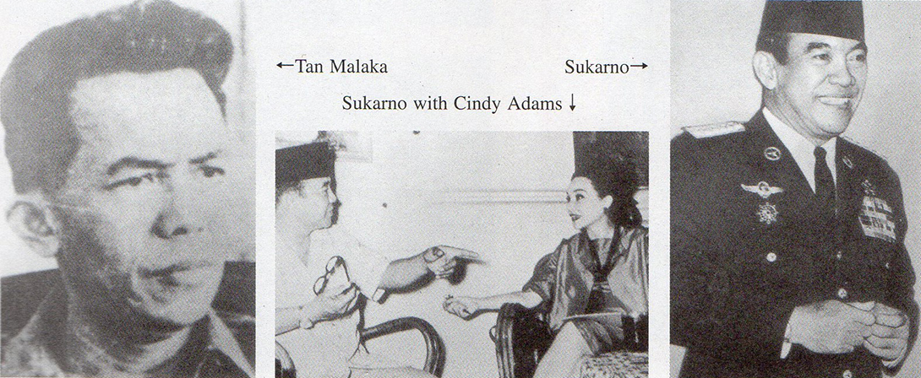

1. “*Notes on the Thai-Burma Railway. Part IV: An Appalling Mass Crime*’ (Journal of Kyoto Scika University: No.22, 2002).   
   
2. *“Notes on the Thai Burma Railway. Part II: Asian Romusha: The Silenced Voices of History’* (Journal of Kyoto Seika University: No.20. 2001).
3. John M. Echols & Hassam Shadily: “*An Indonesian-English Dictionary*” (Cornell University Press. 1963): p.303*.*
4. Tan Malaka: “*From Jail to Jail*’, translated & introduced by Helen Jarvis in 3 volumes. (Ohio University; Monographs in International Studies. Southeast Asia Series: No.83. 1991). To my knowledge only the first   
   two volumes were ever published in Indonesia - “*Dari Pendjara ke Pendjara*” (Widaya, Jakarta. 1947-1948). The first attempt to restore Tan Malaka to his rightful place in Indonesian history was by Benedict R.O’G. Anderson in his seminal work. *“Java in a Time of Revolution: Occupation & Resistance, 1944-1946”* (Cornell University, 1972). See Chapter 12*; “Tan Malaka & the Rise of the Persatuan Perdjuangan.”*   
   
5. Although local Javanese civil servants and clerks, such as Tan Malaka, were employed at the Bayah Coal Mine to deal with *romusha* needs and transportation movements, it should be stressed that no such local staff were evidently recruited to deal with the problems experienced by *romusha* on the Thai-Burma Railway. Here *romusha* affairs were directly administered by the Japanese military themselves.   
   
6. Tan Malaka: op. cit.: Vol. II; p.157.
7. Nishijima Shigetada: “*The Independence Proclamation in Jakarta*” from “*Indonesia Dokuritsu Kakumei*” (pp.186-221; translated & edited by Anthony Reid and Oki Akira: *The Japanese Experience in Indonesia:   
   Selected Memoirs of 1942-1945’* (Ohio University, Monographs in International Studies; Southeast Asian Series, No.72. 1986): pp.299-302.
8. Harry A. Poeze, author of “Tan Malaka, stridjer voor Indonesie’s vrijheid: levensloop van 1897 **tot** 1945” (Nijhoff, 1976).
9. Tan Malaka: op.ci: preface by Helen Jarvis. p.xxi.
10. Tan Malaka: op.cit: Helen Jarvis’ Note 64, p.270.
11. Tan Malaka: op.cit: pp.175 & 176.
12. Tan Malaka: op.cit: Helen Jarvis Note 102. p. 278. An earlier note (Note 5. p. 255) mentions the sources to which she referred. These include G. Kanahele: “The Japanese Occupation of Indonesia: Prelude to Independence” (Ph.D. thesis; Cornell University, 1967) and W.F. Wertheim: ‘Indonesian Society in Transition: A Study of Social Change” (van Hoeve; The Hague, 1956).   
    
13. Tan Malaka: op.cit: Helen Jarvis’ Note 67, pp.271 & 272, citing “interviews at Bayah, 21st & 22nd September 1980.”   
    
14. Tan Malaka: op.cit: pp.163 & 164.
15. Tan Malaka: op.cit.
16. David Boggett: *“Notes on the Thai-Burma Railway. Part IV: An Appalling Mass Crime*” (Journal of Kyoto Seika University: No.22, 2002).
17. Benedict R.O’G. Anderson: “*Java in a Time of Revolution: Occupation & Resistance. 1944-1946”* (Cornell University. 1972): pp.13 & 14.
18. Benedict R.OG. Anderson: op.cit: Note 28, p.14 quotes pp.150-152 & 155 of Tjamboek Berdoeri (pseud.): “*Indonesia dalem api dan bara*” (Malang, 1947)
19. Tan Malaka: op.cit: p.157. In an interesting comment upon postwar Japanese attitudes to their involvement in Southeast Asia, Sumitomo evidently refused to either confirm or deny their involvement in Bayah to Dr. Jarvis. “Despite requests to Sumitomo, I have been unable to document that company’s involvement in Bayah Kozan’ (Note 65. p.27 I).
20. Shigeru Sato: “*War. Nationalism & Peasants: Java Under the Japanese Occupation. 1942-1945”* (M. E. Sharpe. 1994); pp.185 & 186.
21. Shigeru Sato: op.cit; pp.180.
22. I am indebted to Rod Beattie, Supervisor of the Commonwealth War Graves Commission’s Kanchanaburi cemetery, for technical information on the C56 locomotives. An engineer himself, he has frequently assisted in driving those few C56s still maintained in running order by the Thai State Railways and has often been able to discuss the locomotives’ performance with former Japanese engineers on the Railway. Photos of the Saiyoke Yai coaling station were included in *“Notes on the Thai-Burma Railway, Part I”* (Journal of Kyoto Seika University; No.19, 2000). Allied aerial photos of the railway clearly showing coal stored at various areas along the railway are in the possession of Rod Beattie.
23. Lack of information and my present level of knowledge does not enable any accurate assessment of Burma as a possible resource for coal. Low-grade coal could probably have been extracted in Burma. Recently, according to a *Bangkok Post* article of 28th April, 2001, the Burmese military government has announced plans for construction of a low-grade coal-fired electricity plant near Tachilek, opposite the Thai border town of Mac Sal. I have been unable, however, to find any references to Japanese exploitation of coal during their occupation of Burma. Possibly, transportation difficulties hindered such attempts.
24. Chin Kee Onn: “*Malaya Upside Down*.” (Federal Publications, Kuala Lumpur. 1976): p.85.
25. David Boggett: “*Notes on the Thai-Burma Railway. Part Ill: Praise the Prosperity & Glory of the New East Asia*” (Journal of Kyoto Seika University: No.21, 2001).
26. Tan Malaka: op.cit: pp.164 & 165.
27. Tan Malaka: op.cit: p.166.
28. Tan Malaka: op.cit: p.176. Sundanese is the regional language of West Java.
29. Tan Malaka: op.cit: pp.176 & 177.
30. Tan Malaka . op.cit: Helen Jarvis, Note 105 based on a personal interview in Jakarta on 26th Septcmber,1980: p.279.
31. Tan Malaka: op.cit: p.167. According to Tan Malaka’s account, while the *Seinendan* were on terms of service restricted to one month**,** the normal *romusha* contract was for three months and many often stayed much longer. The *Seinendan* members were, of course, considerably younger than the adult *romusha*.
32. PETA *(Tengara Sukarela Pentbela Tanalt Air)* was a voluntary defense force formed and promoted by the Japanese military administration throughout Java and other islands of the Dutch East Indies.
33. Nugroho Notosusanto: “The Peta Army During the Japanese Occupation of Indonesia” (Waseda University Press, 1979): p.153.
34. Sintha Melati: “In the Service of the Underground’ in Anton Lucas (ed): “*Local Opposition & Underground Resistance to the Japanese in Java. 1942-1945*” (Monash University; Papers on Southeast Asia, No.13: 1986): p.2.   
    
35. Nugroho Notosusanto; op. cit.: p.154. For details of the Burmese situation, see David Boggett: *“Notes on the Thai-Burma Railway. Part IV: An Appalling Mass Crime”:* Journal of Kyoto Seika University, No.22, 2001.
36. Nugroho Notosusanto: op.cit: p.153.
37. Nugroho Notosusanto: op.cit: p.152.
38. Kurasawa Aiko (dir.): “*Hakkutsu Maboroshi no Kokusaku Eiga*”(Discovered - Lost Government Propaganda Films, also subtitled ‘*Java Under the Japanese Occupation*’). NHK Documentary broadcast on 14th August, 1989.
39. Cindy Adams: “*My Friend the Dictator*” (Bobbs-Merrill. New York. 1967): pp.203 & 204.
40. Mavis Rose: ”lndonesia Free: A Political Biography of Mohammad Hatta” (Cornell University Modern Indonesia Project, Monograph No.67, 1987); p.109. Sukarno’s quoted comment about saving ‘*millions*” is taken from “Sukarno: An Autobiography As Told to Cindy Adams” (see Note 42 below); p.193.
41. Mavis Rose: op.cit: p.109.
42. Sukarno: “Sukarno: An Autobiography As Told to Cindy Adams” (Bobbs-Mcrrill, New York, 1965 and Gunung Agung, Hong Kong, 1966): pp.19 I & 192. Tan Malaka records the controversial visit of Sukarno and Hatta to the Bayah Coal Mine in Tan Malaka: op. cit: pp.174-176.
43. Sato Shigeru: “*War, Nationalism & Peasants*” (M.E. Sharpe, 1994): p.155. Sato indicates the source of his information as Sarimin Reksodiharjo: “Kenang-Kenangan dari Masa yang Silam” (unpublished autobiography. 1965): pp.253-54 and states “Sarimin was a delegate to the negotiations and was in charge of the issue of human loss.” (Sato Shigeru; op.cit: p.258, Note 5).
44. I am grateful to Mizuno Kosuke, researcher on Indonesian affairs at the Center for Southeast Asian Studies of Kyoto University for drawing my attention to the existence of this Peta Bangkok office. I have, as yet, been unable to locate any records of its activities in Thailand.   
    
45. Kurasawa Aiko: “*Mobilization and Control: A study of Social Change in Rural Java. 1942-1945*” (PhD thesis, Cornell University, 1988); quoted by Murai Yoshinori in his article. *“Asian Forced Labour (Romusha) on the Burma-Thailand Railway”* in Gavan McCormack & Hank Nelson (eds): *“The Burma-Thailand Railway”* (Silkworm Books, 1993); p.63.
46. Nagase has recorded his activities of atonement for the horrors of the railway in Nagase Takashi: “Crosses & Tigers” (Allied Printers, Post Publishing Co. Ltd., Bangkok, 1990). Details of the transfer of locomotive C5631 to Yasukuni Shrine (where it still stands today) appeared in a *Japan Times* article datelined Yokohama (Kyodo), 9th April, 1981. Nagase has published much about the Railway in Japanese, including translations of former POW diaries, such as Leo Rawlings: *“And the Dawn Came Up Like Thunder*” (Rawlings-Chapman Publications, 1972). Eric Lomax’s personal account, “*The Railway Man*” (W.W. Norton. 1995) details his own reconciliation with Nagase after enduring torture at the hands of *Kempeitai* officials. The story has been the subject of a drama entitled “Return to Kanburi” written by Sears Eldredge, Professor of Dramatic Arts & Dance at Macalester College in St. Paul, Minnesota, in 1999. Details of Nagase’s establishing a scholarship fund for the education of poor children from the Kanchanaburi area appear in a Japan Times article of 30th May,1995. It should perhaps be mentioned that there have been some criticisms of Nagase’s work in the repatriation of Asian labourers by some who claim that the repatriations at this late stage might not have been entirely voluntary. The British Ambassador to Japan presented a letter of appreciation to Nagase for his “*efforts to reconcile former British prisoners of war with their Japanese captors*” in early April, 2002. (*Japan Times* article datelined Okayama, Kyodo, 6thApril, 2002).   
    
47. *Japan Times* article datelined Yokohama (Kyodo), 9th April, 1981.
48. Japan Times article datelined Kanchanaburi, Thailand (API ) of 19th July 1995. Some of the articles’ details are puzzling and are contradicted elsewhere. Nagase himself mentions three Javanese by the names of “Mr. Bhun Tham,Mr. Somsar and Mr. Me Wandi”. He also mentions that “*Mr.Yokoyama from the Mainichi Newspaper Press visited the village near Djokjakarta in Indonesia which is Mr. Me Wandi’s native village. He heard verbal evidence from the village chief; ten people from this village went to Thailand and only half of them returned. A rumor said that an eminent producer in the Indonesian cinema industry made a film called Romusha some years ago, but the local Japanese society bought the film at a high price and never showed it to the public. I wonder whether it was true or not*” (Nagase Takashi: op.cit: p.68). An NNN Documentary on the Thai Burma Railway broadcast in Japan on 23rd July, 1995, features the story of a Mr. Boontum Wandee. At that **time** it was stated that on hearing of the death of his brother in Java, Boontum had decided to remain in Thailand. However, a slightly later Thai television documentary featured his returning to his home village in Java. (Date of documentary and the Thai TV Channel which produced it are unclear. Copy in this author’s possession).
49. John H. McEnery: “*Epilogue in Burma 1945-1948: The Military Dimensions of British Withdrawal*” (Spellmount, Tunhridge Wells, l990 and White l.otus, Bangkok., 2000): p.74.
50. John H. McEnery: op.cit: p.96, Note 2.
51. Such anti-Dutch attitudes may have manifested themselves among the *romusha* of the Pekanbaru Railway in central Sumatra. I am grateful to Indrawan Yulianto, an Indonesian studying at Seika, for drawing my attention to the construction of the “*Death Railway of Pekanbaru*” in his moving and detailed report. Built by the Japanese military in 1944 to facilitate the exploitation of inland coal deposits near Pekanbaru in Sumatra, the railway roughly followed the course of the Siak River, linking the inland areas with ports on the coast around Padang. As in the Thai-Burma Railway, both Allied (chiefly Dutch) POWs as well as *romusha* were utilised. The treatment and condition of workers was similar: the Siak River was prone to flooding after torrential rainfall and malaria was endemic in the area. The railway, strangely, was finished on the very day of Japan’s surrender. The report indicates that after the capitulation of Japan, most of the Dutch POWs were kept in the area for some time. ‘The Dutch soldiers had to stay where they were. This created a lot of resentment. In the meantime, the political situation outside the camp worsened as the Republic-oriented Indonesians (i.e. Sukarno sympathisers) refused all cooperation with the ex-prisoners. Officially security was still in the hands of the Japanese, but this was considered far from satisfactory.” The situation was resolved by arming volunteers from among the POW ranks and ultimately the Dutch soldiers were evacuated by the end of November, 1945. Indrawan notes that. “Only a handful (of Dutch soldiers) under Major C.P. Langley remained behind for another few days to organise with the Japanese some assistance for the *romusha*.” (Indrawan Yulianto: “The Death Railway of Pekanbaru”: unpublished report, 2001).