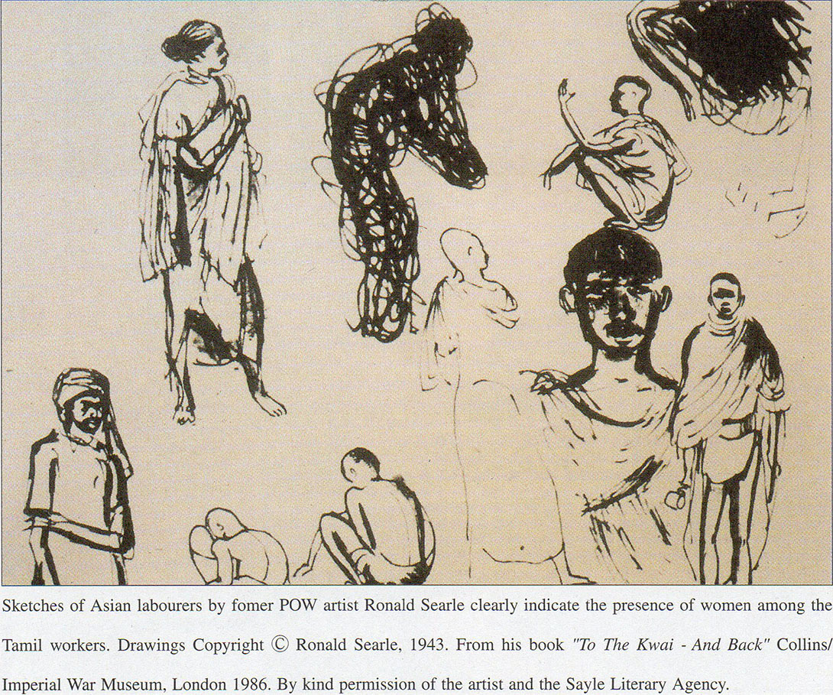

KEY TO THE PHOTOGRAPHS

1. Wartime Japanese helmets displayed in the P Guesthouse, Amphoe Sangkhlaburi.   
2. Remnants of the Railway. The Thai text reads “*Japanese bricks from the era of World War II*”; Hin Dat Hot Springs, Amphoe Thong Pha Phum.   
3. The Japanese-built water tank still stands at Nong Pladuk Junction.   
4. The aftermath of exploded bombs and gun emplacements at Hin Dat Hot Springs; Amphoc Thong Pha Phum.   
5. Base of the Japanese-built water tank on the banks of the Songkalia River, Amphoe Sangkhlaburi. Both *Shimo* (Lower) and *Kami* (Upper*) Sonkurai* camps were situated near the river, the name *Sonkurai* being taken from the Songkalia River.   
6. A P-class 4-6-2 engine built by the North British Locomotive Co. for the Federated Malay States Railway (FMSR) in 1919. It was moved from Malaya to Thailand for use on the Thai-Burma Railway by the Japanese military; Tha Makham Bridge, Kanchanaburi.   
7. C56 locomotive brought from Japan for use on the railway, Saiyoke Noi National Park, Amphoe Saiyoke.   
8. Spirit Shrine at the Japanese-built hot springs of Hin Dat; Amphoe Tong Pha Phum.   
9. The small pool, located some fifty meters from the general bathing area at Hin Dat Hot Springs. Former prisoner of war (POW) accounts relate that the small poo1 was reserved for the Japanese camp commander and his local female companions. Today it is reserved for use by monks of the local temple; Amphoe Thong Pha Phum.   
10. The concrete base supports of the bridge carrying the railway over the River Songkalia can still be seen today near the Three Pagoda Pass, Amphoe Sangkhlaburi.   
11. An Allied bomb case now used as a bell at the Spirit Shrine; Hin Dat Hot Springs, Amphoe Thong Pha Phum.   
12.A cholera isolation tent, reconstructed from records and drawings by former POWs in the Sir Edward Dunlop Memorial Park, Home Phu Toey Resort; Amphoe Saiyoke.   
13.Site of the mass grave for Tamil and other Asian labourers excavated in 1990. The skeletal remains had been removed before this photo was taken; Kanchanaburi.   
14. Japanese C56 class locomotive preserved at the Tha Makham Bridge, Kanchanaburi.   
15. Tamil language inscription on the Japanese army’s memorial to the railway at Tha Makham, Kanchanaburi. It has been defaced by rocks thrown by angry former POWs on their postwar visits to the railway.   
16. “Hcre Lie Buried the Ashes of the 300 Soldiers Whose Names Are Inscribed in the Memorial Building in This Cemetery”. The grave contains the ashes of those POWs whose bodies were burned after succumbing to cholera. The names of the deceased were carefully recorded by surviving POWs. No such lists were madefor the numerous Tamil and other Asian victims; Kanchanaburi Cemetery of the Commonwealth War Graves Commission.   
17 & 18. Remains of a child less than 10 years of age in the mass grave of Asian labourers discovered in Kanchanaburi in 1990. A metal bangle is still visible on the bones of the child’s left arm. Photographs Copyright *Sinlapa Wathanatham, Magazine* (Art & Culture Magazine); Vol.12, No.4; February, 1991; Reproduced by kind permission of Ms. Mukhom Wongthesand the Editorial Board of *Sinlapa Wathanatham* *Magazine.*19**.** Items found at POW camp sites along the railway course (from the collection of Mr. Rod Beattie). 20. The River Kwae at Tha Makham, Kanchanaburi. *“The Bridge on the River Kwai”* is in the background. The flimsy rails in the foreground are said to mark the approach to the former wooden bridge, bombed during the war and never replaced.   
21. The Abbot of Wat Don Thin (Temple) saw women in the columns of Tamil workers marching through Ban Pong.

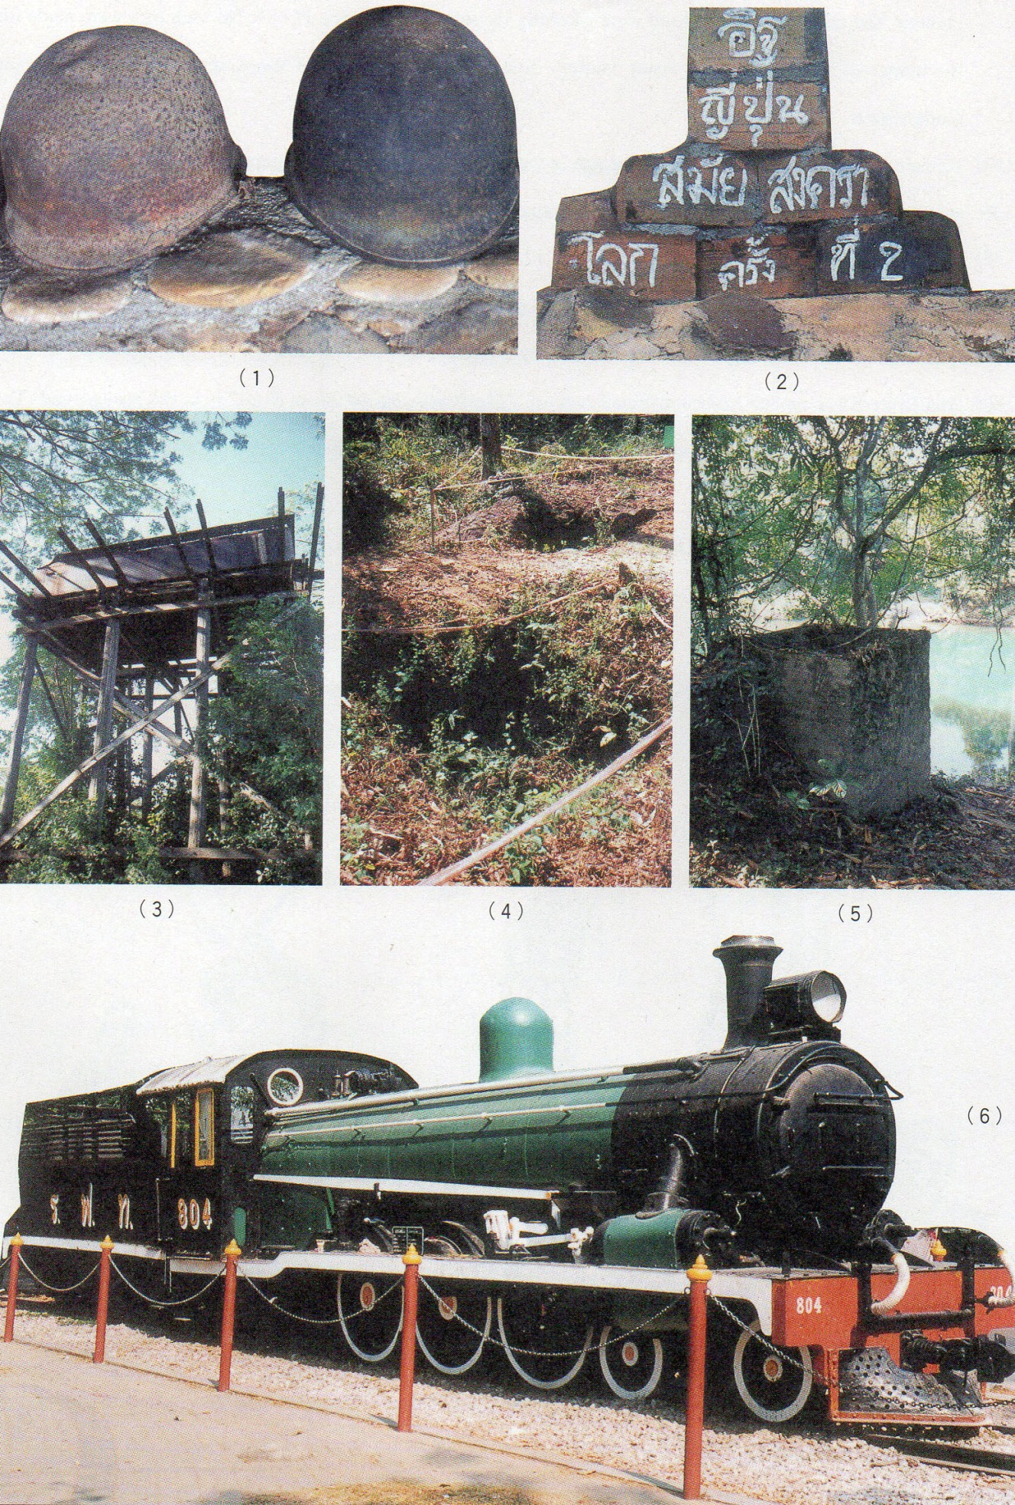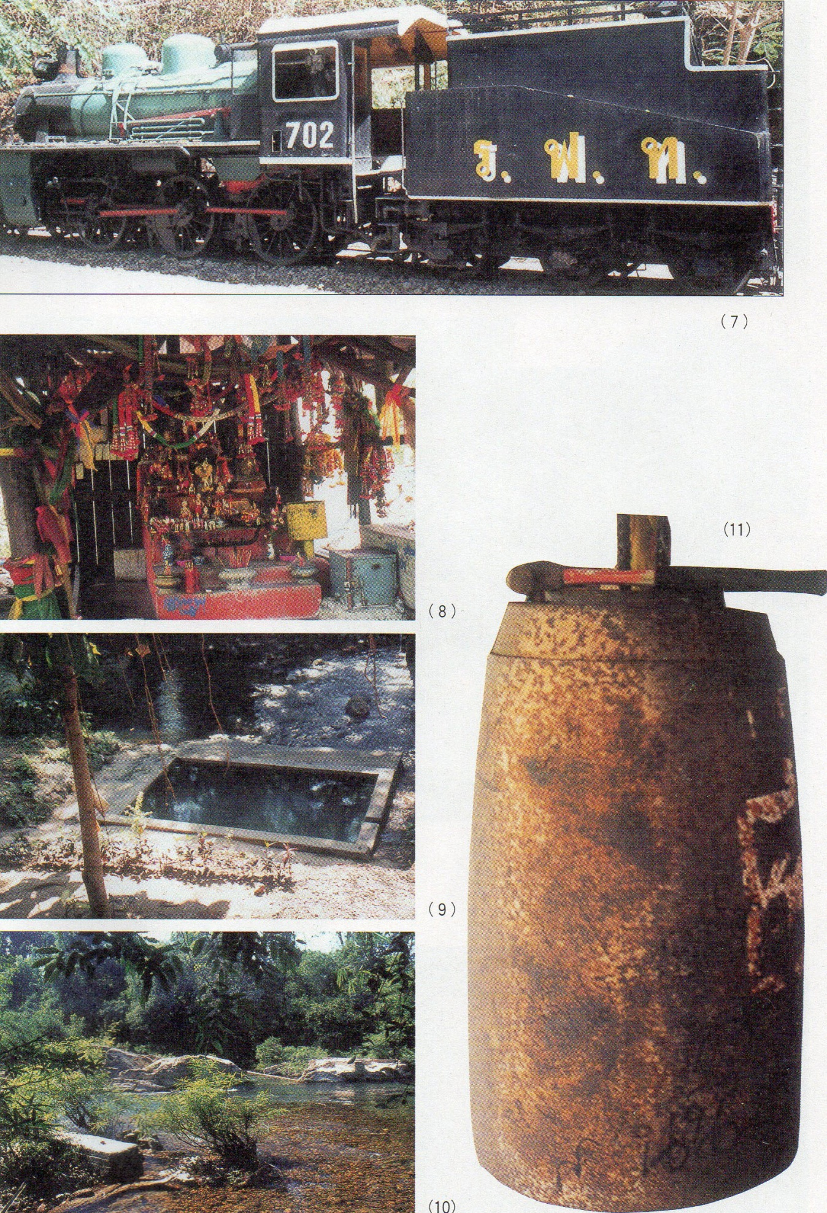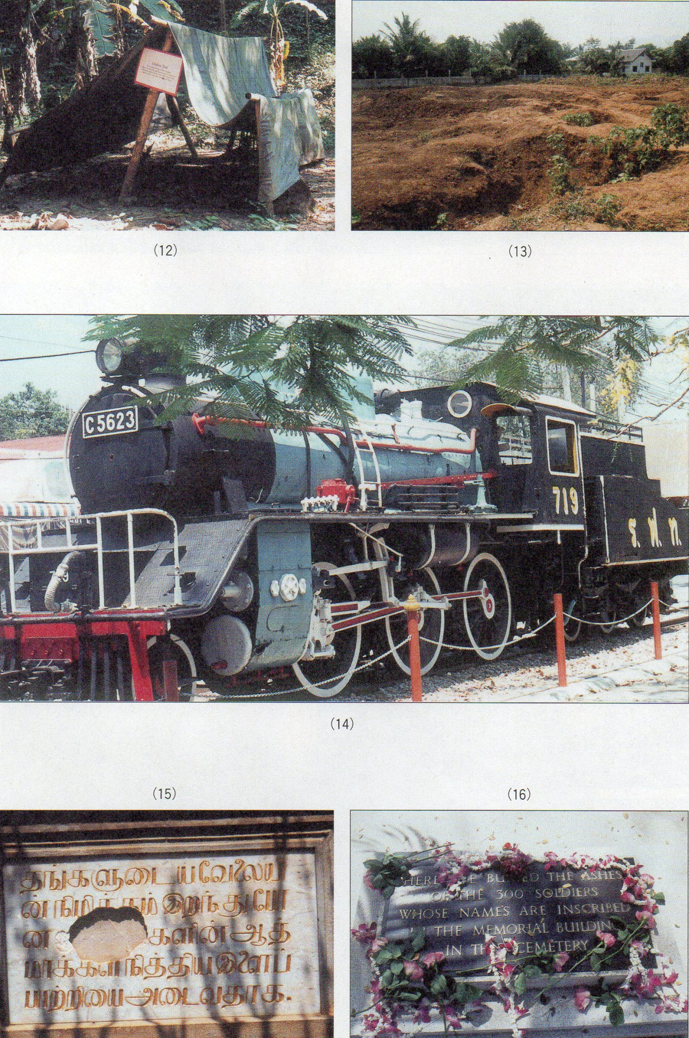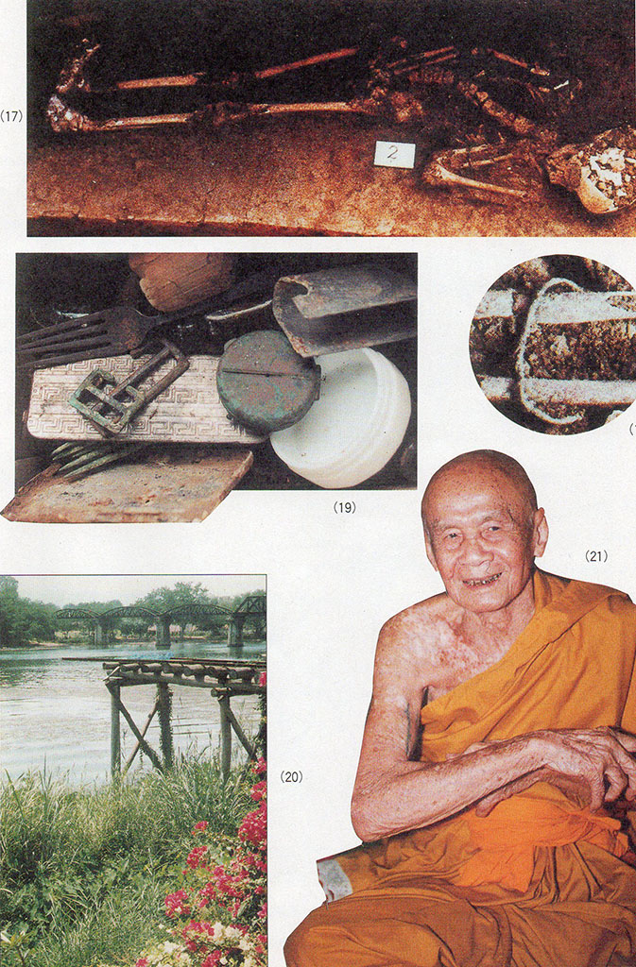

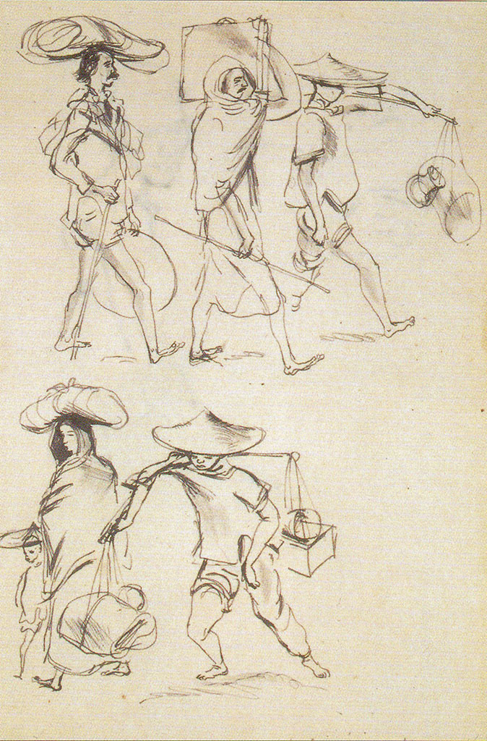

“*Natives Going Up Thailand Jungle*”; sketch Copyright of the late Ronald Searle; “*To The Kwai – And Back*” (Collins/Imperial War Museum, London, 1986); Reproduced by kind permission of the artist and the Sayle Literary Agency.

**NOTES ON THE THAI-BURMA RAILWAY   
PARE VII: INDIAN WORKERS ON THE RAILWAY**

*“The Japanese sent in a huge labour force of Tamils, who were as usual treated like atomized slaves, starved and brutalized and dying in handfuls every week. Cholera broke ot in the Tamil camp. and the Japanese railway administration found a novel way of containing the epidemic: they shot its victims.”*[1]

Former POW, Eric Lomax’s statement would seem to be no exaggeration. The conditions found among Tamil workers can be summed upby one phrase: disease (cholera, malaria, dysentery etc.), compounded by Japanese brutality. The hopelessness of the Tamils, removed from the paternalistic structures obtaining on the British-owned plantations, without any chain of command nor barely any medical attention, totally unaccustomed to looking after their own most basic hygiene needs - the hopelessness of the Tamils is beyond any exaggeration. The Tamils (along with other Malayan and Javanese labourers) were, moreover, working on the most inaccessible, and therefore most arduous. stretches of the rail course:

“While large forces of Siamese and Burmese were also engaged, these were mainly allotted to work at their respective ends of the line. The brunt of construction in the difficult central section fell on the prisoners of war and on the imported Malayan labour.” [2]

It is among the Indian and Tamil labourers that significant numbers of suicides have been recorded;

“The sick labourer was a nuisance and if unlikely to recover quickly better out of the way. Steps were in many instances taken to get him out of the way. Frequently the labourer took steps to interrupt an intolerable chain of events by absconding from camp or hospital or sometimes as a last resort by taking his own life. Total figures for suicides are not available hut evidence indicates that they were frequent.” [3]

A further repugnant feature of the Tamil camps was that many had been encouraged - perhaps expecting the same familiar paternalistic structures of their former plantation life - to bring their wives and children with them. Sketches of Asian workers by former P()Ws - such as Ronald Searle and Leo Rawlings - indicate the presence of women and children, nearly all Tamil.[4] Moreover, the 86 year-old Abbot of Wat Don Tum (temple) in Ban Pong, who had been ordained at the temple some four years before the Japanese army’s arrival, stated clearly that he saw numerous groups of dark-skinned Asiatics - clearly a reference to Tamil workers - moving through Ban Pong on their way to work further up the railway course. He attests that women frequently accompanied them. [5]

“That the Japanese authorities should have sanctioned the introduction of women and children under the conditions likely to prevail on engineering works of this nature in unopened jungle terrain indicates complete failure to appreciate the epidemiological potentialities of such a situation.” [6]

Such general observations as those of Major Campbell above, while raising serious questions, do not present the full picture of the sufferings experienced by Tamil women and children. Writing after the war, Lord Russell of Liverpool produced his *“Knights* ***of*** *Bushido: A Short History of Japanese War Crimes.”* meticulously compiled from the records of the International Military Tribunal for the Far East. In Chapter V of his work, entitled “*Life & Death on the Burma-Siam Railway*”, he mentions these women and children;

“Women and children were also tied up and exposed to the sun for several hours at a time. Many of the coolies of both sexes and of all ages were also subjected to obscene brutalities, which cannot be described here, in order to gratify the perverted sadism of their captors. The evidence given against the unit commander (of the 19th Ambulance Corps, responsible for Asian workers’ medical care), Major Kudo, at his trial included many accusations of rape and indecent assault. At his evening drinking parties many young Tamil women were forced to dance naked to please his guests who then raped them. One young woman who was outraged in this manner died a few weeks later, and her husband went out of his mind. Another member of the camp staff at Mezali, named Onodera, dragged a nineteen year old Indian girl from her tent, raped her, and after forcing a number of coolies to rape her also, committed unspeakable outrages upon her with strips of lighted bamboo. According to an eyewitness, who gave evidence at Onodera’ S trial, the wretched girl became unconscious and died that night.”[7]

The heavy monsoon rains of 1943 inevitably occasioned the outbreak of deadly diseases in the unhygienic surroundings of the Tamil labourers. Former POW doctor, Sir Edward Dunlop, writes in his diary entry for 22nd April 1943 about the arrival of the allegedly Padang Besar-bound Tamils mentioned in the previous article.

“The Tamil coolies have walked from Banpong and they report conditions in Malaya are very bad. Work is scarce; rice very scarce. They have been receiving only about eight pounds of rice a month (normally they eat one and a half pounds a day). They accepted the offer of work at Padang Besar near the border, their rate of pay to be $l.00 a day plus food, and were just a bit disconcerted when the train did not stop until Banpong. Now they are told they are marching to Burma to work. They are most wretched as they cannot stand rain and of course $1 a day here does not buy much at all. They are clad in damn all and have no bedding … some merely carry a glass bottle for water, some a small bundle. There were two women in a party of 400.... Malayan people report that they require a lot of care and die like flies of pneumonia if exposed to the wet. One offered Billy and I cigarettes. It was a sad sight to see these poor wretches trudging their way up the deep slushy mud of our road guarded by armed N (*Nip*: i.e. Japanese) troops - a wonderful tribute to the new order in Southeast Asia. A few spoke English and pathetically asked when the British were coming back to Malaya. It is reported that they spent the night in the English area next door in the open and wet. Just another of those dreary, homeless mass migrations of war along a road of sickness and death.”[8]

Later, his diary entry for 5th March, 1944 sadly notes;

“A visit from Lt-Col. A. C. Johnson...who collects butterflies and orchids assiduously; he told me that he has recently seen a good deal of Maj. Bruce Anderson...who is in a Tamil camp and who is burying about 30 Tamils a day. Now some Javanese are arriving to replace them. Tamil coolies etc. have suffered terrible casualties on the lines. ‘[9]

Military historian Clifford Kinvig also records some of the horrendous conditions of Tamil labourers as they faced the inevitable outbreaks of cholera

“While cholera cut swathes through the ranks of the Allied prisoners, its effects were even more devastating in the coolie camps. Without any understanding of the role of flies and water in the spread of the infection and lacking the support of a medical organisation such as the POWs had, the natives died in their thousands and often lay unburied where they expired. At Tarsao (Tha Sao), for instance, in a coolie camp next to the Australian officers’ battalion it was reported that 240 died in two days. At Tonchan South camp a party of officers was sent into a neighbouring coolie camp to deal with the sick and dead from the disease. Over 130 dead and dying cases, mostly Tamils, were collected and buried in a collective grave for which a large hole had been dug by prisoners from adjacent camps. A medical orderly from Konyu 2 camp later wrote, when we reached the Tamil coolie camp we could see that it was strewn with dead bodies. We were ordered to dig pits and bury the dead, while the Japs stayed at some distance outside the camp. The Tamils had succumbed to cholera.” [10]

The state of Tamil camps was invariably a source of shock to the POWs when they passed through them. Writing of Shimo Sonkurai (Lower Songkalia in Amphoe Sangkhlaburi) camp, another Australian POW writes,

“What we found was a filthy, stinking, sodden camp that had been occupied by Indian Tamils. The few huts that were there had no roofs and the so-called latrines were brimming over with water and flowing down the hill towards the camp and huge, shiny green blowflies were buzzing about.” [11]

Donald Smith. a former British POW, whose account mentions surprisingly little about his Asian labourer co-workers, does nevertheless mention in passing the Tamils,

  “The British and Dutch teams, now reinforced by press-ganged Tamil labour, were pushing on resolutely, and their vanguard had reached a place called Kinsyok (Kin Saiyoke), at least 100 miles north-west of Ban Pong.... A Tamil labourer collapsed one day in agony at Kinsyok, with a thin trickle of rice water flowing from his lips. In four hourshe was dead... The cholera germ does not die when its victim dies, but lives on virulently in the ground where the body lies buried. Only fire can kill the killer. So, while the vile epidemic raged at Kinsyok, a great bonfire of bamboo was kindled to cremate the dead.... By day and night the great fire burned on Kinsyok hill, a grim beacon for the living, a red holocaust for the dead. Returning workers saw the light from afar off, and wondered who would be the next to die. The fiery monument only mocked them in their misery.” [12]

Yet another British POW, Rohan Riven, writes in a similar vein;

“Thousands of Asiatics, mainly Tamils from Malaya, were luredup to the line with promises of high wages. Thousands of others were seized and used as conscripted labour, being guarded in concentration camps.... Cholera swept through their camps, carrying off thousands of starving men each month. British medical officers attached to Tamil camps in Siam are convinced that at least l00.000 and probably as many as 250,000 of these unfortunate people perished along the railway. They tasted to the full the benefits of Japan’s ‘*Asia for the Asiatics’* policy, getting five feet of Asia apiece. Many of them did not even receive this allowance, because the Japanese had them buried seven to a grave to conceal the full number of deaths... As thousands of men became too weak to work, the Japanese adopted increasingly barbarous methods to squeeze the last ounce from their dwindling gangs. Tamils too sick to work were driven up into the branches of trees where they had to remain, foodless and waterless, until they crashed to the ground through weakness. Others were tied up and systematically beaten, tortured with wire and fire, and exposed to every devilry that the ingenuity of the Japanese mind can invent.” [13]

The excerpts that follow below are an edited version of a compilation prepared by Major Campbell consisting of his own and his colleagues’ observations at some of the camps in which Tamil labour was involved. The report was made for the British Government.

***No.1 Jungle Camp, Kinsaiook (Kin Saiyoke), July-August 1943****.*

*1,500 fairly fresh Malayan coolies. Leaking tents. Poor hygiene... Food poor* – *small quantity rice with* 1140 *or three fresh chilies. On arrival (of members of ‘K’ force) labourers dying at rate of 20-30 daily mainly from bacillary dysentery... Epidemic malaria 2 weeks after arrival. Pneumonia prevalent....****Hintok Camp****.*

*1,500 Malayan labourers... Gross overcrowding. Hygiene* - *nil.*

*Sickness* - *colossal... During prevalence of cholera, deaths 10 to 14 daily but many never found. Cholera cases driven into jungle and abandoned.****Hintok, Another camp****.*

*1,500 Malayans. Tents bad. Hygiene very bad. Cholera isolation in tattered tents and fragments of tents spread on bamboo. Patients on ground. No ulcer at Hintok ever cured. Conditions ‘*terrible*’....****Upper Koncuita Camp, 12th August 1943 to 17th January 1944.***

*Labourers started arriving same day as medical party. Soon up to 3,00, but reckoned that 10 to 20 per cent of original strength was lost on the march to the camp. Labourers from Seremban, Kuala Lumpur, Taiping and Kuala Kangsar. A few women and children. Housing 900 to a 70-metre hut (double-tiered); that is three individuals to a metre of sleeping platform about 3 metres wide. Hygiene* - *first months none and no staff. Food poor* - *a very meagre curry. Sick coolies received one meal per day. No boiled water provided. No hospital accommodation Sickness* . *October 1943* - *labour force about 3.cKJO* - *1.200 sick daily. In August and September 50 cases cholera with 6 recoveries. Medical supplies for first six weeks negligible. Deaths: In October 1943, 382. General treatment of the labourers bad, cruel. Sick frequently’ beaten out to work without cause. Judo practiced on sick coolies.****Nike Bridge-Building Camp.***

*Observations over six months. 500 Mala yan coolies. Treatment ‘*terrible*’. Fractures from ill-treatment seen.... 20-30 suicides in six months 300 in one grave) [14]*

The report goes on to detail hospital conditions and particular incidents of cruelty experienced by the labourers.

***Canburi (Kanchanaburi) No. 2 Coolie Hospital.***

*Average 2.0(k) patients or more. At times gross overcrowding. 230 to a 40-metre hut. Some on ground. Conditions in dysentery ward and death-house indescribable. Food bad.... Major Murphy maintains that many in the wards died of thirst or starvation. Medical supplies totally inadequate.... Deaths circa 5,000 in 18 months. (This is regarded by many as an underestimate). Japanese administration bad. Complete indifference to welfare or suffering. Constant beating and maltreatment of patients for offences real or imaginary and frequent examples of gross cruelty.****Wanvei (Wan Yai) Hospital.***

*Average number of patients, 1,500. Maximum number 3,300. Hygiene initially very very bad. Food very poor* - *rice and watery vegetable stew.... September 1943* - *gross overcrowding with patients sleeping in open. September the peak month for mortality* - *600 to 700 deaths. Communal graves up to forty. Total deaths of the magnitude of 4.000 in one year. Japanese manifested very little interest. Ill-treatment of coolies fairly frequent.****Kinsaiook Hospital.***

*At first tents, later huts without sleeping platforms At times gross overcrowding. Up to 1,000 patients****.*** *Sick, evacuated from upcountry arrived sometimes in dreadful condition and with generally some dead. Food, hygiene and medical supplies bad... Deaths circa 2.000 in 15 months.****Takamoto Butai Coolie Camp at Nike, August-October 1943.***

*Conditions in this camp holding about 2,000 Malayan labourers were extremelv bad. Huts were dilapidated. There was no attempt at hygiene. Latrines disgraceful. Food ‘*dreadful*’. Morbidity, extremelv high, about 50 per cent being sick daily... Sgt. Pullen states that the burial pit was a horrible affair. It was a pit about 15 by 15 by 20 feet deep into which the naked bodies of men, women and children were thrown. He states that he has seen in the pit movement of limbs which was not due to rigor mortis.****Timonta Coolie Hospital, January-February 1944.***

*A 2nd class Japanese private with a 5-star Japanese did “*a fair amount of killing off of sick*” immediately prior to the evacuation of the hospital on 16th February 1944. Various types of injections were given to numbers of sick labourers* - *injection of air into vein, a mercuric salt intravenously, overdoses of morphia* - *causing many deaths. There were 35 or 40 deaths in the nine days preceding evacuation, a very considerable increase on the rate previously...*

***No.2 Labourer Hospital, Canburi.***

*A number of coolies who absconded .from the hospital were brought back and were given an intravenous injection by the M.O. (Medical Orderly), Takana. They were then sent to the wards and all who had been given injections died in considerable agony. Many showed signs of an extreme ulcerative stomatitis, while two, reported by Capt. Lennox, had suppression of the urine. The opinion of the Medical Officers who saw the cases was that they had received a mercuric salt intravenously.****Nike Bridge-building Butai (possibly Osaka Tai).***

*Conditions in this working camp are stated to have been appalling. Deaths over six months were given as 2.000 whereas the average number of labourers maintained (by constant immigration) was in the neighbourhood of 500. 20-30 suicides in the period. The treatment of the coolies was brutal, and fractures resulting from violence were seen.... When the Butai was moving, a yen’ sick coolie was taken by a Japanese sergeant of this Butai to the edge of the communal burial pit, hit over the head twice with a shovel and buried....****No.2 Coolie Hospital, Canburi****.*

*Coolies were punished for absconding by being kept standing for several hours with weights tied to the penis....****Kinsaiook Hospital.***

*An Indian labourer suffering from cerebral malaria was kicked in the face by a Japanese private, in course of periodic evacuations* of *sick. All except a few completely helpless patients were made to walk (or crawl) to the station, a distance of three or four kilometres.****Nike Coolie Camp....***

*A coolie suspected of theft was tied to a tree, flogged and struck over genitals. Another form of punishment witnessed was the bringing of lighted bamboo into contact with body and face producing burns.****Koncuita Camp****.*

*About August 1943,Pvte. B. Cussens... reports that 50 to 60 cholera suspects were each given a large dose of morphia by a Japanese corporal and the following morning survivors were given a cup of saturated potassium permanganate. All died. [15]*

It is perhaps astonishing that, despite the unspeakable conditions detailed above, the Tamil labouring community managed to cling to a sense of humanity manifested in their preserving of their cultural traditions deep in the Thai jungles. But such, indeed, appears to have been the case, as witnessed in the 26th August 1943 entry of Sir Edward Dunlop’s diary;

“Other celebrations about the place included the Tamils who were celebrating the coming of age of two young boys. After much beating of drums etc. they appeared to go into a hypnotic trance and had to be revived by buckets of water. Then one of them forced a piece of iron through his tongue, seemingly without pain or blood, and led a wild procession around the camp, running, yelling and beating tomtoms. Muhammadans (presumably either Malay or Javanese workers) were also said to be celebrating Ramadan. We alone seemed to have nothing to celebrate.” [16]

One important item from Major Campbell’s list of atrocities has yet to be mentioned.

“***Hygiene Unit at Nike, November 1943.***

*In Nike Coolie camp all cholera and dysentery cases were driven about a kilometre into the jungle and there segregated in a hut under Japanese guard. Many were seriously ill*.” [17]

Quite recently, evidence of what had happened at the Nike camps turned up in a particularly startling fashion. Born in 1909 and educated at St. Joseph’s Institution and Raffles Institution, Tan Choon Keng had several years of medical training when war disrupted the lives of the people of Singapore. He volunteered to work as a paramedical official on one of the groups that the Japanese were organising from among the medical orderlies held as POWs in Changi prison and others suitably qualified among the civilian population. These groups were dispatched to Thailand in order to provide relief from the unsanitary conditions facing the Asian workers on the Railway. At 90 years of age, Tan Choon Keng was interviewed by historian Goh Chor Boon, Professor at Nanyang Technical University. Tan’s story was published by Dr. Goh under the title, *“Living Hell: Story of a WWII Survivor at the Death Railway”.*  According to his account, Tan Choon Keng was sent to Nike where he was told that “*as many as 6,000 labourers had been admitted to the hospital in Nike, mainly struck down by cholera and dysentery. It was estimated that 1,750 had died.*” The following is Dr. Goh’s summary of this part of his interviews, including direct quotations from Tan Choon Keng himself (Tan is referred to by his initials, C.K., throughout the book).

“One night, CK (Choon Keng) was asked to report to Dr Kono, the medical officer. In CK’s opinion, the captain was not totally a typical Japanese soldier who thrived on sadistic practices. He was a reasonable man who had the welfare of his subordinates, including the civilian hospital assistants under his charge, at heart.

‘*Take these cans to the workers’ quarters*,’ ordered Kono.

There were about 10 large canisters in the room. CK was curious. What could be in the cans? As he moved towards them, it dawned upon him that these were oil canisters. Instantly, unspoken fear raced through his mind and body. His worst fear was confirmed when Kono’s dreadful words came sprouting out from his mouth;

*‘Pour on the building and beds and set fire!’*

CK was shell-shocked.

‘*My body turned cold,*’ he recalls pensively. For the first time the usual and spontaneous ‘*Yes, Sir!*’ was not there.

‘*But, Sir,… these people are still alive,*’ he retorted, knowing full well that he would face punishment for going against orders.

There were nearly 250 Indian (Tamils) and Javanese men, women and children cooped up in the 60- metre long hut. The women and children had followed their husbands and fathers to this god-forsaken place to work on the railway... For those in the hut, one thing was in common too. Their nails were all bluish-black, sign of impending doom. Unlike the prisoners (of war) who had their own medical doctors, the Asian labourers were simply left to die. Because of their strength, the *romusha* (forced labourers) were treated more like machines, totally replaceable and dispensable. Their only epidemic control was to throw the sick on the fire. The Japanese did not allow funeral services for dead *romusha*. Itwould be too time consuming...

‘*Are you sure? Can something else be done?*’ CK pleaded.

Much to his surprise, the medical officer remained calm and even spoke softly:

‘*CK, you listen to me. These people are dying, nothing can be done*.’

Reluctant, CK called his men who, as expected, questioned him on the decision.

‘*Look boys, just follow the order, OK?*’

They silently put on rubber boots and lugged the 10 buckets of black oil. Those steps leading to the *romusha* quarters seemed to take an eternity. No words were spoken amongst the 10 men, each carrying the black liquid. They poured it on the roof and the external structure. Inside the attap hut, they spread out and spilled the oil all over the beds but not on the bodies of the poor souls. Some of the labourers attempted to dart away but they were simply too weak to move an inch. CK could not remember what went through his mind then. His mental faculty was frozen at that moment of anguish.   
 *‘We poured the crude oil all over the roof, the wooden walls and the sleeping planks. We did the job very quickly. I dared not look into their eyes. I only beard some whispering ‘tolong, tolong’ (help, help!). It was the most pitiful sight. God forgive me. I was not happy to see them being burnt alive. All Asian labourers, with their wives and children. They could not walk, all their nails blackened. As the fire engulfed the hut I could not hear them crying out because of the loud crackling noise from the burning wood. The heat was very intense and we ran and ran. After this incident, I used to say to myself: Is there a God on earth? If there were a God he would not allow all this to happen.’*

He could not also remember who had lit the flame of doom but was quite sure that the person was not one of them. All he knew was that he and his men ran as hard as they could - for more than 150 metres towards their own quarters - not daring to turn back to witness their act of inhumanity. They kept running and running. What could they do? It was well into the night. CK and his men occasionally glanced towards the direction of the inferno. Itwas still ‘*daylight*’ there and the smell of burning wood and human flesh simply refused to be lifted. It remained as a pall over the dead and served as a pricking reminder to CK and his men of their hideous task.”[18]

Writing of his experiences in captivity immediately after the war in 1946, John Coast summarised the plight of Asian and Tamil workers in vivid terms,

“The Nips regarded their fellow Asiatics as machines pure and simple, and utterly failed to regard them as men - human beings. Consequently, when, as was inevitable, cholera hit the camp after only a few days, the Nips forbade our medical officer to waste time on them. Their way of thinking was that the Tamil who got cholera would die, therefore don’t bother with him; let him die: but just try to keep enough of them till the railway was through in that sector... A normal way of disposing of Tamil corpses was to sling them in the flooded river, but as anyone between 200 and 240K (kilometre distances along the railway course) can witness, they were generally left out in the open to die, sitting or lying in pools of their own excrement, covered with countless infected flies and bluebottles. One corpse propped up against a tree, was picked clean to the skeleton in 48 hours by ants, rats and other creatures, and there the skeleton still sat, just as the man had died. On another occasion, when they were still shallowly burying the bodies, a gruesome hand was left sticking out above the ground. There was no earthly devilry and suffering these people did not experience.”[19]

Perhaps, as a final and most pertinent observation, the remarks of former prisoner, C.H. Lee, made at Tonchan Camp, deserve serious reflection. Lee had himself been a rubber planter in Malaya in the pre-war years and had witnessed the sad plight of the Tamil workers on the Railway.

“Little has been said of the fate of these men (the Tamils), all of whom enjoyed, or thought they enjoyed, British protection in Malaya.... We had the protection of our officers and doctors; they had nothing but the tender mercies of the Nipponese.” [20]

THE AFTERMATH

Little was done after the war to recompense the Tamil community for the sufferings it had experienced. There are indications, however, that some few people at least were seriously concerned about the Tamil experience on the Railway;

“When the war ended and the scale of the distress could be appreciated, public and private bodies moved in to help. Voluntary welfare agencies reconstituted the Indian orphanages in Penang to which many of the destitute children were consigned. By 1947 the (British Malayan) Government had arranged to distribute a grant of *$1.5* million to the widows and dependants produced by the railway tragedy: this was a sum greater than the whole of its entire annual social welfare budget.” [21]

Charles Gamba had also noted that in 1946 ‘*there were 5,591 widows. 6.795 children whose mothers were still living and 2,324 orphans*.” [22] But possibly the most important indirect result of the Japanese occupation was the increasing politicisation of the Malayan Tamil community. This was stressed in Ramasamy’s study, but even so, little financial compensation was ever forthcoming.

“Even after the war, the hardship suffered by the families of the labourers as a result of the forced recruitment to Thailand was constantly highlighted by the trade unions under the influence of the PMFTU (Pan Malayan Federation of Trade Unions), a labour affiliate of the MCP (Malayan Communist Party). Among the demands that were put forward by the unions was compensation to be paid to the families of the labourers who had died in Siam. To those Indians who experienced the Occupation period, the forced recruitment of Indian labourers to Siam has been a sore point. Some of the persons who were interviewed felt that the Japanese Government should provide financial compensation for those families who had suffered. They were also unhappy that the Malaysian Government had been silent on the issue. Even the South Indian Labour Fund, established during the colonial period, has not been utilized for the benefit and welfare of those families who suffered as a result of the forced recruitment”.[23]

The Congress Party of India did send a medical mission to Malaya to consider measures to relieve the distress. Its official report on the mission carries the dedication, “*In Memory of One Hundred Thousand Malayan Indian Victims of the Siam Death Railway*.” [24] But the spirits of the Indian dead have hardly rested peacefully. “*Grisly Find: Mass Grave Unearthed*” were the headlines of the *Bangkok Post’s* 18th November 1990 edition which announced the discovery of some 400 labourers’ bones in Kanchanaburi. The find was allegedly occasioned by recurring troublesome dreams experienced by Sompong Chawangal, a local bike shop proprietor. The latter contacted a nearby teacher and owner of the two-acre plot of sugar-cane held near his residence, Ananya Watanayaem, who said he had earlier come across skeletons when ploughing his field. [25]

“Ananya’s elder sister, Lek Pailom, then 75 years of age,   
recalled that when she was about 20 years old, field hospitals for sick Indian, Malayan and Singaporean prisoners of war or slave workers were located on a large piece of land where the Kanchanaburi provincial hall and business area are now located. ‘Every morning the Indians dug a hole in this area to bury dead bodies in the evening. The bodies were simply thrown into the pit and covered with dirt. Some days, 2 or 3 bodies were buried; some days more than 5”. [26]

A Chinese organisation was called in to investigate the grave and re-inter the bones in an appropriate manner to placate and enable the release of the angry spirits. [27] Concerned at the haphazard and hardly professional nature of the excavations, the Thai Government’s Fine Arts Department appointed the Director of nearby Muang Singh Historical Park, Sathapon Khwanyun, to take over and supervise the site. The latter published a full report of his findings in the *“Sinlapa Wathanatham”* (Art & Culture) magazine’s February 1991 issue. The report stresses that this was by no means the first time that such graves had been unearthed in the area: such discoveries had been a common occurrence and usually the excavated bones had been quietly cremated by such (Chinese) spiritual organisations as the *Jin Siang Tung*. The full extent of the burial site may never be known as the owners of nearby properties did not want their own land disturbed. Excavations established beyond doubt that the bodies were those of Asian labourers, most probably Indian, and that not inconsiderable numbers of women and children were among the victims. Information was also gathered from the local community. Maj. Ruanisak Chaigomin stated that the Japanese had referred to the victims as *“kulito”* (possibly derived from the English word, *“coolie“),* the term they invariably used for Asian labourers. Mrs. Urai Bosap (65 years of age) stated,

“They made a huge pit for the burials. After a few bodies had been tossed in, they would add white lime (to avert unpleasant odours) before piling in further layers of the dead. The grave was finally covered with earth. The people were all very dark-skinned and must have been Indians.” [28]

A later report again carried an interview with Lek Pailom, who talked of the 1943 cholera epidemic;

“Lek Pailom... had been 28 in 1943.... and remembered that hundreds of Malayans and Indians had been held during the war in a slave camp located on the land where the remains were found... *‘I saw Japanese soldiers digging huge graves into which bodies were dumped. Some were sick but still alive’*.” [29]

Micool Brooke, then a *Bangkok Post* journalist, visited the site in the very early stages of excavation,

“The excavated hole measured about 20 metres square and was located in a sugar cane held about half an acre in size.... I approached the edge of the grave, unknowing what I expected to see. And yet I also felt a strong sense of embarrassed shame at intruding upon the sorrow-covered grave. And sorrow and remorse did overwhelm me when I looked down and saw hundreds of skeletons pressed together, their arms reaching out. They had tried to crawl out of the grave before they finally suffocated to death.” [30]

THE JAPANESE MILITARY MEMORIAL TO THE RAILWAY

Upon completion of the railway on October 17th 1943, the Japanese military authorities determined to erect a memorial to the many people who had lost their lives during the railway’s construction. This unusual monument still survives today, at Tha Makham, some 100 meters downstream from the famous bridge. Artistically, it is hardly a particularly attractive monument**,** being a cenotaph-type structure made of the rough concrete that had sufficed for the railway s construction. Usually unvisited and ignored by the regular tourists to Kanchanaburi, this monument is nevertheless of considerable significance and importance in memorializing the tragedy of the railway.

Forming the four corners of a square at some 10 meters distance from the cenotaph itself, are four wall-like structures, bearing memorial plaques of marble inscribed in the languages of those who had lost their lives in building the railway.[31] One corner structure (two tablets) records a poem in classical Chinese (a literary form known as *kanshi* in Japanese). At another corner, inscriptions appear in both Vietnamese [32] and the peculiar *“reformed”* Thai script in use during the era of Thai Prime Minister Plaek Phibunsongkhram. The third corner structure was bombed during an Allied air raid on the bridge, after which only the English language tablet memorializing the Western prisoners of war (POWs) was restored. (The second, now missing tablet possibly contained an inscription in Burmese). The final corner bears memorial inscriptions in the Indonesian/Malaysian [33] and Tamil languages. A further Japanese language inscription on the rear of the cenotaph itself mentions the deaths of Japanese military personnel. It might perhaps seem somewhat out of character for the Japanese military to erect monuments to the victims of its own brutality or mismanagement and, as early as 1944, even admitting that people had died at all, especially in the somewhat mundane task of building a railway! However, the memorial’s importance lies in the fact that so many Asian languages appear; this has given the Japanese army’s wartime memorial the distinction of being the *only* monument of the war era in the Kanchanaburi area to recognize the existence and enormous sufferings of the Asian labourers. [34] Those involved in the railway’s construction hold widely differing opinions about the validity of the monument. Opinions expressed by former Allied soldiers (POW5) have been fairly negative, with some notable exceptions. Comelis Evers, a former Dutch POW, writes of the railway’s completion in his own account, ***“****Death Railway”.*

“A holiday was declared for October 25 (1943) and on that day a gaily festooned train arrived at the camp, which unloaded extra rations for the Japanese troops and even some for the prisoners. All the Japanese and Koreans who had collaborated on the construction of the track received a medal. And we learned that a memorial to the Allied troops who had ‘contributed’ to it, was going to be erected near the bridge on the River Kwai. This did not interest us very much at the tune. It was only after the war when we came face to face with the monument that the cynicism of the Japanese in commemorating those whomthey had drive, mercilessly and callously, to their deaths, struck us in full force.” [35]

Eric Lomax, the former British POW whose account has been frequently mentioned in previous articles, points out that the monument has often been defaced by stones thrown by former Allied prisoners visiting Kanchanaburi, such is the hatred that they still bear towards Japan as a result of their cruel treatment.

“The Japanese War Memorial which POWs were forced to build some time in1944, is a sadder and more neglected place. A cenotaph now showing blotches of weather and stress was erectedin a compound surrounded by low trees: it is ill-kept and deserted. The cenotaph incorporates plaques to the dead of other countries, like an afterthought. Some ex-POWs, who can never forgive, throw stones at the memorial when they come here: the scars are visible on the stained concrete.” [36]

The projectiles thrown by visitors have done rather greater damage than Lomax indicates. Several of the inscriptions on the marble tablets have also been defaced. Although damage to the Malaysian/Indonesian language inscription was repaired by the Japanese Association, that of the Tamil language still renders a part of the text illegible. Former Japanese *Kempeitai* (Military Police) official, Nagase Takashi, is more specific;

“It is true that there is a memorial tower which was built by the Japanese Arm But there are very few visitors partly because of the difference in religion of the Thai. It has even become the object of hatred from the ex-prisoners who visited the Kwai. They throw stones at the memorial, (and) pull out flowers offered, candles and incense sticks to stamp on. The ex-POWs still have deep-seated resentment towards the Japanese. In the construction of the tower the British POWs were made to design it and carry cement for it. They still say in anger. ‘*Why did we, the victims, have to build the memorial tower for our own comrades?*’.” [37]

  Opinions about the annual memorial services held at the site by the Japanese army also differ considerably, depending on a prisoner’s perspective and memories. A particularly negative impression was recorded by Rohan Rivett.

“On arrival at Tamarkan (Tha Makham) we found a gang of British captives engaged in building a memorial to those who had died on the railway. The Japanese chose a point midway between the camp and the Tamarkan bridge across the river for this memorial, which had commemorative tablets at its four corners and a tall cenotaph in the center. On 21st March Brigadier Varley, together with a selected number of officers and men, has marched over to the memorial to witness the opening service. Representatives of the various native races and sects employed on the railroad were present, while gold-braided officers of the Thai army, navy and air force sat with the Japanese officers under a specially erected marquee. The Japanese, sublimely unconscious of the irony of things, decked out the whole memorial as if for a harvest festival, the cenotaph and oblation stone before it being covered with many types of the fruit and vegetables for lack of which the prisoners had died. While newsreel photographers filmed us from every angle, various Asiatic representatives delivered speeches which were received with absolute apathy by the natives present, who looked as if they had been shanghaied into attendance. The Japanese and Thai officers fidgeted and looked grim and bored throughout the whole ceremony. Finally, Brigadier Varley read out a statement emphasizing that the conditions under which prisoners had worked would be investigated after the war. The entire ceremony was an insult to God and man, carried through with a blatant hypocrisy and a lack of sincerity which no Japanese took the trouble to conceal. At the end, they lined us all up black, white, yellow and brown, and solemnly presented each person with a tin of biscuits - a gesture apparently meant to suggest that all was now forgiven and forgotten. I have never been present at a .function so patently meaningless to everybody concerned. Prisoners and Asiatics alike, knowing the Japanese by bitter experience, knew that this was merely a gesture required by the demands of face. The only real point of interest was that on the memorial the Japanese admitted 76.000 deaths among the fellow Asiatics whom they were ‘*redeemin*g *from Anglo-Saxon bondage*.” [38]

It would be interesting to know the opinions of the *“representatives of the various native races and sects”* but, needless to say, none of these were ever recorded. A rather different view of the same ceremony is, however, provided by Sir Edward Dunlopin his 12th March 1944 diary entry;

“Up betimes and on parade and ready to go to Takanoon. There is a most impressive monument tothose who have lost their lives in making the Thailand/Burma Railway. **A** party to attend consists of 20 British, 10 Dutch, 10 Australians and we were told to send well-dressed soldiers! This we did by free borrowing. We marched across between two rivers almost two miles to the monument - atall, substantial cenotaph of concrete with some marble slabs for inscription set in a square of approximately 20 metres with four right-angled corner bastions of stone and cement, each inscribed on the inner side with languages of the people concerned: Nipponese, Thai, Hindu, Malay etc. The English caption read, ‘*May they rest in peace,’* which indeed they deserve. The monument was adorned with fruits and vegetables, bottles of *saki* (sake), lampangs of tobacco and such good things. A table in front with a white cloth had upon it a brass urn in which three sticks smoked. Also some candles. We were drawn up before the monument with a hollow square arrangement, an N (Nipponese. i.e. Japanese) general and higher staff officers on the left; Many other N of high rank and many Thai officials and higher service officers on the right. In the center were the various native groups to the right, the British, American, Dutch and Australians on the left; a N priest, a 2-star private with bayonet at side, did most of the initial ceremony which was complicated and impressive. The N general then approached and read a scroll with his message and this was interpreted in several languages. Thai officials and many Japanese officers paid their respects then any religious persons approached the monument, paving their respects and reading scrolls. Brigadier Varley also read a scroll after advancing and saluting the cenotaph. ‘*They shall grow not old as we that are left grow old. In the morning and at the going down of the stat, we will remember them*’. Many pictures were taken, including cine films. Huge numbers of colourful wreaths were grouped about the central cenotaph. It was extremelyhot and this interesting ceremony took about two hours. I wish 1 understood more of it. Afterwards, all men were given a tin of biscuits and allowed to go to the Tamarkan camp for lunch.” [39]

After the war’s end, the monument’s maintenance passed from the (now defeated) Japanese Imperial Army to the Japanese Association of Thailand, an independent group run by Japanese residents to address the various needs of the substantial community of Japanese residing within the kingdom. Some years ago, the same association actually purchased the title to the land on which the monument stands, to prevent it from being appropriated by and incorporated within the neighbouring dubious “war museum” near the bridge, mentioned above. [40] The same association has continued to hold an annual memorial service for the railway’s victims every March. The Japanese Shingon priest who, re-ordained according to Thai Theravada Buddhist rites, is the resident monk at the Japanese Ossuary located in Bangkok’s Wat Liab Templecustomarily leads the service. The solemn prayers and sutras recited at the service make ample and clear reference to both the Western and Asian victims.

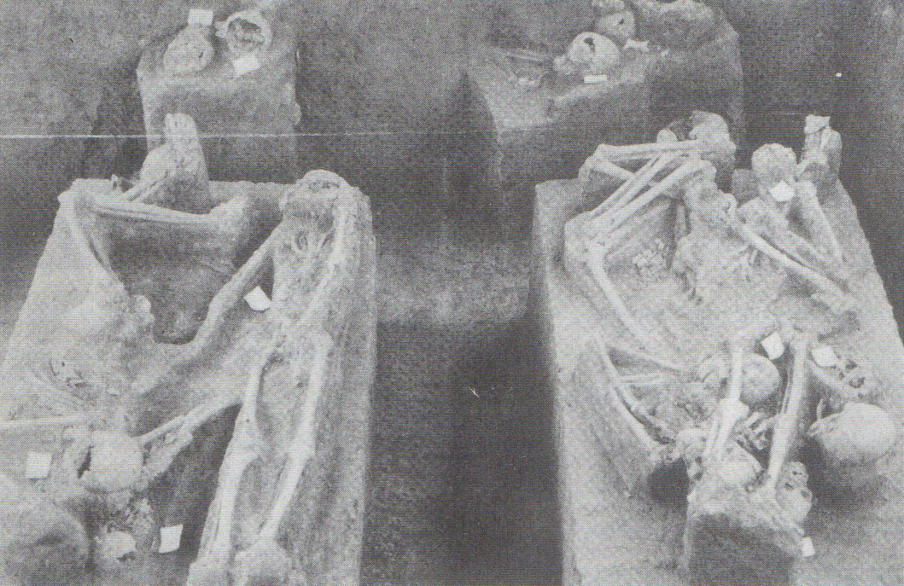

Skeletons of Tamil labourers still lie in their grave after excavation in Kanchanaburi in 1990. Photo: Copyright of *Sinlapa Wathanatham Magazine* (Art & Culture Magazine); Vol.12. No.4; (February, 1991); reproduced bykind permission of Ms. MukhomWongthes and the Editorial Board of *Sinlapa Wathanatham Magazine.*

I am deeply grateful to former British prisoner of war, Mr. Ronald Searle, for permission to reproduce his sketches of Tamil workers, and also to both Ms. Camilla Roberts of the Sayle Literary Agency and Mr. Robert Suddaby, Keeper of the Department of Documents at the Imperial War Museum, for assisting in obtaining this permission. Likewise, I am indebted to Ms. Mukhom Wongthes for arranging permission to use photos from the Thai magazine, *Sinlapa Wathanatham*, (Art & Culture Magazine). Appropriate copyright line   
acknowledgements appear with the reproductions. Needless to say, the above-mentioned persons are in no way responsible for the contents or opinions expressed in the text. Responsibility for any shortcomings rests with the author alone.

1. Eric Lomax: “*The Railway Man*” **(W.W.** Norton, 1995); p. 149.
2. Major R. Campbell: “*Report on Use of Malayan Labourers on Thailand-Burma Railway*”, Report to the Under Secretary of State, Colonial Ollie, dated 25th November, 1945; (Public Records Office document *C027316781I);* p.8. This important report was acknowledged in the previous article (“*Part VI: The Background to Indian Labour in Southeast Asia*”; Journal of Kyoto Seika University, No. 24; note 12. p. 33). I am indebted to RodBeattie, Supervisor of the Commonwealth War Graves Commission’s Kanchanaburi cemeteries, for obtaining a copy of this invaluable document on a recent visit to London.
3. Major R. Campbell: op.cit; p. 20.
4. See “Notes on the Thai-Burma Railway: Part II: Asian Romusha; The Silenced Voices of History” (Journal of Kyoto Seika University; No. 20, 2001). The sketches appear in Ronald Searle: “To the Kwai - And Back; War   
   Drawings. 1939-1945” (Collins & The Imperial War Museum, 1986); p.116, and Leo Rawlings: “And The Dawn Came Up Like Thunder (Rawlings Chapman Publications, 1972); p. 86.
5. Interview with the Abbot of Wat Don Tum Temple, Ban Pong, conducted with the assistance of Dr. Chamvit Kasetsiri, former Rector of Thammasat University; July 13th 2002. The Abbot repeatedly used the word *“khaek’* usually denoting a person of Indian origin. Although the word can also be applied to persons from Africa, the Middle East, Indonesians and even Malays, his insistence that the workers he had observed were “*dark-skinned*” leaves little room for doubt that, in the context of the Thai-Burma Railway, he was referring to Tamil women in the workers’ lines.   
   
6. Major R. Campbell; op.cit; p. 9.
7. Lord Russell of Liverpool: “*The Knights of Bushido: A Short history of Japanese War Crimes*” (Greenhill Books, 1958); p. 93.
8. Sir Edward Dunlop: “*The War Diaries of Weary Dunlop: Japan and the Burma-Thailand Railway, 1942-1945*” (Penguin, Australia, 1990); p. 244.
9. Sir Edward Dunlop: op.cit; p. 383.
10. Clifford Kinvig: “*The River Kwai Railway; The Story of the Burma-Siam Railway*” (Brassey’s, 1992); p. 135. The details from Tonchan South Camp were taken from T.H. Newey: “Report on H Force” (unpublished manuscript. Imperial War Museum): p1. The quotation is from E.S. Benford: “*The Rising Sun On My Back*” (privately printed, Imperial War Museum).
11. Tim Bowden: “*Changi Photographer; George Aspinall’ s Record of Captivity*” (ABC Enterprises & William Collins Pty. Ltd., Sydney, 1984); p. 114.   
    
12. Donald Smith: “*And All The Trumpets*” (Geoffrey l3les. London. 1954); pp. 122-125.
13. Rohan D. Rivett: “*Behind Bamboo: An Inside Story of the Japanese Prison Camps*” (Angus & Robertson, London, 1946); pp. 266-267.
14. Major R. Campbell: op.cit; pp. 13-14.
15. Major R. Campbell: op.cit; pp. 19-20 & 23-25.
16. Sir Edward Dunlop: op.cit; p. 319.
17. Major R. Campbell: op.cit; p. 26.
18. Goh Chor Boon: “Living Hell: Story of a WWII Survivor at the Death Railway” (Asiapac Books, Singapore, 1999); pp. 80-84.
19. John Coast: “Railroad of Death’ (The Commodore Press, London, 1946); pp. 140-148.   
    
20. C.H. Lee: Untitled Manuscript (Imperial War Museum); p. 28; quoted in Clifford Kinvig: op.cit; p. 130.   
    
21. Clifford Kinvig: op.cit; p. 201. In a footnote. Kinvig credits F.S.V. Donnison: “*British Military Administration in the Far East, 1943-46*” (HMSO (Her Majesty’s Stationery Office), London, 1956); PP. 281-286. Donnison also notes. “*It was difficult for workers impressed from Malaya to make their own way home, for, in their case, the journey was much longer and more difficult... A group of ex-prisoners of war which had volunteered to slay and care for these workers, and to repatriate them, found some 35,000 still on the railway. These were mostly Tamils taken off the estates in Malaya, but there were also Chinese, Malays and a number of Javanese.*” (F.S.V. Donnison: op.cit; p.280).
22. Charles Gamba: “*The Origins of Trade Unionism in Malaya: A Study in Colonial Labour Unrest’* (Eastern Universities Press, Singapore, 1962); note 70, pp. 32-33. Gamba cites as his source United Planters Association of Malaya **(**UPAM**:** “*Circular to Members; No.* ***5,*** *Item 6 (iii) of Proceedings of Meeting Held on April 26th 1946*” (Kuala Lumpur).
23. P. Ramasamy: “Indian War Memory in Malaysia” in P. Lim Pui Huen & Diana Wong (eds.): “*War and Memory in Malaysia and Singapore”* (Institute of Southeast Asian Studies, Singapore, 2000); p. 94. The same author notes that the demands for compensation to be paid to families of labourers who had died in Siam was made by striking workers of the Sagil Estate in Johor in May, 1947; See P. Ramasamy: “*Plantation Labour, Unions, Capital & the State in Peninsular Malaysia*” (Oxford University Press, 1994); p. 74.
24. C.S.R. Sastri: “*Congress Mission to Malaya*” (Tenali, 1947; quoted in Clifford Kinvig: op. cit; p.202.

   
25. Micool Brooke: “*Captive of the River Kwai*” (Merman Books, Bangkok, 1995); p.105. Brooke renders Sompong’s surname as Charoenchai. I have referred to him as Chawangai, following a literal transcription of the Thai letters found in *Sinlapa Wathanatham* (Art & Culture) Magazine (See Note 28 below).
26. “*Bangkok Post*”; 18th November, 1990.
27. The *Sinlapa Wathanatham* report lists the organisation’s Chinese name as “*Jin Siang Tung*” (See Note 28 below).
28. Sathapon Khwanyun: “*A Newly Discovered World War II Graveyard in Kanchanaburi*” (in Thai): *Sinlapa Wathanatham* (Art & Culture) Magazine, Vol. 12; No.4, February 1991; pp. 90-102. Urai Bosap uses both the word, *”Indian”,* as well as the Thai word, *“khaek”;* (see Note ***5*** above), when referring to the victims. I am indebted to Thanawalai Jaroenjandang for translation assistance.   
    
29. Micool Brooke: op.cit; p.105.
30. Micool Brooke: op.cit; p.107.
31. One western POV account states that themarble slabs had been obtained by forcibly confiscating marble tables (a common Sino-Thai itemof furniture) from the local Chinese community, but I have regrettably been unable to locate the description in question.   
    
32. The Vietnamese language inscription reads, *“A memorial to the spirits of those Vietnamese labourers (lit. Romusha) who died constructing the Thai-Burma Railway”*
33. The national languages of both Indonesia and Malaysia *(Bahasa Indonesia* and *Bahasa Malaysia* respectively) are the same, the language of Sumatra having been selected as independent Indonesia’s national language, rather than Javanese, the language of the majority of the population. The language of Sumatra and that of the Malayan Peninsula, being populated by essentially the same peoples, was, to all intents and purposes, identical. The inscription reads. ***“****Paying our respects to the souls of Moslems who worked her; Allah rewards you.”* Translation by Murai Yoshinori from his article *“Asian Forced Labour (romusha) on the Burma-Thailand Railway”* in Gavan McCormack & Hank Nelson (eds.): *“The Burma-Thailand Railway”* (Silkworm Books,1993); p.61.   
    
34. More recent serious museum displays, especially those of the Australian Government’s Hellfire Pass Memorial Museum and the Thai-Burma Railway Center’s museum in Kanchanaburi itself, devote considerable display space in their exhibits to introducing the horrific situation faced by the Asian labourers. Another less reputable “*war*” museum, run by local business interests and conveniently located by the side of the famous bridge to attract as many tourists as possible, contains a rather distasteful memorial to Asian workers, displaying actual skeletons and bones, questionably obtained from the excavation of mass graves in Kanchanaburi. Further details about this somewhat controversial museum will appear in future articles.
35. Cornelis B. Evers: *“Death Railway”* (Craftsman Press, Bangkok); p.60.
36. Eric Lomax: *“The Railway Man’* (W.W. Norton, 1995); p.268.
37. Nagase Takashi: ***“****Crosses and Tigers****”*** (Post Publishing Co., Bangkok, 1990); p.70.
38. Rohan D. Rivett: *“Behind Bamboo: An Inside Story of**the Japanese Prison Camps”* (Angus **&** Robertson, London, 1946); pp.315-316. The grounds for Riven’s assertion of 76,000 Asian deaths are unclear,   
    
39. Sir Edward Dunlop: *“The War Diaries of Weary Dunlop: Japan and the Burma-Thailand Railway, 1942-1945”* (Penguin Australia,1990); pp.384-385.   
    
40. The same museum had previously purchased rights to the land on which lay the remains of the approaches to the (subsequently bombed) wooden bridge across the river, which was pictured in *Part* ***VI*** of this series. The photo was taken before the museum in question was constructed. The track and flimsy riverside approach to the wooden bridge now feature as one of the Museum s exhibits. Despite verbal undertakings to the contrary (and the illegality of such river-side construction), the same museum built an extension blocking the Japanese monument’s view of the river.