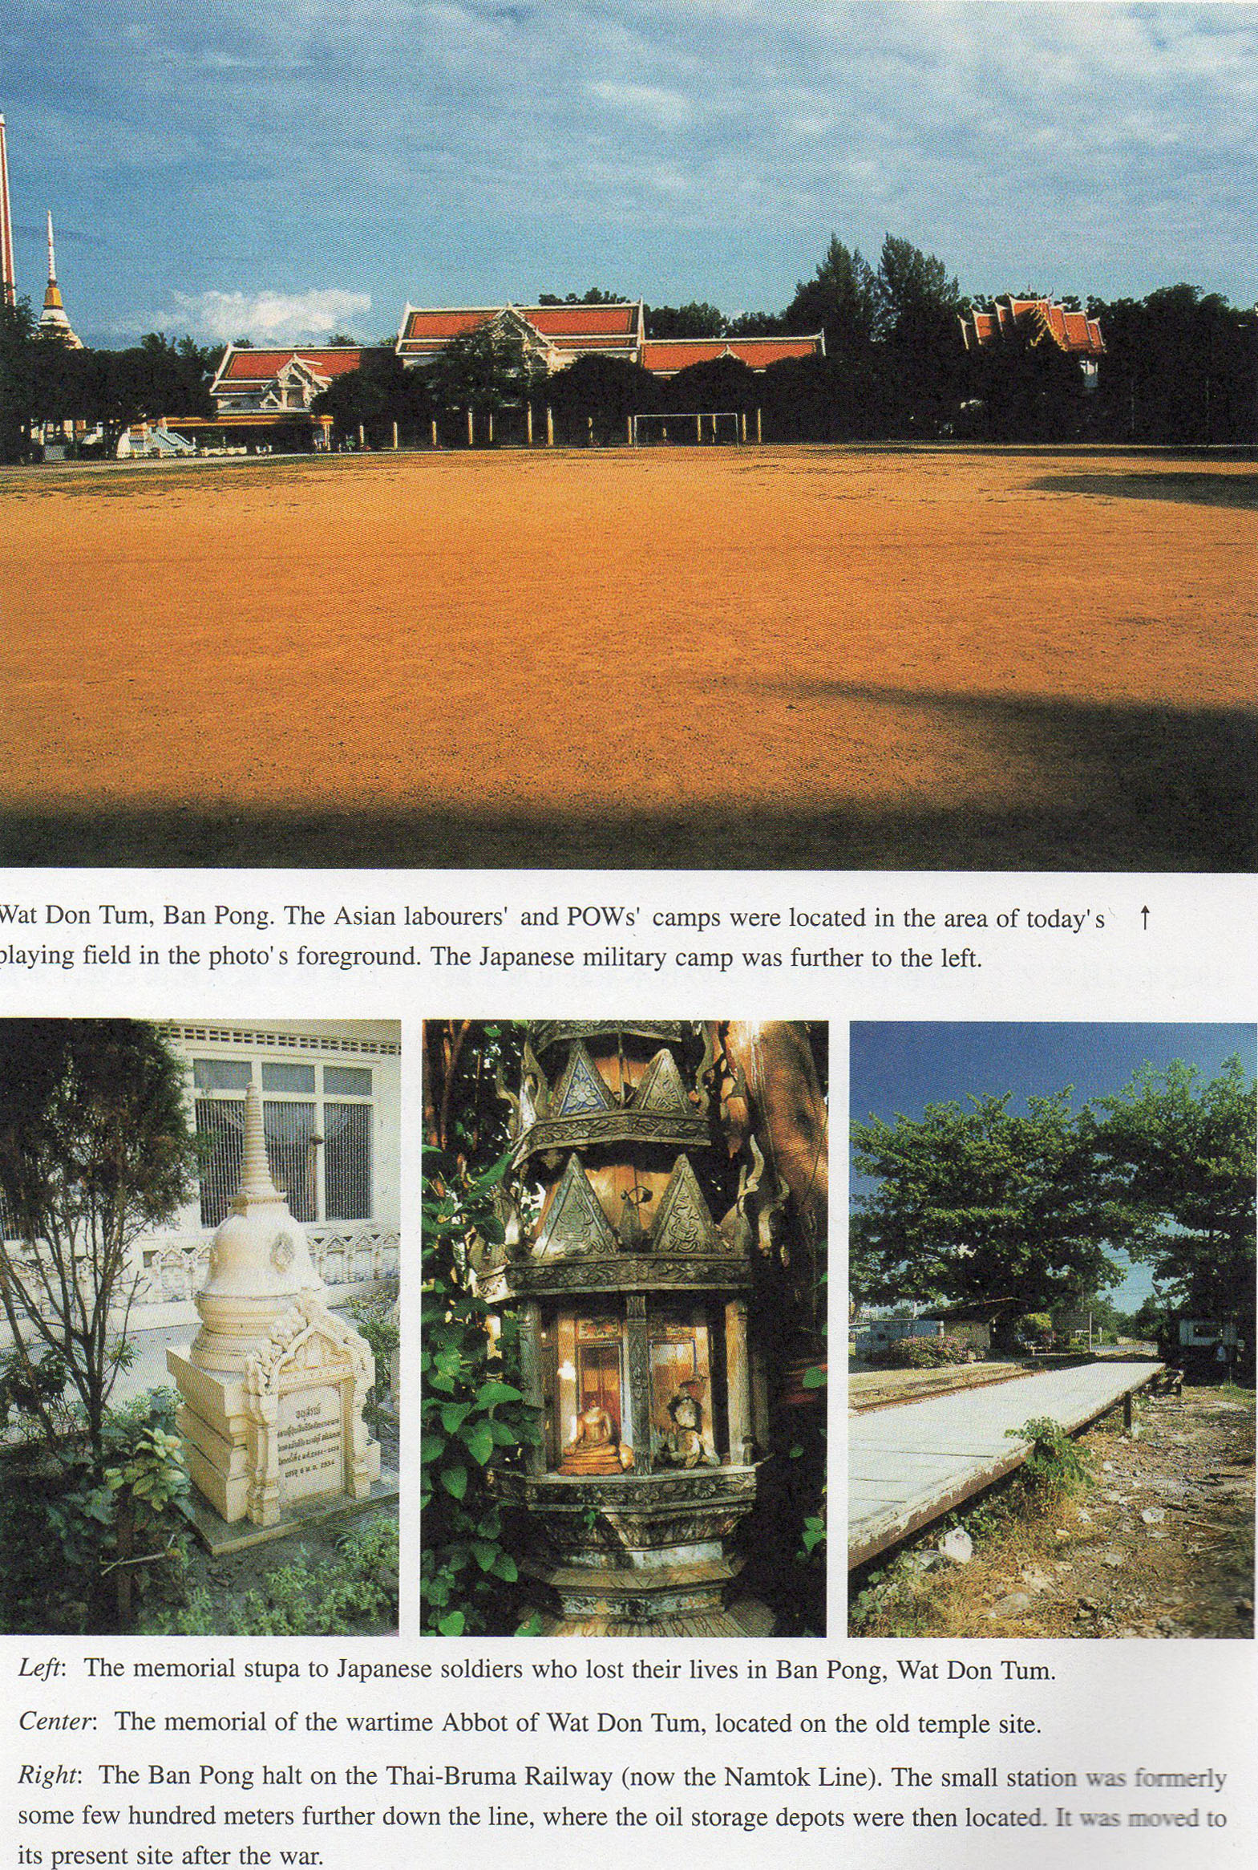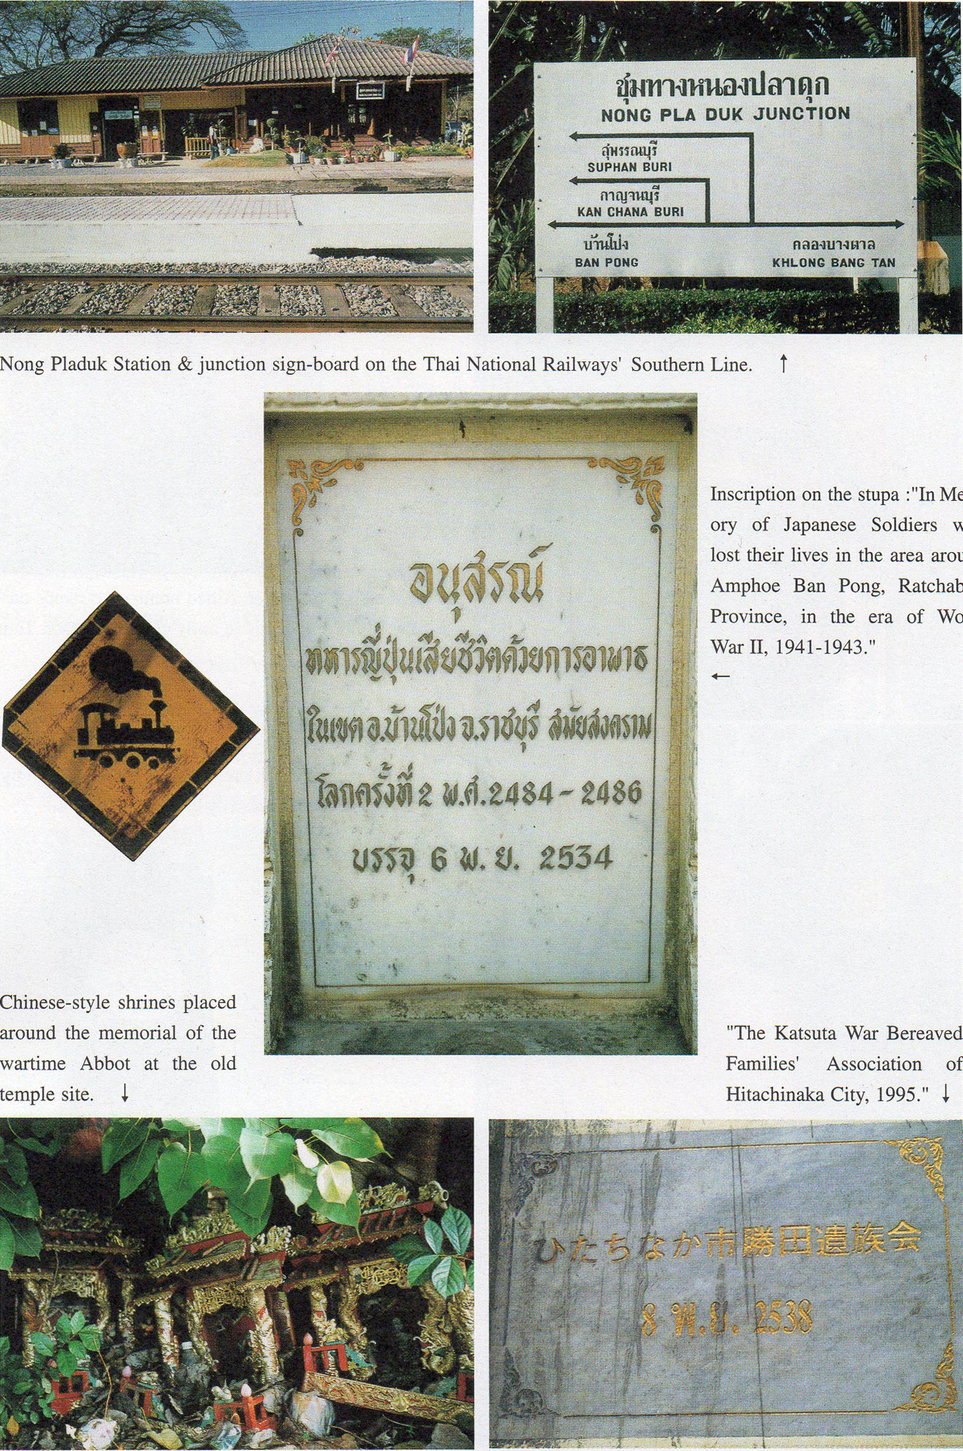

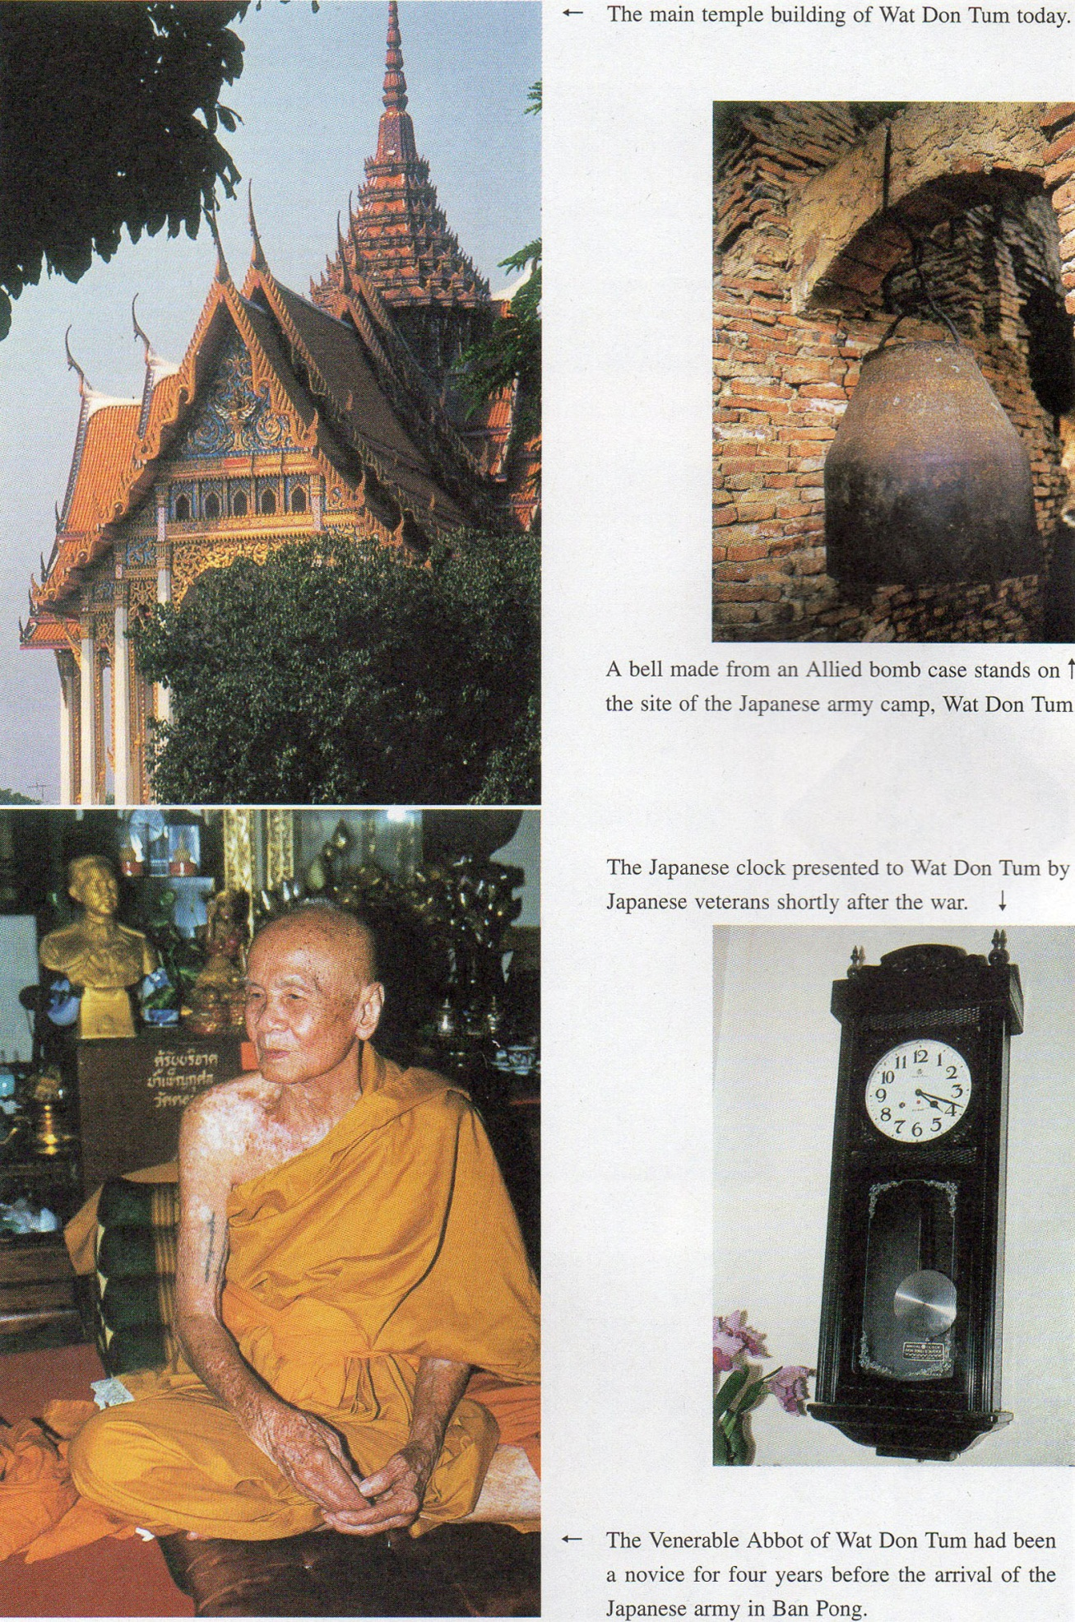

**NOTES ON THE THAI-BURMA RAILWAY   
PART VIII: TIIAI LABOUR & THE BAN PONG INCIDENT**

The important topic of Thai labour on the Thai-Burma Railway must not be neglected, even though estimates of the numbers involved are highly suspect and no known accounts survive of the experiences of the participants themselves. Although the Japanese destroyed most records pertaining to Asian workers at the war’s end, such military statistics as have survived indicate that there were considerable numbers of Thais involved. Statistics for the 4th Battalion of the 9th Railway Regiment (quoted in an earlier article) list 8 per cent of the total labour force as Thai. [1] Thai labour was used in the construction of the first section of the railway, from Nong Pladuk (the junction station with the main Southern Line), through Ban Pong, to Kanchanaburi.

“With Thailand... the planners of the new line had to proceed with a little more respect for the diplomatic niceties. Although the country had been attacked and practically occupied by Japanese forces, it still remained technically independent throughout the war... Indeed part of the reason for the delay in starting the railway project at the Thai end was the opposition of local Siamese landowners who had to give up property to make way for the new line. Negotiations were necessary and a series of conferences was held in Bangkok between Thai government representatives, Thai National Railways and the Japanese authorities.... An agreement was finally reached according to which Thailand provided the land for the Japanese right of way and also agreed to undertake some of the work at the south(and much easier) end of the projected line. The Thais were to help with the railway roadbed construction between Ban Pong and Kanchanaburi, where the line was to run parallel with a motor road already in existence and for the continuation of the motor road from Kanchanaburi to Wan Yai which lay some 120 kilometres to the North West of the line’s projected starting point. With Thailand bearing some of the cost and supplying a portion of the labour and materials, it appeared that the Japanese construction task would be eased considerably” [2]

Japanese military statistics *for* Thai labour probably underestimate the number of Thai personnel. Both (Thai-) Mons and (Thai-) Chinese seem to have been included under the ***“****Mon****”*** or *“Chinese”* categories rather than *“Thai”.*

“When it became necessary in 1942 to build the Thai-Burma Railroad, the Japanese Embassy’s chief liaison man, Fujishima, prompted the Chinese Chamber of Commerce (located then, as now. on Bangkok’s South Sathorn Road) to establish a joint stock company *(Manho**Yogen Koshi)* that played a crucial role in supplying gravel and other materials for the project. In 1943, the Chamber raised 1.2 million baht for labour recruitment and signed up 16.000 Chinese coolies by offering twice the normal wage for the hazardous construction work”. [3]

 Japanese historian, Murai Yoshinori, has found that;

“12,968 Thai Chinese *romusha* (labourers) were to have been received by the Japanese, but only 5,641 reached the labour camps; others ran away en route. The number of Thai *romusha* is unknown. For the construction of the railway between Nong Pladuk and Kanchanaburi about 5,000 (Thai) *romusha*were registered (September and October **1942).** In Kanchanaburi prefecture about 700 *romusha*were hired by the Japanese (October 1942). On 18th December 1942, Thai *romusha* and some policemen attacked the Japanese military base of Ban Pong. After this, Thai people **became** very reluctant to become*romusha.”[4]*

Considering the importance of this Thai labourers’ attack on the Ban Pong military camp, its omission from many accounts of the railway is curious. As Thailand had never been a Western colony and was regarded (at least by Britain) as a war-time Japanese ally, the fate of Thai labour working on a military project within Thailand itself, was never a subject of Allied concern. Nevertheless, the Ban Pong riots were of sufficient significance to force the Japanese army to seek civilian labour from occupied Southeast Asian countries outside Thailand, and to restrict the recruitment of Thais. On their part, ordinary Thais indeed became increasingly resistant to work on the railway project, not only due to news of the Ban Pong events, but also to the persistent rumours about the appalling conditions pertaining for those Thai workers who had been contracted by Thai companies to assist in the construction of a Japanese military railway in the Kra Isthmus. [5]

The best description of the Ban Pong Incident is that given by E. Bruce Reynolds in his pioneering study, “*Thailand and Japan’s Southern Advance*”. It is quoted in full.

“The fall flooding had slowed construction, and by mid-December only 13 kilometres of track had been laid. Considerable tension had developed between the Japanese, who mistrusted their allies, and the local residents. A Thai police lieutenant, Sisuk Mahinthorathep, recalled that the Kempeitai conducted searches, arrested people, and tortured suspects without regard to Thai law. It seemed to him that the bullying Japanese were about to take over the whole district.   
 “This mutual hostility flared into violence on 18th December when a Japanese sentry struck a Thai monk after a dispute about his presence in a restricted area. The Thai consider the head the most sacred part of the body and even a Thai monarch must treat a monk respectfully. Thus, when the monk complained to a group of Thai laborers that he had been slapped in the face, they were outraged. After nightfall they formed into an angry mob that attacked and killed a Japanese sentry with bamboo sticks and knives. Other Japanese soldiers heard the commotion and ran to the aid of their comrades. Chaos ensued. The Thai officials and the commander of the Japanese guards sought the assistance of the Kempeitai, which sent out a call for reinforcements. As ‘*the sound of gunshots and battle cries echoed in the night air*,’ would-be peacemakers reached the scene of the melee, now involving several hundred people. After about 20 minutes’ effort, the authorities from the two sides were able to break up the fight. Accounts indicate that at least two Japanese were killed.   
 “Lt. Sisuk, who had been left in command of the police headquarters in Ban Pong, was not sure what had happened, but fearing an imminent Japanese attack, he deployed 30 men, armed with rifles and two machine guns, around the building. They watched nervously as several trucks loaded with armed soldiers passed by from the direction of Kanchanaburi and headed toward the Japanese camp. Next, a black car and two trucks loaded with more than 20 armed soldiers slowed at the roundabout in front of the station. Although Sisuk claimed that the Japanese dismounted and opened fire with a machine gun, the Japanese contended that they were fired upon without provocation. They later concluded that a nervous Thai policeman probably opened fire at a Japanese who emerged from one of the vehicles. In any event, the shooting continued for several minutes before Thai officials and the commander of the Japanese guard arrived and intervened. Two contemporary Japanese accounts placed their toll at four dead (including a military doctor) and two seriously wounded.   
 ‘*From the next day the local people’s attitude was extremely bad*’, a Japanese officer noted in his diary. A series of anti-Japanese incidents ensued, including the destruction of a mile of railway track, an attack on Japanese soldiers by armed Thais and stone throwing by Thai women. A Japanese show of force restored a surface calm, but in the officer’s view the atmosphere remained ‘*oppressive*,’ and the surroundings ‘*disagreeable*.’ [6]

Several details differ slightly according to various sources. Even the date of the Incident itself is unclear and the figure of deaths disputed.[7] Just as the Ban Pong disturbances have often been ignored, so their importance and long-term effect on wartime Thai-Japanese relations have likewise been underestimated. Settlement of the affair was complicated by the demands of the Japanese Southern Army which, though headquartered in distant Saigon, retained direct command of all operations related to the railway’s construction. Thai Prime Minister. Field Marshal Plaek Phibunsongkhram, in an attempt to calm the situation had ordered the Ban Pong and Kanchanaburi districts cleared of foreign residents within 7 days. [8] It is probable that the Japanese military was unimpressed as it appeared that the order also applied to Japanese civilians.

“The Southern Army soon confronted him (Phibun) with a series of demands so sweeping that they aroused concern in the Greater East Asia Ministry (in Tokyo) that Phibun’s authority could be undermined if he were forced to accept them. These involved execution of ‘*criminals*’ involved in the Ban Pong incident, the transfer of policemen and discharge of officials involved, reparations ranging from 20.000 baht for each dead officer and 1,000-3.000 baht for each injured soldier, a formal apology, and various preventative measures. Among the latter were a vigorous public re-education effort to eliminate anti-Japanese attitudes, and special training for policemen.” [9]

Execution was also demanded for the monk whose head had been hit by the Japanese guard - the alleged “*ringleader*” of the affair - despite Thai insistence that no matter what the crime, a monk could not be given the death penalty under the country’s legal arrangements. The total compensation amounted to the (then) not inconsiderable sum of 80,000 baht. [10] The Southern army’s excessive demands on Thailand perhaps indicate the prejudice towards local Thais prevalent among the Japanese military, rank and file as much as the Southern Command itself. On the Thai side, it should not be forgotten that in December the previous year the Japanese had actually invaded Thailand (leading to several Thai military and civilian casualties in Chumphon, Nakhorn Sri Thammarat and elsewhere) and there was a general feeling and resentment at being “occupied”. Moreover, relations with the Japanese civilian community (now numbering some 1,500 in Thailand) as well as with the Japanese military were far from harmonious.

“The language barrier between the two peoples contributed to misunderstandings, and quarrels were often intensified by economic inequities or simple jealousies. The Thai were feeling the economic affects of the war for the first time, but Japanese, whether they came from the homeland - where a four-year conflict had already forced severe austerities - or chaotic China, found life in Thailand very pleasant. In fact, to soldiers in transit from one grim battlefront to the next, Bangkok seemed a veritable oasis.... Free-spending Japanese pleasure seekers, who benefitted from the devaluation of the baht, became the favored clients of night spots and brothels, much to the irritation of local patrons. Japanese messages had expressed concern aboutquarrels between their soldiers and Thai civilians as early as May 1942, and (Japanese Ambassador) Tsubokami reported in August ‘*numerous incidents of friction between Thai officials and the Japanese residents and military groups*,’ ‘*frequent skirmishes*,’ and an increase in thefts and robberies. [11]

Some Allied POW (Prisoner of War) accounts mention the ill-treatment frequently experienced by the local Thais. Passing through Ban Pong camp a month or so before the incident, British POW Charles Fisher records.

“Ban Pong provided a final surprise in the course of our one-day stay there. On our arrival we had noticed a bunch of about a dozen scared-looking Thais lined up outside the guard room, as we trooped in. It now appeared that they had been caught carrying on a highly illicit trade in bananas and other equally dangerous goods with the prisoners, and were to be punished accordingly. One by one, they were dragged forward, and thrown to a waiting gang of Japanese toughs who alternately pummeled, punched and slapped them, or kicked them in unmentionable but proportionately painful places. Then each of four guards seized a leg or an arm of each of the victims in turn and swung the wretched men wildly to and fro in the air for a few minutes to gain momentum, before flinging them into a stinking puddle. For most of us this was the first sight of naked brutality on the part of the Japanese, and it was horrible.” [12]

The Ban Pong affair had important ramifications, one of which was the establishment of a newly organised Bangkok Garrison Command under the leadership of General Nakamura Aketo.

“Arrogant attitudes displayed by both military and civilian Japanese in the heady early stages of the war made matters worse, setting the stage for the eruptionof violence at Ban Pong in December 1942. Coming at a time when the Japanese high command had been shaken by setbacks in the Guadalcanal campaign, the Ban Pong incident was a warning signal that alerted Tokyo to the seriousness of the problems in Thailand. This led to the dispatch of General Nakamura (Aketo) to head the new Thailand Garrison Army, a real turning point in Japanese -Thai relations. Not only were Nakamura’s warm personality and his ability to understand the Thai perspective priceless assets, but he was farsighted in recognizing that Thailand’s potential as a military supply base could be maximized through the maintenance of friendly relations. He eschewed the impetuous, heavy-handed approach that had led the Imperial Army into conflicts elsewhere. While Ambassador Yamamoto exerted his influence to avert any military action against the Thai in the final months of the war, given the Japanese army’ s well-known capacity for independent action, Nakamura deserves particular credit for the fact that the Japanese-Thai alliance did not end in a bloodbath.” [13]

General Nakamura does seem to have achieved a degree of popularity in Thailand, quite unprecedented among Japanese military leaders in Asia. On a postwar private visit to Bangkok the former General was widely welcomed by a wide spectrum of Thai political leaders. He appears to have maintained his friendship with wartime Thai Premier Phibun after the latter’s exile to Kamakura in Japan. (Following the Sarit coup against Phibun’s second postwar administration in 1957*,* the latter went into exile, first in Cambodia, and then Japan, where he remained until his death); Phibun even wrote the introduction for Nakamura’ s autobiography, entitled “*Hotoke no Shireikan”* (The Buddhist Commander) published by Nihon Shuhosha in 1958. Nevertheless, Reynolds’ highly positive evaluation of Nakamura tends to follow that enunciated in his autobiography by the General himself. It might, for example, given the present understanding of the issues involved, be a little difficult to enthuse over Nakamura’s establishing a “*Comfort Station*” (military brothel) in Bangkok as a positive step! Admittedly the indiscriminate rape of Thai women by Japanese soldiers is equally appalling, but it might be argued that the opening of a Bangkok “*Comfort Station*” merely enabled the same rape to be perpetrated in secret, hidden from the public gaze.

“A face-slapping incident had triggered (the events in) Ban Pong and (Thai) Ambassador (to Tokyo) Direk, who was on leave in Bangkok, had impressed upon Nakamura how deeply the Thai resented such behavior on the part of the Japanese.... The Japanese lack of self-consciousness about nudity and their habit of urinating in public places had offended Thai sensibilities, too, so Nakamura took up Ambassador Tsubokami’s suggestion that a pamphlet explaining Thai customs and cultural taboos be prepared. The *Keinpeitai* (Military Police) took responsibility for insuring that a copy was distributed to each soldier entering the country.... The soldiers’ nocturnal activities had been the root of many quarrels, so the Garrison Army established a separate army brothel - a ‘*comfort*’ facility as it was euphemistically called - to keep the enlisted men out of the local establishments. Tominaga made arrangements with the Thai government, which provided a building and agreed to the hiring of local women to staff it. The brothel soon began operations.” [14]

The information that local Thai women staffed the brothel was taken from Tominaga Kametaro’s diary account, *“Chototsu Hachijunen”* (Eighty Reckless Years); Tokyo, 1987), a manuscript copy of which is in Reynolds’ personal collection. It seems highly unlikely that the bodies available were *only* those of Thai women. Many accounts attest to the presence of Korean and even Taiwanese, as well as Thai and Mon women in Japanese military brothels along the Thai-Burma Railway and in Kanchanaburi itself. [15]

“General Nakamura responded to the political crisis by intensifying efforts to solve the festering problems that his new command had inherited. At the top of the list was the Ban Pong incideni The Thai had resolutely resisted the Southern Army’s demand that the Buddhist monk considered the ringleader in the allair he executed, claiming that their laws did not permit the execution of a monk. Nakarnura not only recommended that the demand be dropped. hut suggested that an 80,(X)O baht indemnity he handed hack as a fund to benefit the families of Thai soldiers killed in the fighting with the Japanese army in December 1941. To Nakamtmra’s surprise, the Southern Army accepted his ideas, permitting the settlement of a nettlesome controversy.”[16]

The incident’s settlement had, however, taken several months. Although the Thai-Burma Railway operations were under the direct command of the Southern Army, it should be mentioned that Nakamura had himself journeyed to Kanchanahuri on March 4 1943 to inspect the railway construction. He must also have passed through Ban Pong and must have been at least partially aware of the horrific conditions obtaining along the railway course. Moreover, just before the war’s end in May 1945, command of the railway forces had been transferred to Nakamura’sGarrison Command. [17] Just how aware Nakamura was of the conditions prevailing in the railway camps may never be fully known, and whether he might have been able to affect any amelioration is doubtful. Quite how Nakamura was able to have his terms for settlement of the Ban Pong incident accepted by the Southern Army’s Saigon command still remains a mystery. But the suspicion remains that the Ban Pong events might have given Prime Minister Phibun cause for caution in his dealings with the Japanese. Some Thai historians have recently tried - quite convincingly - to correct the overwhelmingly negative views of Phibun that have generally obtained within contemporary Thailand. Phihun was, they argue, pressured by circumstances and was never ideologically pro-Japanese; rather he reluctantly promoted what he saw as being Thailand’s national interests of survival (which conveniently happened to coincide with his own) in a situation which allowed him few options. It has even been suggested that Phibun’s administrations were arguably somewhat more ‘democratic’ compared with those that followed. [18] Phibun distanced himself from the Japanese on certain important occasions; his two most famous “*absences*” are – first - that of December 1941 (when Phibun absented himself from Bangkok, probably to evaluate the Japanese invasion of South Thailand, and was thus able to delay signing any agreements with Japan) and – second - his adamant refusal, despite considerable pressure from the Japanese Embassy, Nakamura and even Tokyo itself, to attend what he probably regarded as a purely propaganda exercise - the convening of the 1943 Greater East Asia Conference in Tokyo, comprising the heads of Japanese-occupied or Japanese- supported Asian governments. (Only Thailand’s Premier was absent; the country being represented, instead, by its Foreign Minister, Prince Wan Waithayakon). The Ban Pong events had occurred between Phibun’s two great “*absences*”. Moreover, his government had resolutely refused the Southern Army’s original demands for the Incident’s settlement. To what extent might Premier Phibun have been personally influenced by the events at Ban Pong? In this context, it is curious to note that on hearing of the impending arrival of General Nakamura in Bangkok, Phihun again absented himself from the capital, leaving vanous deputies to greet the General in his place. [19]

Much about the Ban Pong disturbances remains hazy and the entire affair is not well-known in Thailand today. In an attempt to set the incident within the context of wartime Ban Pong, a casual visit to the town’s temple, Wat Don Tum, indicated that its Abbot had been a temple novice at the time of the Japanese army’s arrival. It also revealed the presence of a small stupa, erected in 1991, commemorating those Japanese soldiers who had lost their lives around Ban Pong. On a subsequent visit to Wat Don Tum, on 13th July 2002, the Reverend Abbot agreed to articulate his wartime memories.

Today, Wat Don Turn is a substantial temple, constructed in the contemporary Bangkok/Rattanakosin style. It lies on the main road through Ban Pong itself and is clearly visible from the railway, for the main rail track runs behind the large temple compound. The junction of the Thai-Burma Railway (today’s Nam Tok Line) with the main Southern Line is only a few tens of meters from the temple’s access gate to the rail tracks. The Nong Pladtik Junctionstation is a kilometer or so to the left of the same gate, and two Ban Pong stations lie a few hundred meters to the right, on their respective forks in the rail track: the main Ban Pong station of the pre-war Southern Line and the small Ban Pong halt of the (newer wartime) Thai-Burma Railway. [20] The Abbot explained that during World War II, the main temple building was located some few hundred meters to the East of the present site, this old site now containing only the memorial tomb of the wartime Abbot and those of other substantial parishioners. Today Wat Don Tum stands on the site of the former Japanese army camp and other camps housing both Allied prisoners (POWs) and Asian labourers. Several hundreds of Thai workers had been employed building the rail track from Nong Pladuk but the Abbot believes that, for the most part, they were not local people, but had been brought by the Japanese from other regions. He confirms that the road to Ban Pong had been completed before the war and predates the construction of the railway. The Abbot also talked sadly at some length of the “*dark-skinned Indians*” (presumably Tamils) who had sometimes come with women and children to labour on the railway. [21] There were evidently several hundred POWs and some thousand labourers in the Ban Pong camps at any given time. (Ban Pong acted as a transit camp for workers proceeding into the jungle to work further up the rail course). There had been severe floods in 1942, both Bangkok and nearby Suphanburi having been very seriously affected. Ban Pong itself was not spared and the Wat Don Tum camps were similarly flooded. Former British POW, Charles Fisher, graphically recalls the state of the camp some few weeks before the Ban Pong incident;

“We entered Ban Pong camp after a short march from the railway station... A neighbour of mine, formerly an inspector under the Ministry of Agriculture, stated that he would unhesitatingly have condemned the Ban Pong huts even for pigs, and it was not meant as a figure of speech. Elsewhere, the camp stood knee-deep in mud, and the only way of making any reasonable progress was to follow behind someone larger and more energetic than oneself, placing one’s feet carefully in his footsteps. A short distance from the main residential area a shimmering cloud of buzzing bluebottles marked the site of the latrines... vast open pits at the bottom of which was a seething, squirming mass of white maggots. The stench beggared description; no wonder the place was called Ban Pong!” [22]

A later arrival at the camp, former British POW, Jeffery English, described the Ban Pong camps in terms that accord with the Abbot’s explanation;

This ill-defined compound, besides the four huts, boasted as its only embellishments a well, an enormous latrine, and surprisingly enough a Buddhist temple. The temple, of course, had been there long before the camp, the Nips (Japanese) having chosen the site to get the use of the well without having to prospect for and dig one for themselves: it still remained in full operation with the bright-robed priests in their saffron habits strolling straight through our huts on the way in and out and to and from the road. Inside, the huts were quite reasonably clean, but the rest of the compound was in an appalling state of dirt and neglect. The dismal, squalid little forecourt was simply a stretch of uneven, bare earth, with a wide ditch separating it from the road and overflowing with stinking refuse from end to end. Half-dried-up puddles were dotted about the area, choked with mucky litter; and accumulations of rubbish of every sort were scattered about, caught in the undergrowth, trodden in the mud, or heaped in mountainous drifts in odd corners. A notice in English, headed “*Regulations for Coolies and Prisoners-of-War*” was posted up on a large notice-board at the entrance of the camp. Although headed in the plural it stipulated only one single regulation, which ordered us to use the proper latrine instead of the surrounding bushes. The coolies who had preceded H Force obviously couldn’t read, and evidences of their illiteracy were plastered in copious profusion about the shrubberies and even in the drain trenches round the outside edges of the huts; flies in their hundreds of thousands were eagerly feeding and breeding and storing up even more dysentery for us. The cook-house, on the other side of the road, was even worse. We were not expected to cook for ourselves, and this was a static cook-house, manned by a mixed all-Asian staff. A Nip soldier in charge; Thai women, Tamil Indians, and the ubiquitous Chinamen all seemed to have their grimy fingers in the pie; and, not being hound by the ‘*Regulations for Coolies & Prisoners-of-War.*’ they simply used the hedge behind the boilers for all purposes.” [23]

Also participating in the Wat Don Tom interview was Thai historian and former Rector of Thammasat University, Charnvit Kasetsisri. Born in Ban Pong the year the Japanese arrived, 1941, Charnvit’ s father, Chern Kasetsiri, had been Deputy-Mayor of Ban Pong.

“My father sometimes represented the Nai Amphoe (District I lead) in talks with the Japanese because he could speak English. lie was there at the incident, too. lie became rather friendly with the Japanese at the camp. They gave my Mother, who was a nurse, some medicine to take care of me when I was sick. When the Japanese were defeated and had to leave they gave our family one *sukiyaki* pan, one bicycle and a knife. I still have the knife.”

The Abbot clearly recalled Chern Kasetsiri and remembered he was one of the officials trying to assist in resolving the incident. By and large, the Abbot’s description of the Ban Pong incident confirms that of E. Bruce Reynolds quoted above. However, the Abbot pointed out that the novice whose being struck on the face had been the cause of the disturbances, was not actually a monk from Wat Don Tum, but had come from elsewhere. The novice had been found on the railway track, without the special permission from the Japanese authorities which was an essential requirement for entry, and had been interacting with the Allied prisoners. Tbe incident had flared up after the novice had talked about the face- slapping later in the day with a group of Thai labourers. As it was already evening, the Abbot observed that many of the Thais who had gathered might have been somewhat intoxicated with liquor. The noise of the subsequent shooting could be heard for about half an hour.

Both interview participants drew attention to the enormous changes which took place in the mainly Chinese merchant community of Ban Pong as a result of the war. From being a sleepy little village on the Southern Railway, Ban Pong became a thriving center of economic activity due to its location - along with Nong Pladuk - as a base of the railways operations and construction. Much new wealth (of those businesses acting as contractors for the Japanese) replaced the more traditional families and community leaders. This was a nation-wide phenomenon.

By the end of January 1942, the ranks of the old Chinese leaders were sadly depleted. The most prominent of the prewar Teochiu leaders, Yi Kuang-yen, had already been assassinated, and three of the other top leaders arrested or deported before the Japanese occupation. In December 1941 and January 1942, the chairman and three executive committee members of the Teochiu Ass ociation were arrested after refusing collaboration and sentenced on one charge or another to long imprisonment. At least three other prominent Teochiu leaders fled upcountry to avoid arrest. The Hainanese had been similarly stripped of their top leadership. Their three most important leaders had been deported prior to December 1941 and in that month the chairman of the Ch’iun-tao Hui-so (Hainanese Association) was arrested by the Japanese. Leadership of the other speech groups was also weakened, but to a lesser degree. Most of the smaller Chinese associations ceased operation during the occupation, but the Chamber of Commerce and the major speech-group associations elected to continue on whatever basis was possible. These decisions were made in hopes of forestalling confiscation or requisition of association properties as well as of continuing eflorts to protect Chinese interests.” [24]

Other commentators have shown how these changes, coupled with the hardships resulting from the high inflation, caused many resentments to surface.

“While these military loans (to the Japanese) created severe budgetary problems for the Thai government, ordinary Thai citizens were suffering from inflation and shortages. War hardships in Thailand were not equally shared, though, and some managed to enrich themselves. In order to understand how these war profiteers made their gains, it is important to recall that the money the Japanese borrowed was pumped into the local economy. Inflation undermined the value of the currency, but the baht never completely lost its value: in fact, it fetched a favourable black-market exchange rate with such Japanese army-administered currencies as the Burmese military rupee. Despite a threefold increase in the cost of living between 1941 and March 1944, the profiteers were able to pocket enough of the inflated currency being pumped into the economy to come out well-ahead. This created resentments and jealousies that added to the political problems of the Phibun regime... Although Japanese business interests had the inside track in procurement activities, their enterprises were relatively few in number. This reality, coupled with the destruction of the Japanese merchant fleet, opened a window of opportunity for the Chinese businesses that dominated the local economy.” [25]

In Ban Pong, prominent among the “*new wealth*” were families involved in the purchase, storage and sale of oil. (Both Ban Pong and Nong Pladuk hosted enormous oil storage facilities for the railway enterprise). The Abbot explained that it was, in fact, through the contributions and alms of such families, their relatives or descendants that the present impressive buildings of Wat Don Tum had been constructed after the war. (One son of a wealthy oil-dealing family had donated the not insubstantial sum of 300,000 baht). Commemorative photos of these temple benefactors are displayed in the Abbot’s quarters and their ashes have been laid to rest behind the temple’s main complex. Charnvit also confirmed,

“During this time many people got so rich because of the war and their good connections. But my Father was very idealistic and he did not profit from the war.”

He also recalled his Mother’s mentioning long after the war had ended that their family could have been extremely wealthy if her husband had been a little less scrupulous. [26] But for the ordinary local Thais, the war was marked by extreme poverty. This general, overwhelming poverty was highlighted in a popular Thai movie abotit the war released a couple of year ago, entitled appropriately *“Satang”* (The satang is a small unit of Thai currency. there being one hundred satang to one baht). [27]

  “Japanese traders employed a tactic of buying and stocking goods inside Thailand to create an artificially high price once the market panicked and caused a run on specific items. Perhaps most damaging to the economy was the trade deficit caused by trading transactions in favour of Japan. The Thai currency, the baht, had to be devalued to one-third of its real value in exchange with the Japanese yen. Japan also demanded loans to facilitate her military expenditure in Thailand. As a result, inflation was rife and the Thais faced exaggeratedly high prices for practically every consumer item... By 1943, the inflation rate was about 20 million baht per month, while shortages of consumer good, especially medicine, became critical.” [28]

Less sympathetic views of Thai poverty appear in the diaries of several prisoners, who were sometimes the victims of local Thais’ persistent efforts to extort wealth by selling scarce foodstuffs at exorbitant prices. As most prisoners still had some limited possessions left that could be sold, the Ban Pong camp seem to have been a hot center of trade with the locals. One rather amusing if sad account survives and is quoted in full;

By tea-time, trading had reached a fever-pitch of activity. Everywhere one looked one saw men slinking off into the bushes at the back (of the camp), pairs of trousers or rolled-up mosquito nets tucked under their arms: whilst in those bushes and welling through all the numerous gaps in the fences, scores of clamorous Thais were making the most of a lifetime’s opportunity.. Even crossing the road to the cook-house one would find oneself accosted by a native tugging urgently at the sleeve of the shirt which one was wearing, muttering. *‘Mister! Tree tical’.* I myself was involved in a highly undignified chase and a squabble, my plate being snatched from me by an eager young Thai woman who simultaneously thrust a fifty-cent note into my other hand before running off. Fortunately, she slipped in the mud and fell down, and I was able to catch up with her: whereupon a helpful bystander seeing me waving the fifty-cent note in my hand called out *“Fifty cent no good. Nice girl. One tical”* - evidently mistaking me for a would-be client for personal services, for which I was offering below the going rate. Thais and prisoners alike regarded each other with the utmost suspicion - they refusing to part with their money until they had handled the goods: and we learning only too rapidly their tendency to run away without paying at all. A curious sort of snatch-as-snatch-can was in vogue as a consequence, whereby the two parties danced about, feinting and crouching like a couple of all-in wrestlers seeking an opening, with us attempting to grab their money before we gave them the goods, and they intent on seizing the goods and darting away through the crowd without paying.   
A system less liable to deadlock soon evolved, more formal but quite as picturesque. We and the Thais placed the goods and the money on the ground at a distance of about 3 yards apart: the Thais counted out the notes for us tosee, and then, at a given moment, we each dived towards the other’s pile. This did away with the former danger of where the Thais did in fact hand over some money, but usually in a little role, which, by the time that we ourselves had counted it, was frequently found to be somewhat short of the price which had been agreed.   
A regrettable number of the Thais were there primarily for a little thieving rather than for honest trade, and mostwould filch if they got the remotest opportunity. Several unfortunate fellows were robbed of their boots whilst bathing naked at the well, whilst one had his trousers stolen before his very eves whilst crouching over the latrine. He’d taken them off and hung themn on a bush just out of his reach and the brazen Thai who did the deed took a most unfair advantage of the difficulty of immediate and modest pursuit to jeer at his victim and to make a rude noise at him prior to running off leaving the erstwhile owner to creep back trouserless to the hut.” [29]

The Abbot did strongly indicate however that, rather than the Ban Pong Incident itself it was the Allied bombing that remained the most vivid wartime memory of the Ban Pong community.

“There were two major bombing runs on Ban Pong itself. Of course, bombs were dropped elsewhere, too. Besides Bangkok, Ratchaburi was hit and six bombs fell on Nong Pladuk. In Ban Pong the oil storage depots caught fire and the noise was terrifying. So many people lost their lives as a result here in Ban Pong.” [30]

Charnvit (who, of course, was too young at the time to remember the bombing itself) later recalls being told by his Mother that she had taken him as a young child to Samut Phrakan to escape the bombing, leaving her husband in Ban Pong. Several prisoners also write of these devastating bombings in which many POWs also died, in their subsequently published diaries;

“We saw bloody stretchers being lifted carefully out of the railway cars. We were summoned to help carry the wounded men to the operating hut.... Since Nong Pladuk was located beside a marshalling yard, our fliers had apparently mistaken it for a military base. One hundred and twenty- five men were killed outright and over four hundred wounded.” [31]

In the precincts of Wat Don Turn, there is a small memorial chedi (stupa) in memory of the Japanese who died in the area during the war. Its inscription translates,

“In Memory of Japanese Soldiers who lost their lives in the area around Amphoe Ban Pong, Ratchaburi Province, in the era of World War II. 1941-1943.”

The Abbot explained how it came to be erected.

“There were many Japanese killed in the area, too. After the war, a group of some ten former Japanese soldiers visited the temple. I can’t remember the exact year now. They must have been former soldiers themselves because they came unaided from Bangkok; they knew the area well. They made merit and gave food to the monks and alms to the temple. They had come to search for the bones of the Japanese dead. They arranged for us to make the small memorial chedi and presented the temple with a clock. (It was made in Japan and they carried it all the way to Thailand with them). There aren’t actually any ashes of the dead Japanese in the chedi itself; rather they wrote the names of the dead on long strips of wood - several names on one strip - and these were placed in the chedi. I don t know how many names were written in all but I think it was more than a hundred. They gave about 40,000 baht to the temple. Later, a larger group of Japanese, perhaps between 80 and 100 came to the service marking the chedi’ s completion. Many local Thais attended, too. You must understand that although the (Allied) prisoners are commemorated in the Kanchanahuri cemeteries, there were no memorials to the Japanese who had also lost their lives. At the time of the dedication service they presented the temple with a couple of sofas. Since that time, however, no Japanese groups have ever visited.”

It seems that the funds were used to construct further amenities in the Wat Don Tum compound, for one large building bears a Japanese language inscription, “The Katsuta War Bereaved Families Association of Hitachinaka City, 1995”. Although one might wish that other nations’ victims, particularly those from the local Thai community, also had their appropriate memorials, the stupa is a dignified and tasteful memorial to those Japanese who lost their lives in a difficult by-gone era, in a foreign land, far from their home and whose legacy is still bitterly contested. [32]

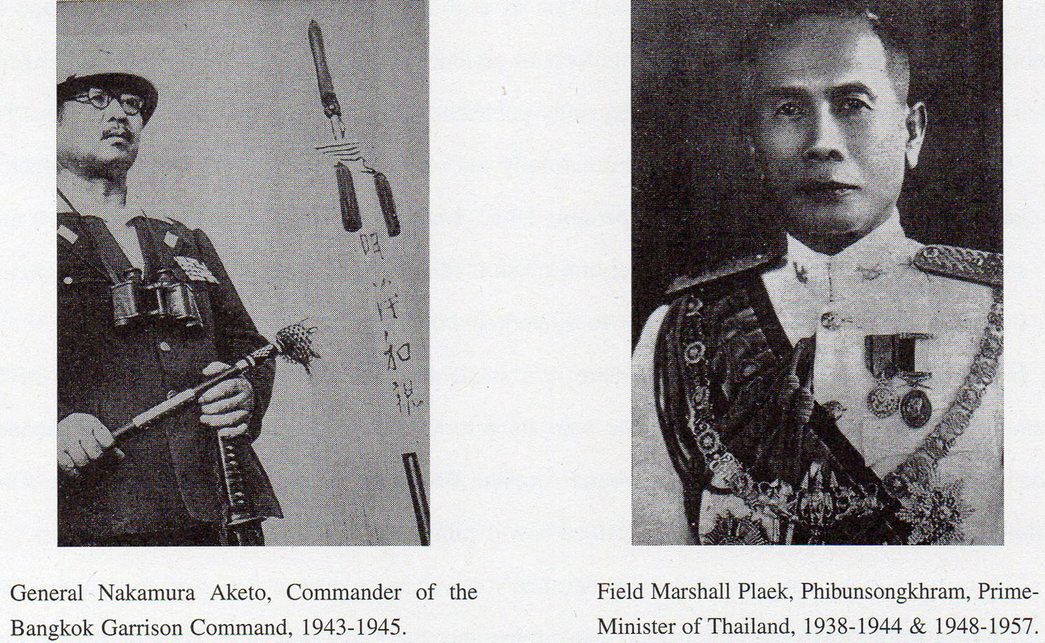

1. Hiroike Toshio: “*Taimen Tetsudo –* *Senju ni Nokeru Hashi*” (The Thai-Burma Railway: The Bridge Remaining on the Battlefield): Yomiuri Shimbunsha (Newspaper), Tokyo, 1971; p.237. (Other figures were Malay 67% and Chinese 25%).
2. Clifford Kinvig: “River Kwai Railway: The Story **of** the Burma-Siam Railroad” (Brasseys, 1992); p.38.
3. E. Bruce Reynolds: “*Thailand and Japan’s Southern Advance: 1940-45*” (Macmillan, 1994); p.177.
4. Murai Yoshinori: “*Asian Forced Labour (Romusha) on the Burma-Thailand Railway*” in Gavan McCormack & Hank Nelson (eds.); “*The Burma-Thailand Railway*” (Silkworm Books, 1993); p.62.
5. Although started after the Thai-Burma Railway, construction of the Kra Railway finished earlier. The Kra Isthmus Railway was built to link Chumphon (on the Bangkok Southern Line) to Victoria Point (now renamed Kaw Thaung), the most Southern town of Burma. The railway ran from Chumphon, through Kraburi to a terminal at Khao Fah Chih on the River La-Un, whence goods were transferred by boat to Ranong and Victoria Point in Burma. The railway will be the subject of future articles.   
   
6. E. Bruce Reynolds: op.cit; pp.138-139. The Japanese officer’s diary quoted towards the end of the lengthy description was taken from lwai Ken: “*C56 Nampo Senjo e Iku*” (The C56 Goes to the Southern Battlefields); Tokyo, 1978. A Thai account of the incident was written under the pseudonym ‘Khamsan’: “*Kiat Tamruat Thai thi Yuthaphum Ban Pong*” (The Honour of the Thai Police on the Ban Pong Battlefield): Tamruat Samphan (Police Relations); V-55, November 1982. A useful contemporary Japanese account is Tominaga Kametaro: “*Chototsu Hachijunen”* (Eighty Reckless Years): Tokyo, 1987; pp.169-171. An account based on Thai sources available in Bangkok’s National Library is Yoshikawa Toshiharu: “*Thai-Men Tetsudo: Kimitsu Bunsho ga Akasu Asia Taiheiyo Senso*” (The Thai-Burma Railway: The Asia Pacific War as Revealed in Secret Documents);  
   Dobunkan, 1994.
7. E. Bruce Reynolds: “*General Nakamura Aketo - A Khaki Clad Diplomat in Wartime Thailand*” in Chaiwat Khamchoo & E. Bruce Reynolds (eds.): “*Thai-Japanese Relations in Historical Perspective*” (Institute of Asian Studies, Chulalongkorn University, 1988); p.169, in which the number of Japanese deaths is recorded as 6. In a footnote, Reynolds explains, “*Murashima Eiji has found a Thai Foreign Ministry document confirming the date as 18th December*.” (Murashima Eiji, Nakharin Mektrairat & Somkiat Wathena: “*The Making of Modern Thai Politics*”; Tokyo, 1991).   
   
8. Similar orders had been issued for other “sensitive” military or security-related areas from May 1941. In January of 1942 several of Thailand’s northern provinces were cleared of non-citizens. The measures were probably primarily intended to remove ethnic Chinese and has been discussed in “*Part II: Asian Romusha: The Silenced Voices of History*” (Journal of Kyoto Seika University; No. 20, 200l). Fuller details appear in C. William Skinner: “*Chinese Society in Thailand*” (Cornell University Press, 1957**;** pp.270-275.   
   
9. E. Bruce Reynolds: “*Thailand and Japan’s Southern Advance, 1940-l945*” (Macmillan, 1994); p.139.
10. Nakamura Aketo: “Hotoke no Shireikan” (The Buddha’s Commander); Nihon Shuhosha, 1958; pp.50-SI.
11. E. Bruce Reynolds: op.cit; pp.136-137.   
    
12. Charles A. Fisher: “*Three Times a Guest*” (Cassell, 1979); pp.65-66.
13. E. Bruce Reynolds: op.cit; p.234.
14. E. Bruce Reynolds: op.cit; p.151. “*Direk*” is Direk Jayanama who at various times had been Foreign Minister and had also served as wartime Thai Ambassador to Japan. His account, “*Siam and World War II*” is available in English (Social Science Association of Thailand, Bangkok, 1978).
15. Further details of these accounts will be introduced in a future article.
16. E. Bruce Reynolds: op.cit; pp.150-151.
17. Nakamura Aketo: op.cit. Also “*Chutai Yonen Kaisoroku*”, Vol. 1, in the Archives of the National Institute of Defense Studies; Tokyo (as noted by E. Bruce Reynolds: op.cit.)   
    
18. See Charnvit Kasetsiri: “*The First Phibun Government & Its Involvement in World War II*” (Journal of the Siam Society; Vol. 62, No. 2; July 1974); pp.25-88 and, for the “*more democratic than what followed*” argument, See Kobkua Suwannathat-Pian: “*Thailand’s Durable Premier: Phibun through Three Decades, 1932-1957*” (Oxford University Press, 1995) pp.310-311.
19. In this less famous “*absence*” Phibun unexpectedly delayed his return from an inspection tour of Thai troops fighting in the Shan States. See E. Bruce Reynolds: “*General Nakamura Aketo - A Khaki-Clad Diplomat in Wartime Thailand*” in Chaiwat Khamchoo & E. Bruce Reynolds (eds.): op.cit; pp.169-170.
20. Following the construction of the Southern Line’s Ban Pong Station, the area that grew up around it (and the later wartime Ban Pong halt) was re-named Ban Pong Mai (New Ban Pong). I am unable to identify the old name by which the area was previously known from the recorded tape; the name starts with Nong (as in Nong Pladuk) but the second word is unintelligible.
21. Details of this part of the interview were included in the previous article; “Part VII: Indian Labourers on the Railway” (Journal of Kyoto Seika University; No. 25, 2003)
22. Charles A. Fisher: op.cit; pp.65-66.
23. Jeffery English: “*One For Every Sleeper - The Japanese Death Railway Through Thailand*” (Robert Hale, 1989); pp.71-72. Chapter 6, from which the excerpt is taken, has its title miss-spelt, “Bampong”.   
    
24. G. William Skinner: “*Chinese Society in Thailand: An Analytical History*” (Cornell University Press, 1957); p.272.
25. E. Bruce Reynolds: “*Thailand & Japan’s Southern Advance, 1940-45*” (Macmillan, 1994); p.272.
26. |  |
    | --- |
    | Personal communication from Chamvit Kasetsiri. It is highly probable that the merchants honoured after the war for assisting Allied prisoners in the camps along the railway were also from this group of people fortunate enough to enter into contracts with the Japanese military. One such was Boonpong Sirivejapanadah (sometimes rendered Sirivejjabhandu), a Kanchanaburi trader and wartime Mayor of Kanchanaburi, who supplied the camps by barge from the River Kwae Noi, and who received an MBE (Member of the British Empire) from Britain in 1948. His services to the POWs are recorded in many of their diaries;   *“In 1947 it was rumoured that Boonpong was in some political and financial trouble. The Far East POW Association raised funds which were sent to Bangkok. Shortly afterwards Boonpong and his wife established the Boonpong Bus Company which remains one of Bangkok’s successful companies to this day.”* (from Boonpong’s obituary in the *Times*; 17th February 1982).   That Boonpong was in financial difficulties after the war suggests that he had been a target for the rivalries and jealousies among the merchant community caused by relationships with the Japanese military. He had also been the victim of an unsuccessful assassination attempt in 1945.   “*Boonpong had been shot late on 26 September and was lying, seriously wounded in Kanchanaburi. Weary (Sir Edward Dunlop) ordered the SMO (senior medical officer) to* ‘*report upon the condition of Mr. Boonpong, injured Thai civilian, who has done so much for prisoners of war’*.” (Sue Ebury: “*Weary, The Life of Sir Edward Dunlop*”: Penguin, Australia, 1994; p.522).   In 1998, Boonpong’s grandson,Veeravej Suhhawat, received an award in memory of his grandfather’s services from Australian Prime Minister John Howard when visiting Bangkok. ***(****Bangkok Post****,*** 25th April, 1998).   Also, Mr. Lee Soon (who had moved from China to Thailand as recently as 1920), the contractor for canteens in the railway camps, received the (British) Kings Medal for Courage in the Cause of Freedom and was made an Officer of the Order of Orange Nassau by the monarch of the Netherlands. (Micool Brooke:  *“Captive of the River Kwae*”: Merman Books, Bangkok, 1995; pp.41-SO). |

   
27. *Satang*”, 2000, directed by Bhandit Rittakol
28. Kobkua Suwannathat-Pian: op.cit; p.268.
29. From the “*Bampong*” chapter of Jeffery English: op.cit; pp.74-76. The Tical was the Thai currency Unit (now more commonly known as Baht) and the note referred to as ‘50 cents’ was probably 50 sating. More seriously, financial rewards were handed out by the Japanese military to those Thais who captured escaping prisoners. Sir Edward Dunlop describes such an incident in his diary entry of 25th March 1943.   
     *“Included in the lorries from upriver were four tommies roped together who had escaped and been caught. They had run away with a lorry until the petrol gave out. Then the Thais who were guiding them gave them away for the payment of money. They have been told they are going down for execution*.” (Sir Edward Dunlop: “*The War Dairies of Weary Dunlop: Japan and the Burma-Thailand Railway, 1942-1945*”: Penguin, Australia, 1990; p.225).   
     Other prisoners record more positive impressions of local Thais.

    *“We developed quite a complex trading system with the Asian community and it was very successful. Our prime needs were food, medicines or drugs if possible, and they needed materials of any description to help in their**businesses. We had a very good relationship with the local people.*” (Tim Bowden: “*Changi Photographer: George Aspinall’s Record of Captivity*”:   
    ABC Enterprises & William Collins Pty. Ltd., Sydney, l984: p.l35)and   
     “*The Thai people rendered great services to POWs, with food, medical supplies**and news, often at great risk to themselves*.” (Geoffrey Pharaoh Adams: “The Thailand to Burma Railway; An Illustrated History”: private publication, 1978; p.9.)   
    
30. Ernest Gordon: “*Miracle on**the River Kwai*” (Collins, 1963); p.205.
31.
32. Hitachinaka City and Katsuta town are near Mita inlbaraki Prefecture (northeast of Tokyo). The official English rendering of the *“Izoku-kai”* is rather long, “*The Japan Association for Bereaved Families of the War Dead.*”